Publication_Figures

ET

## Allele Frequency

## Linear Polygenic Models

### Small vs High parameters

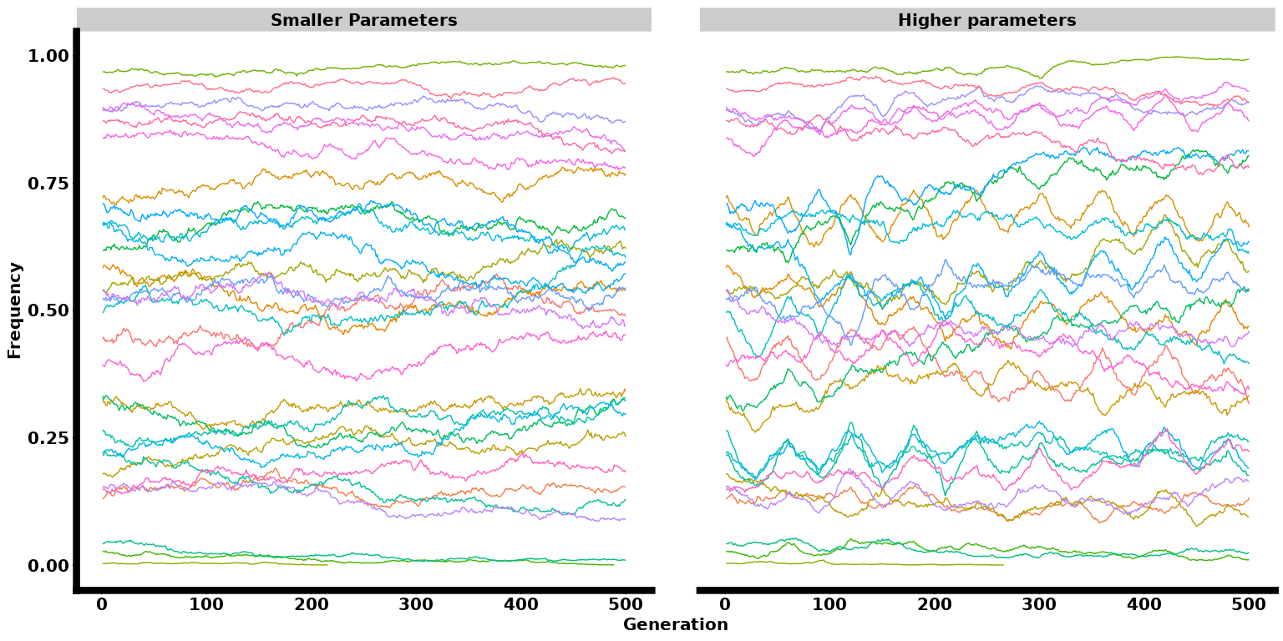

### Heritability Effect

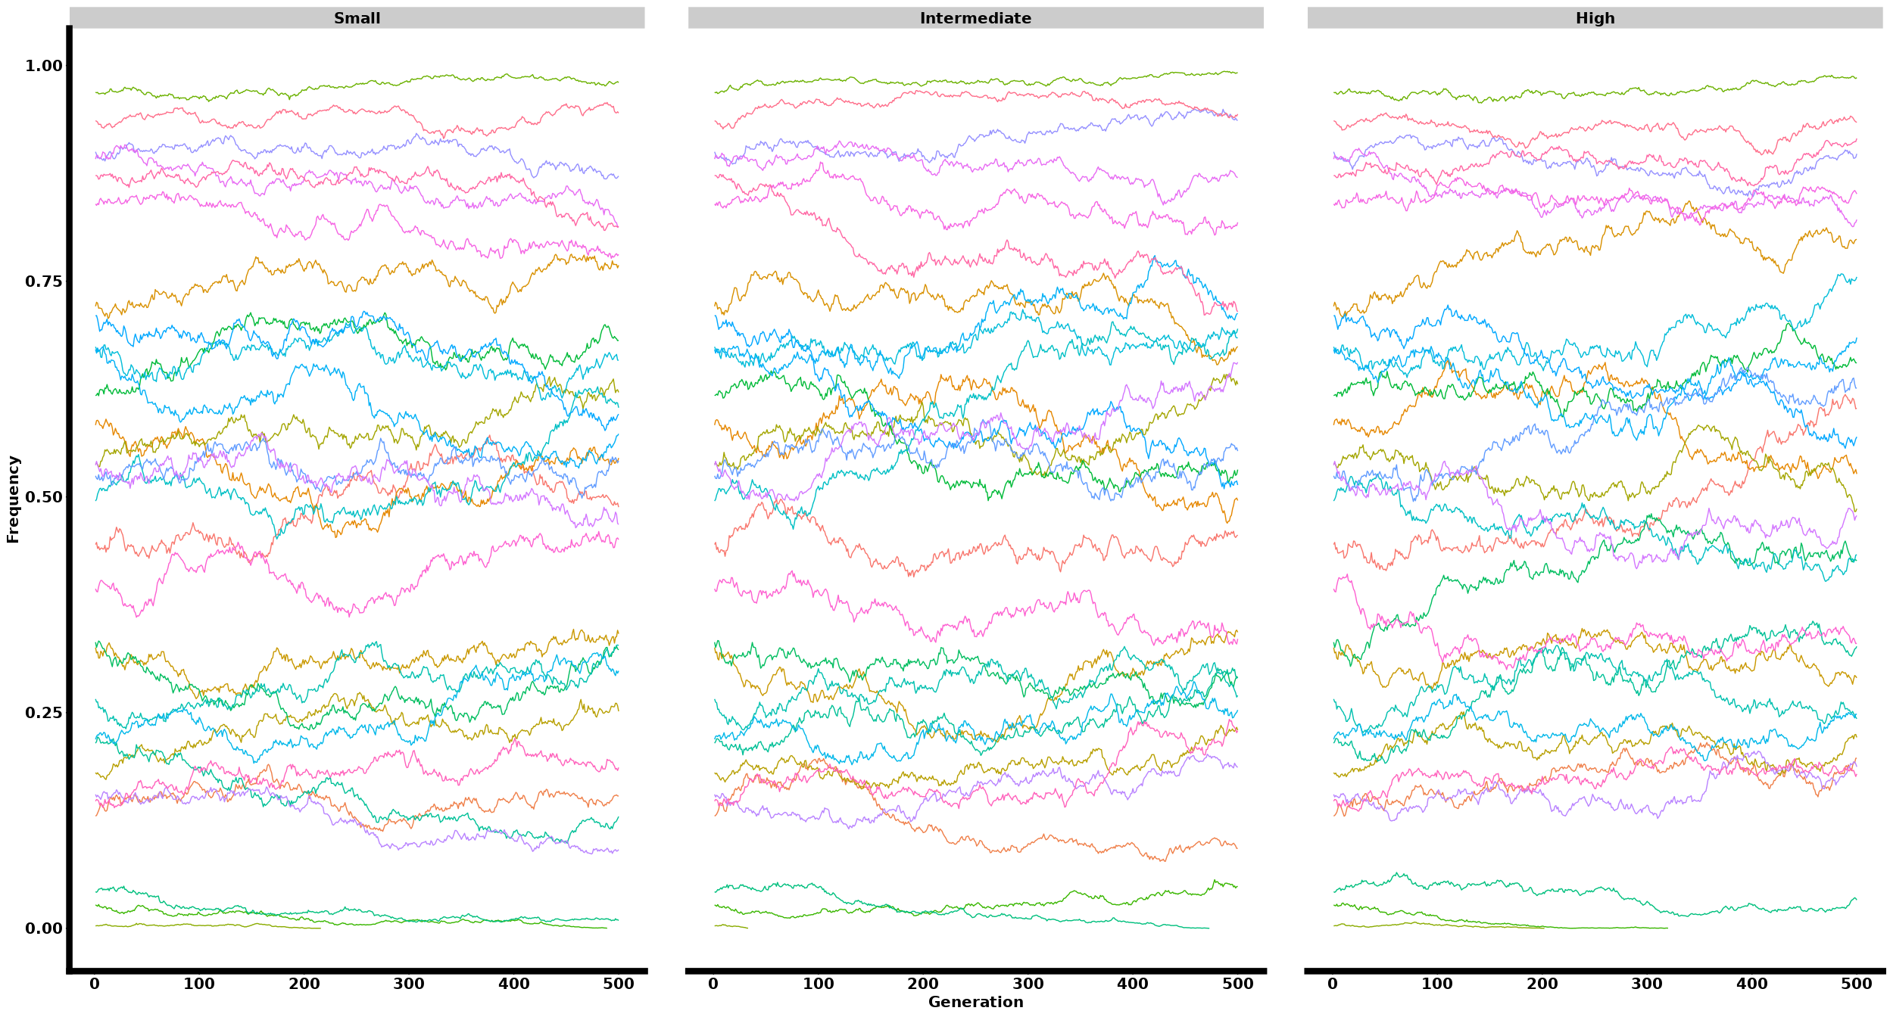

### Heritability and Selection Pressure

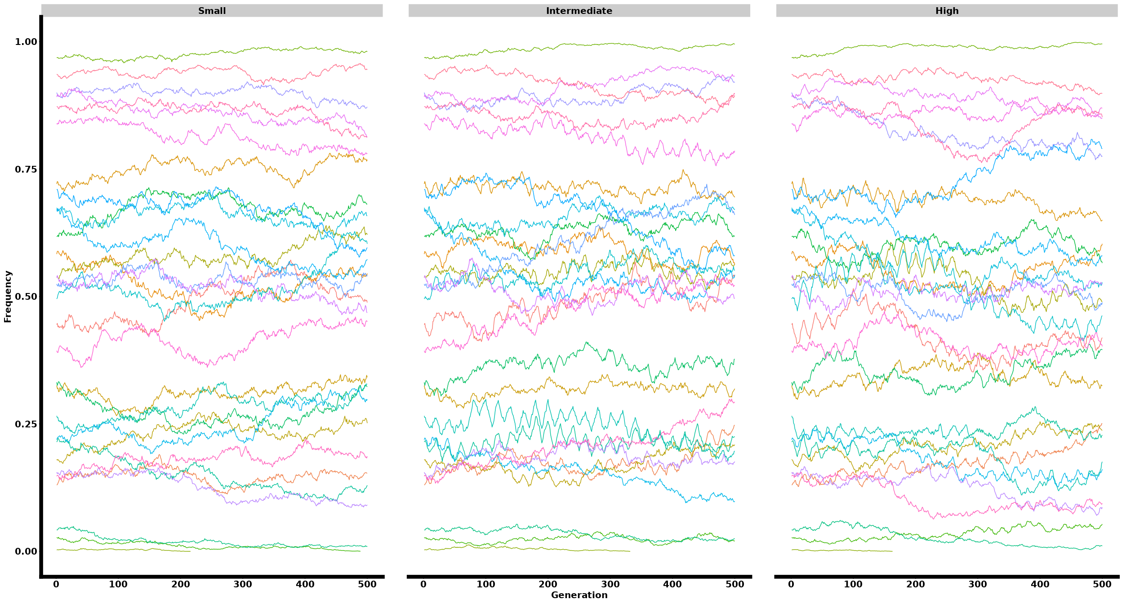

### Selection Length Effect

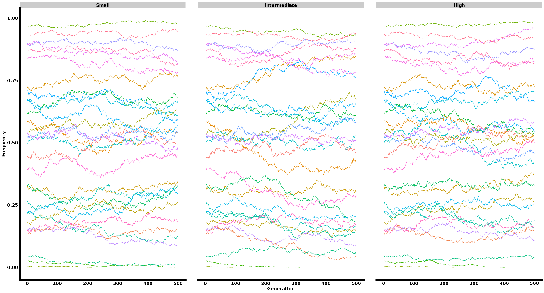

### Selection Length vs Heritability Effect

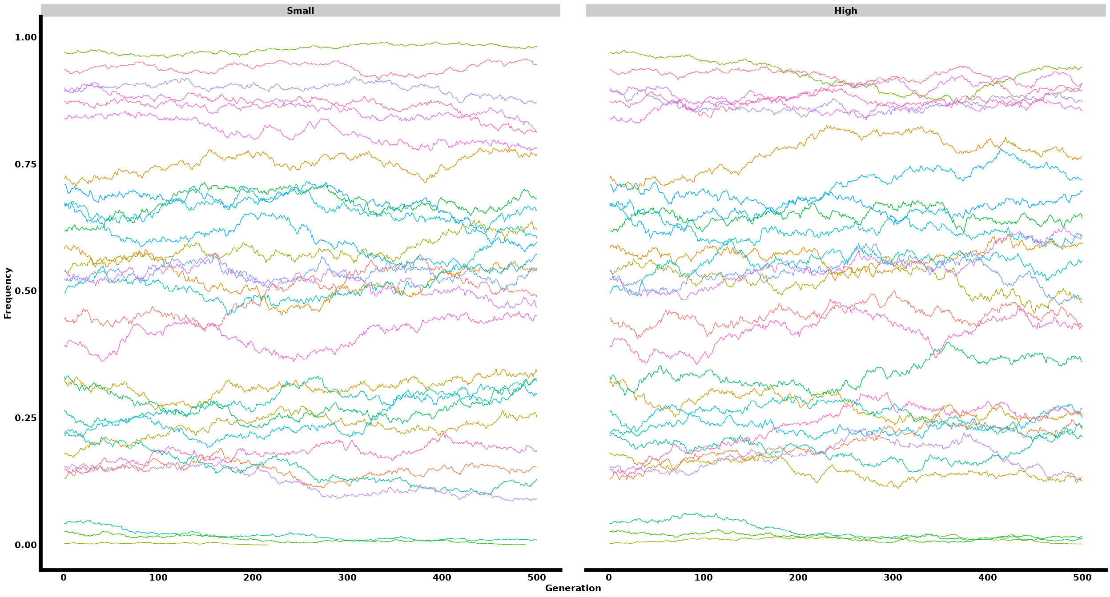

### Selection Length vs Selection Strength Effect

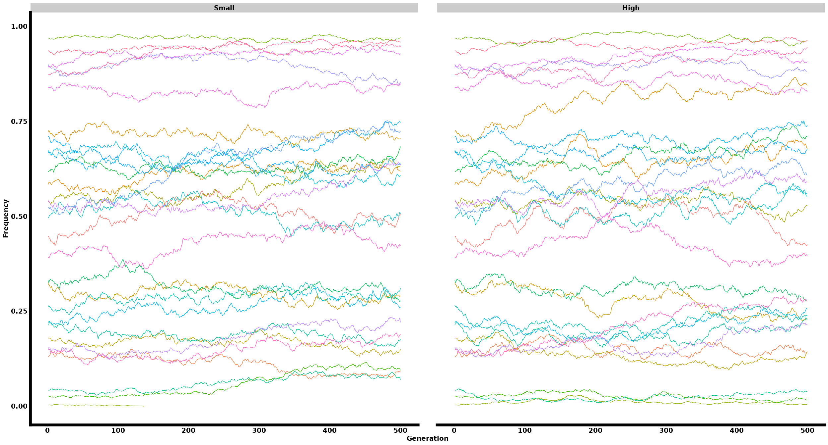

## All in one

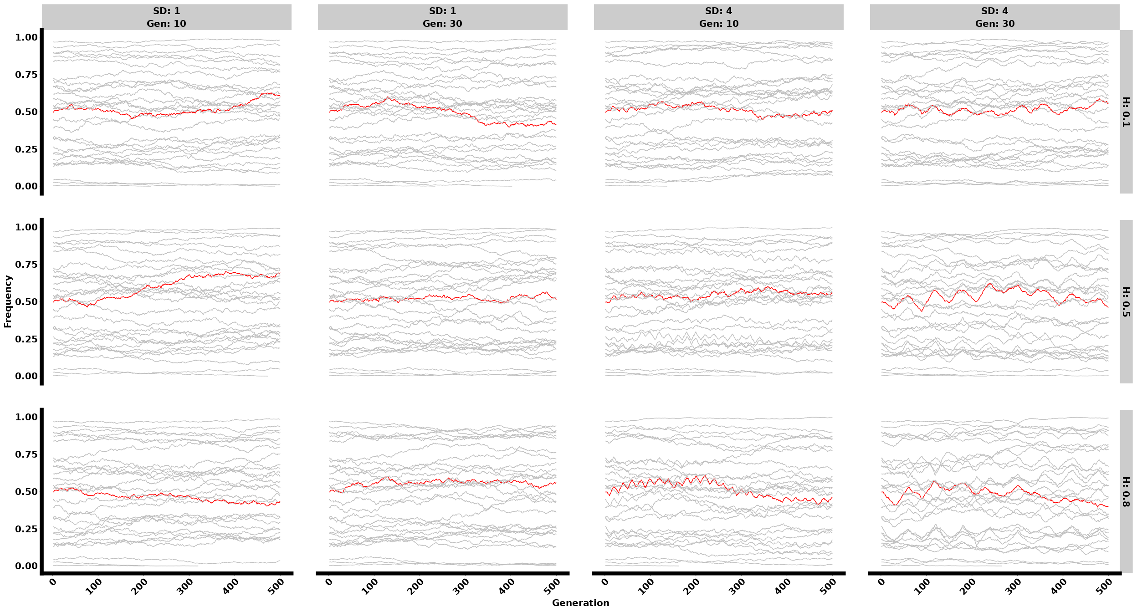

####Let’s try frequency with Effect

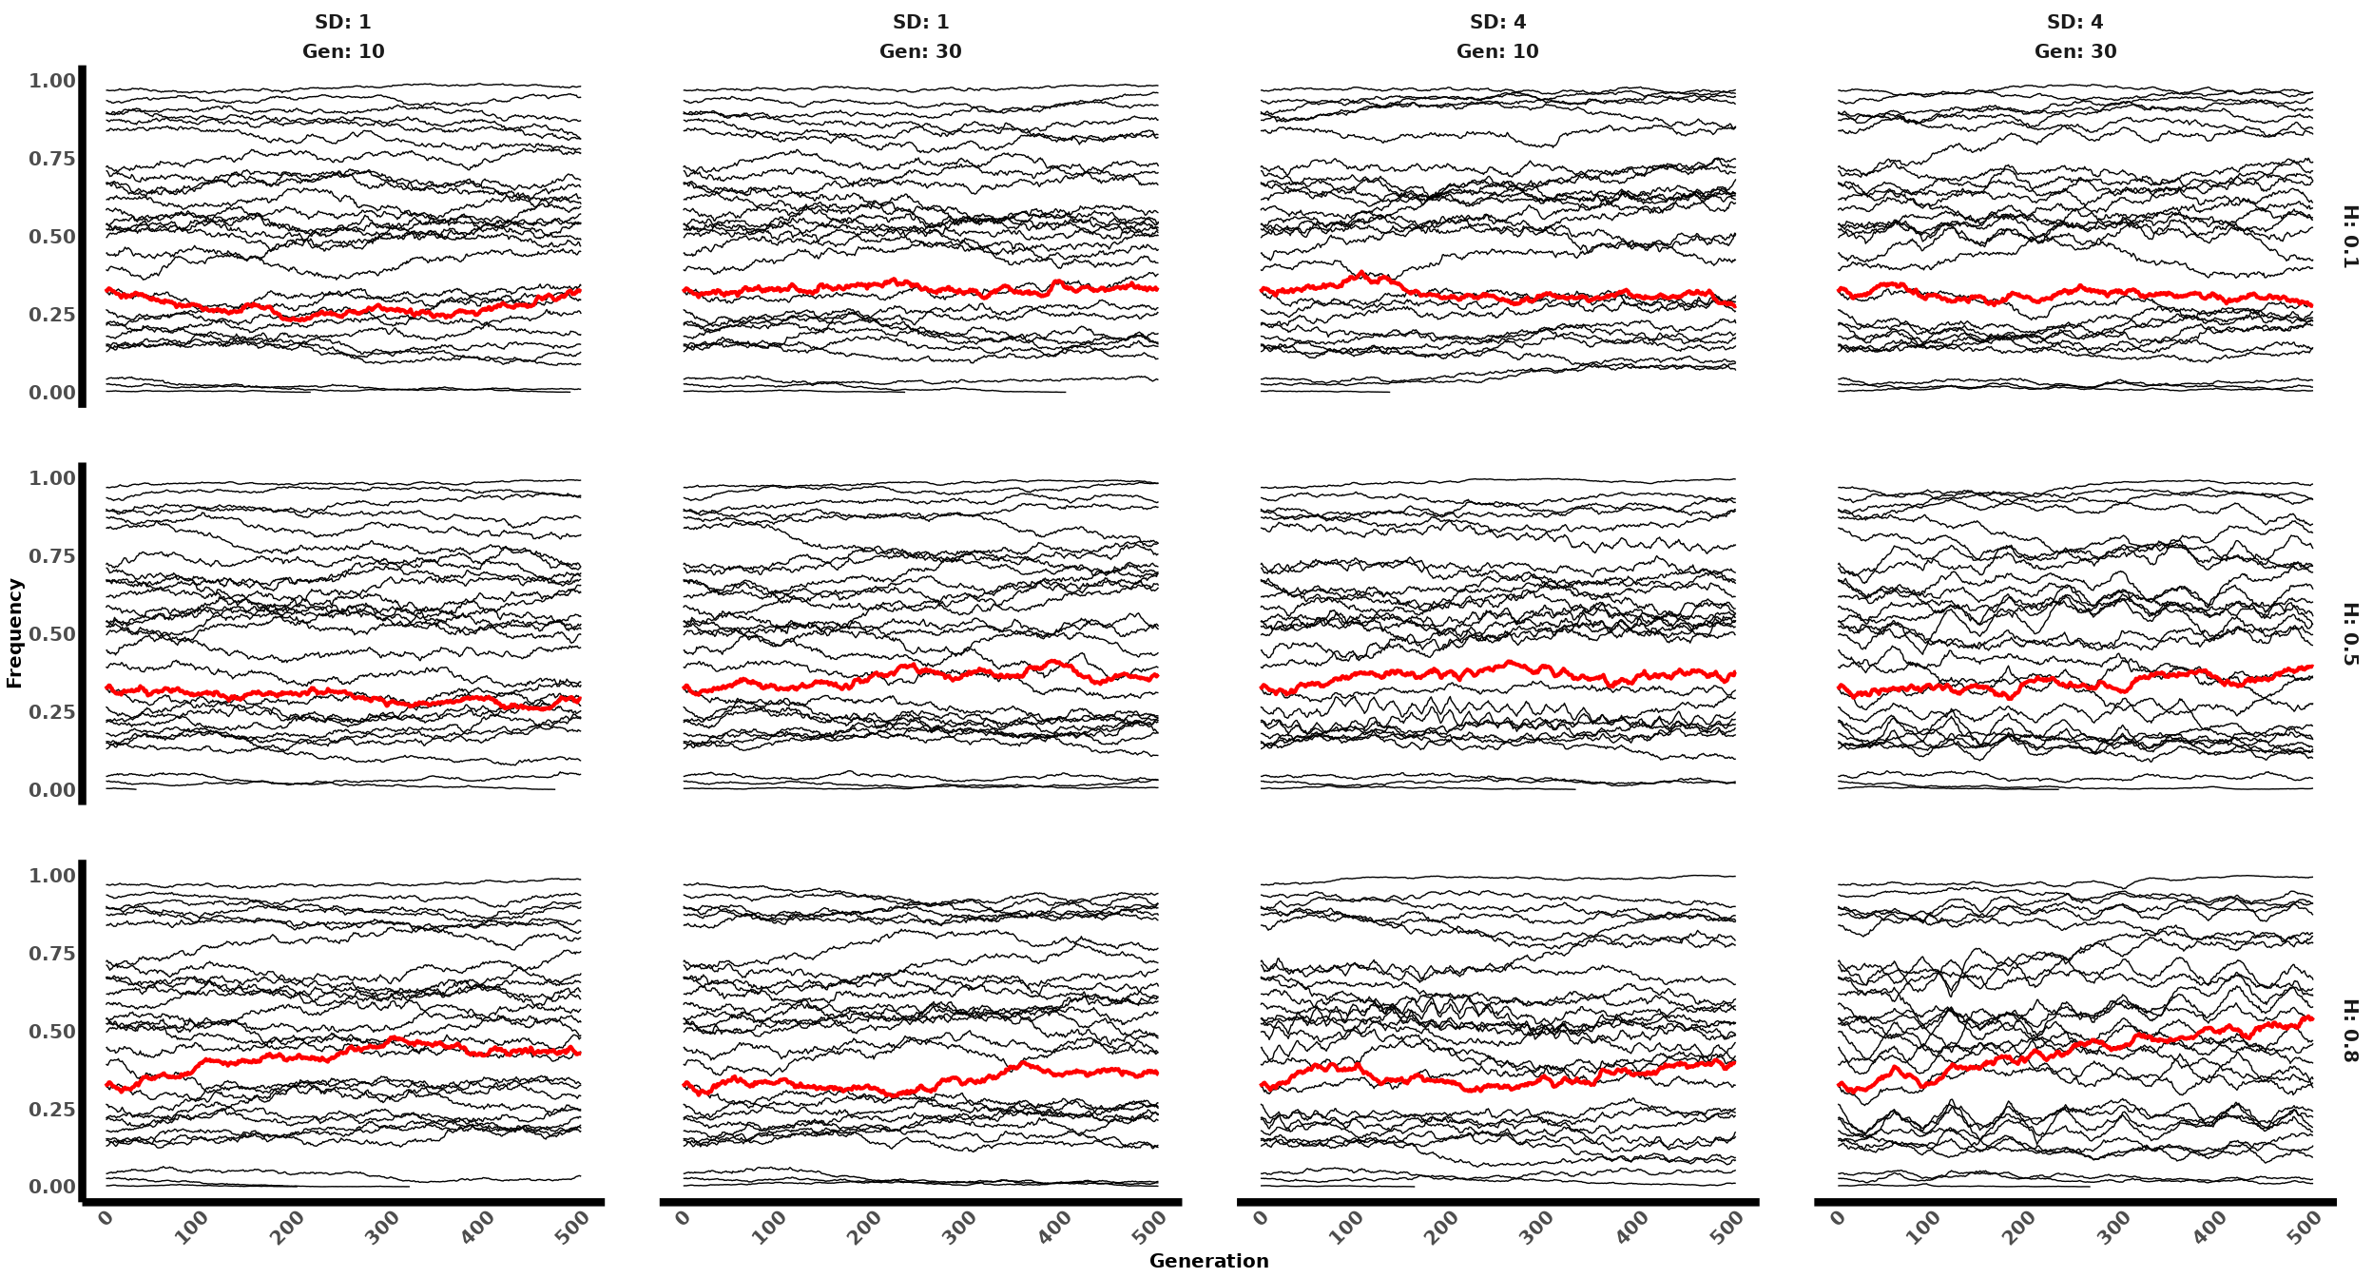

### Effect of QTL and Initial Frequency

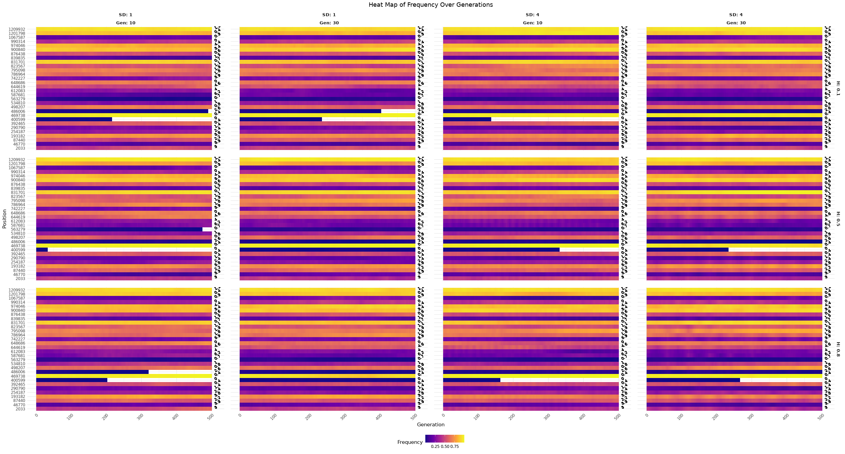

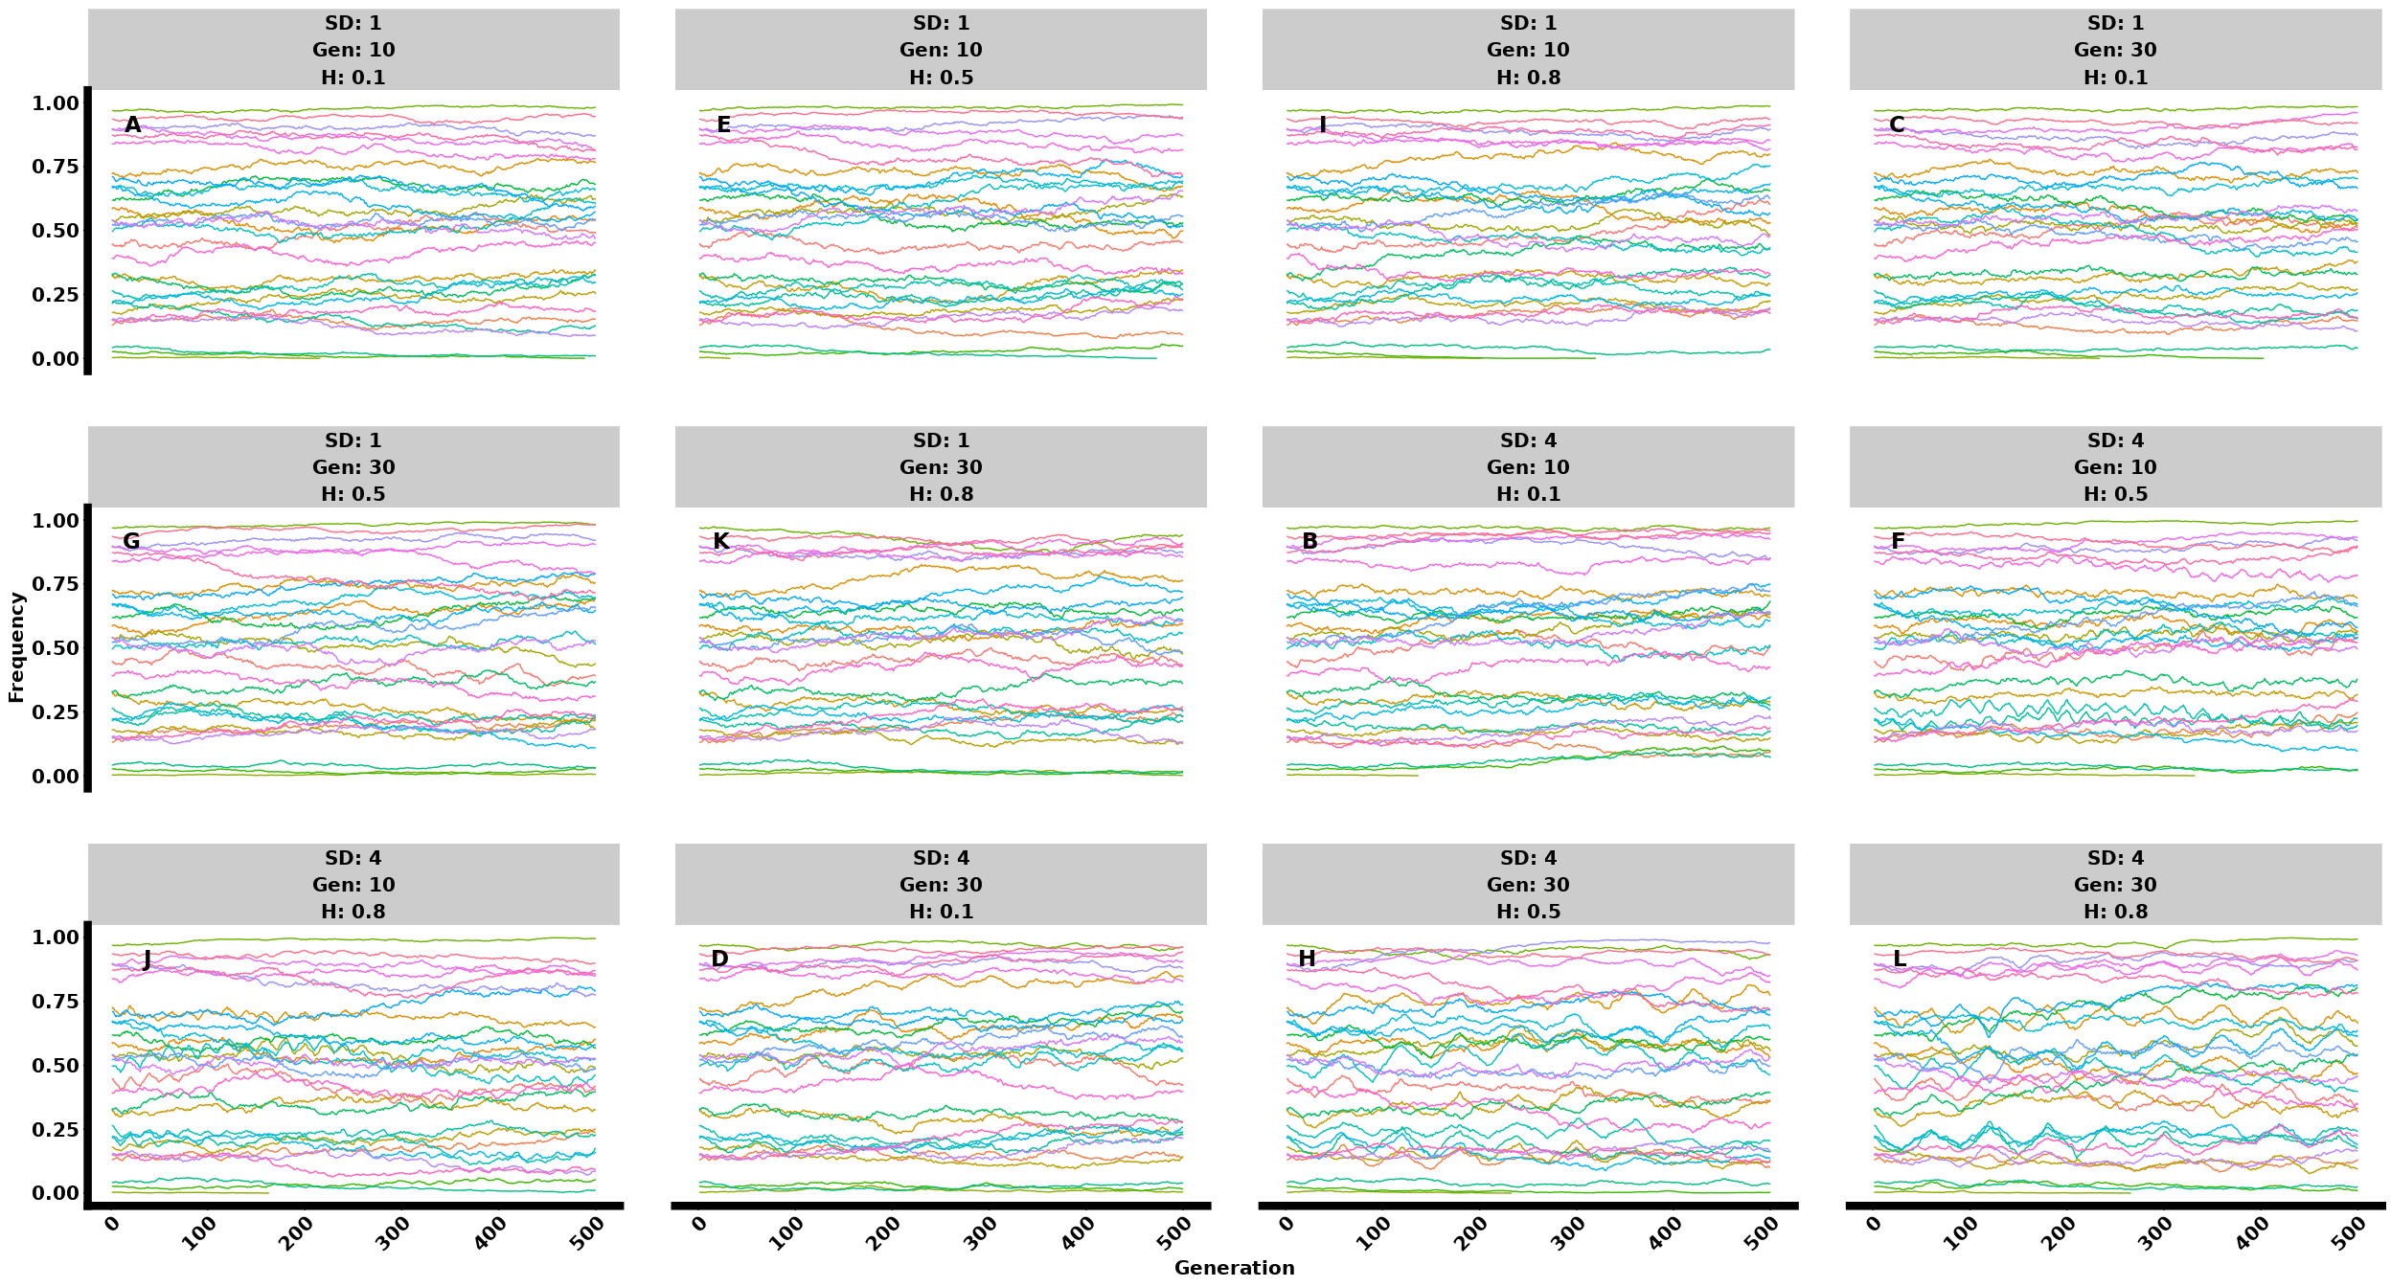

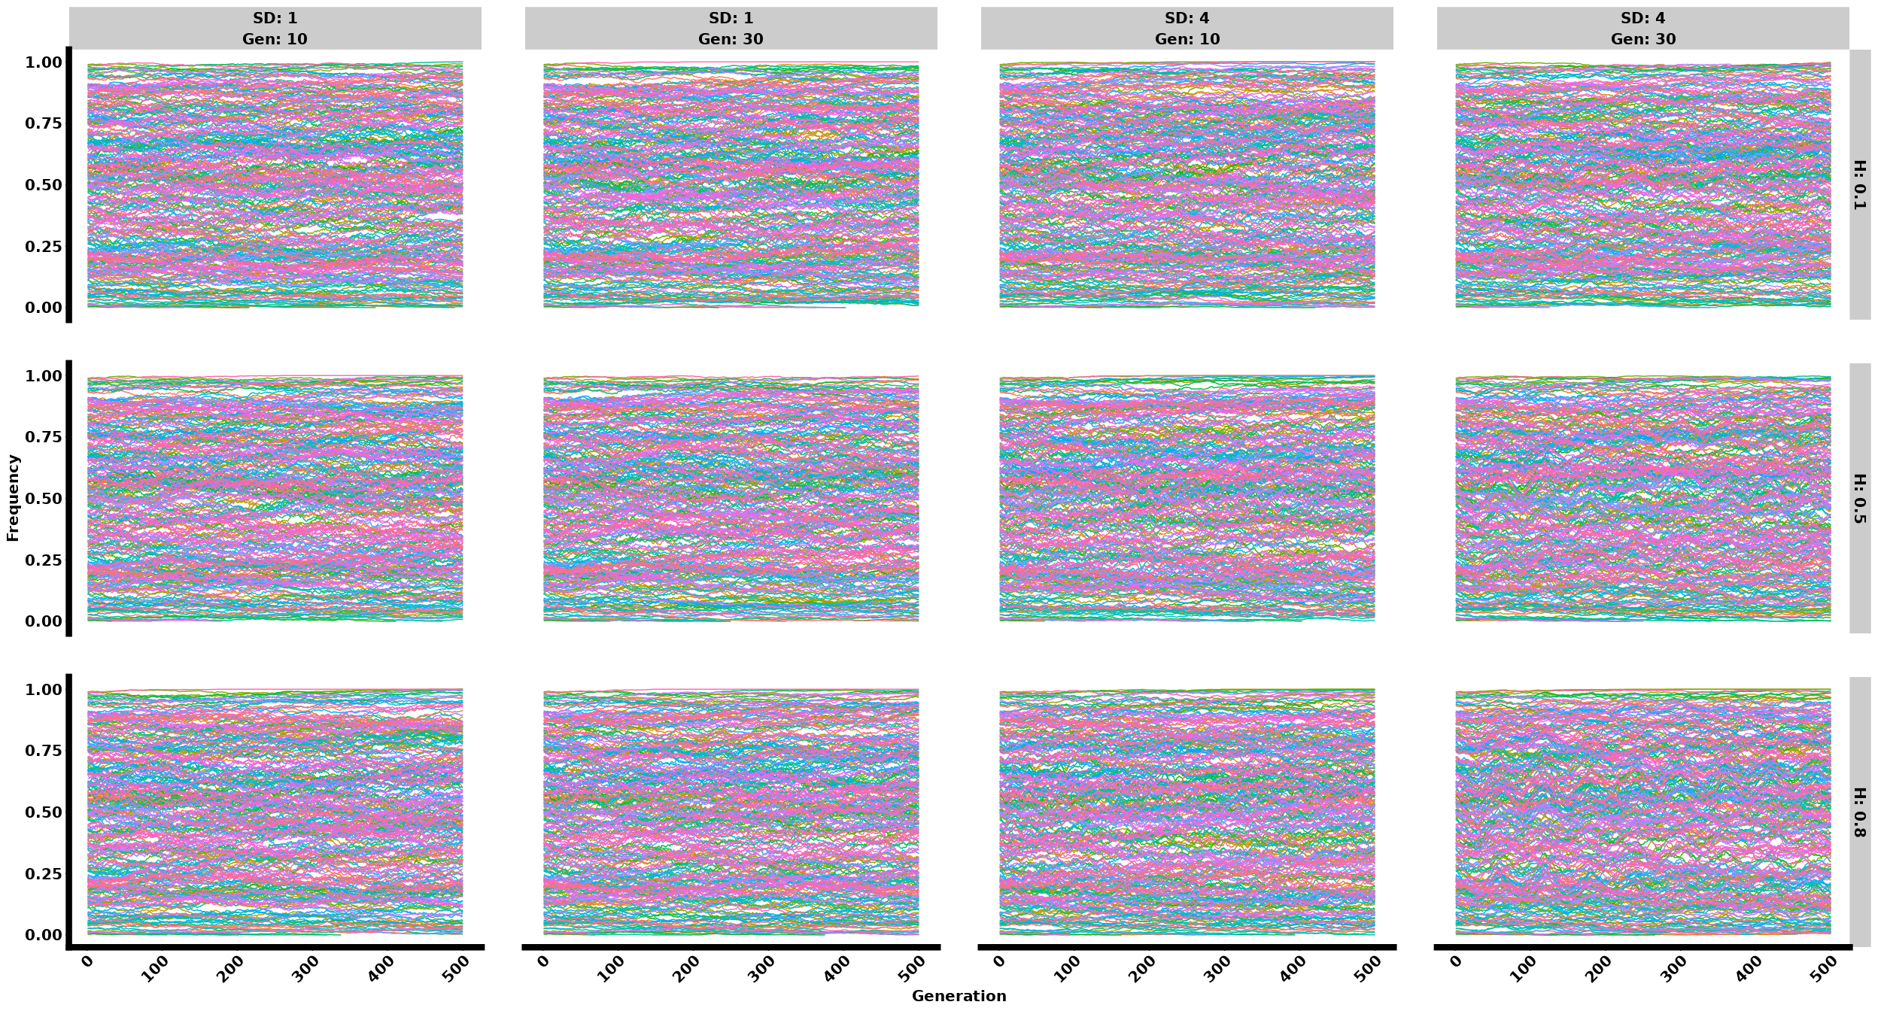

### Many replicates

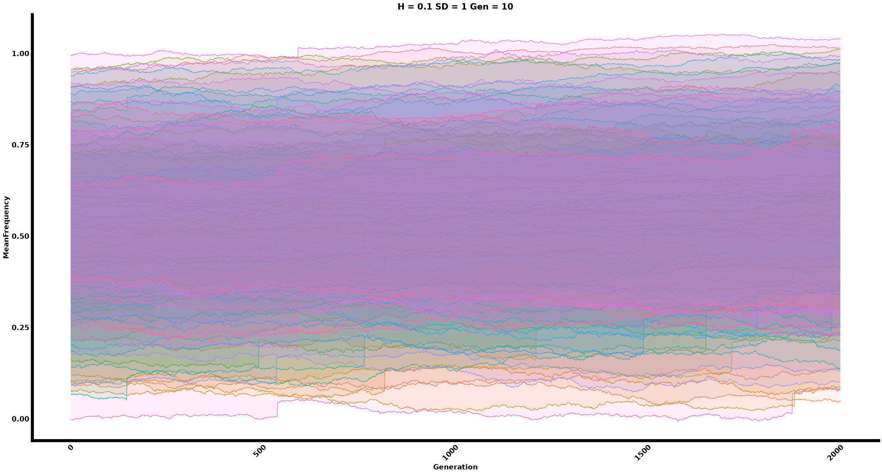

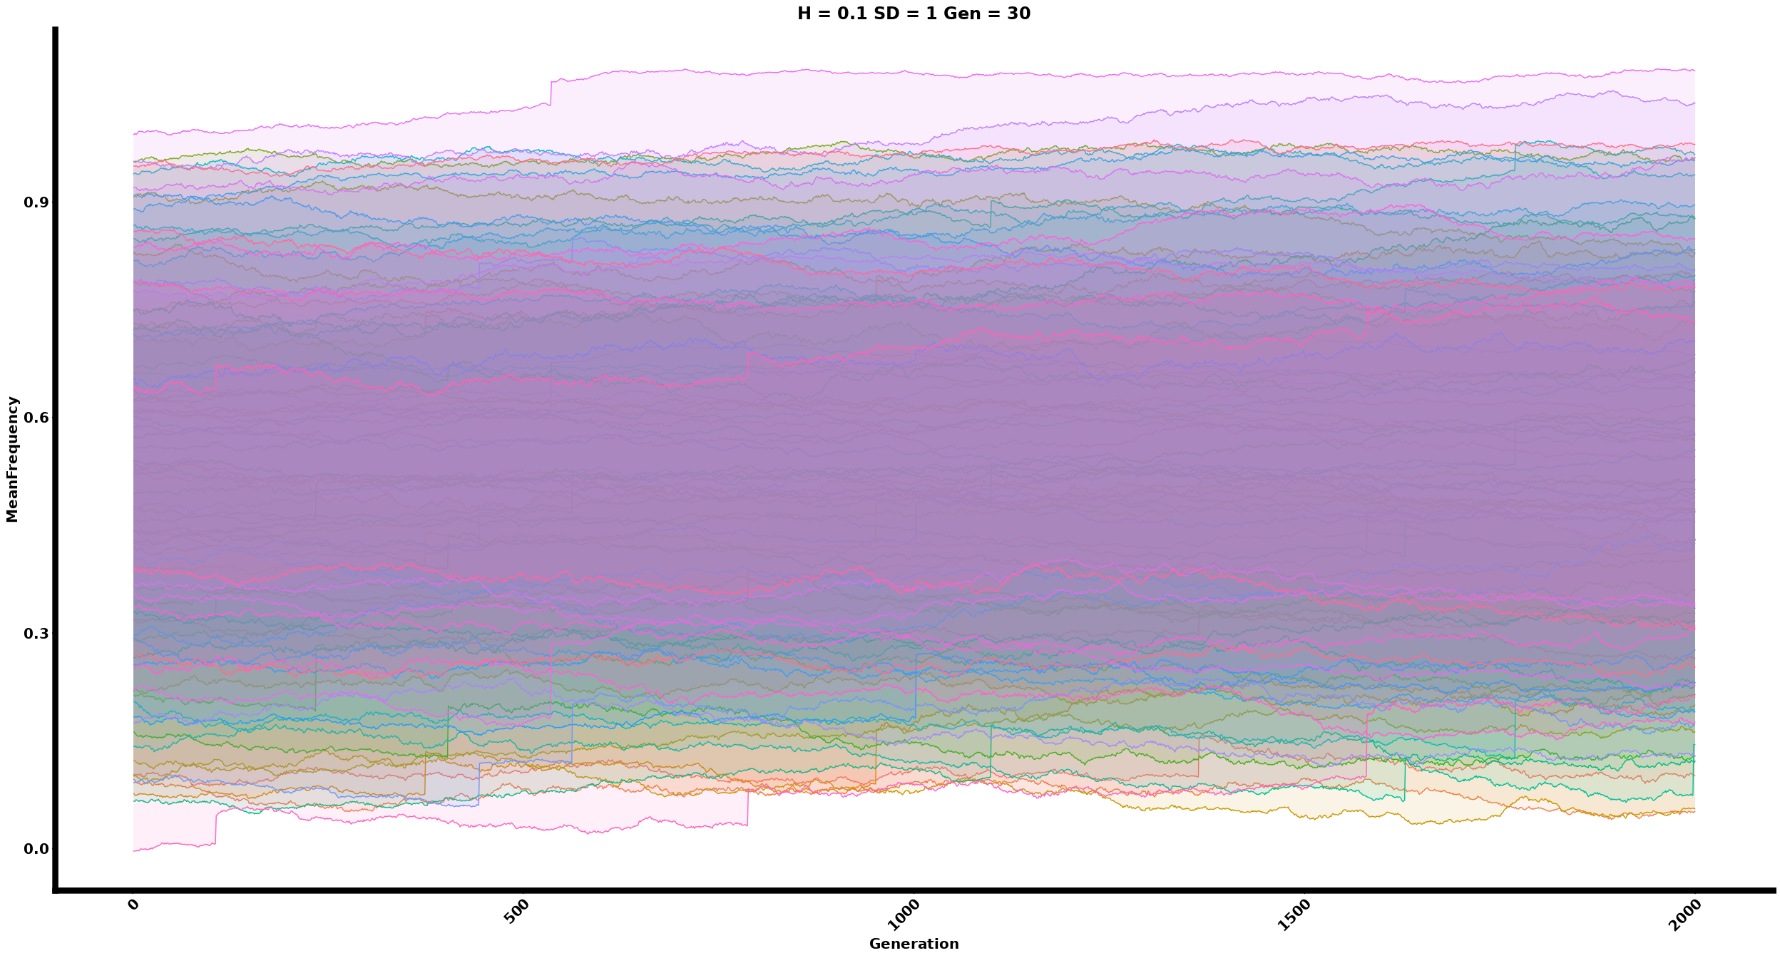

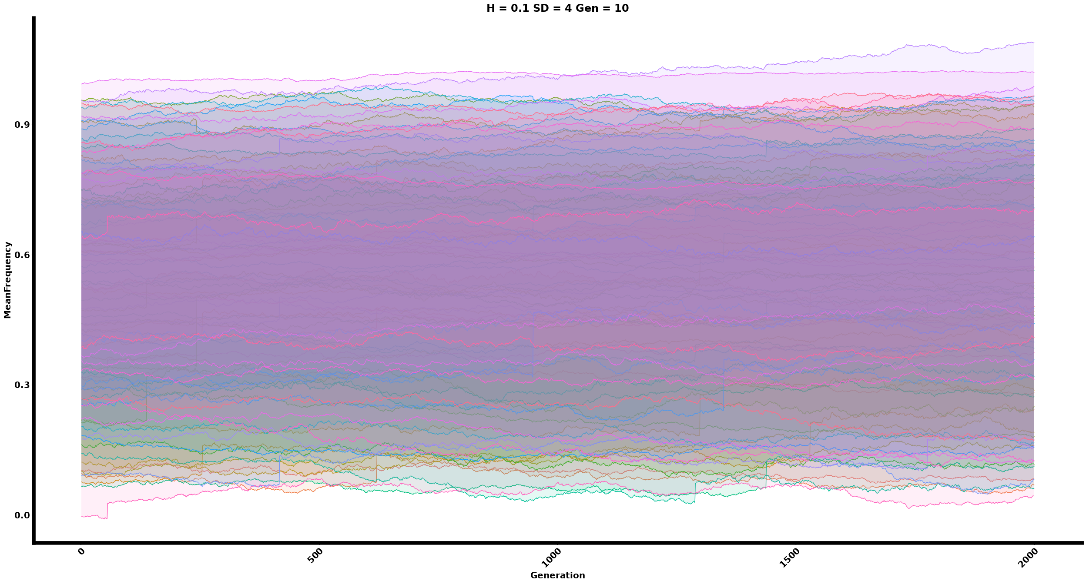

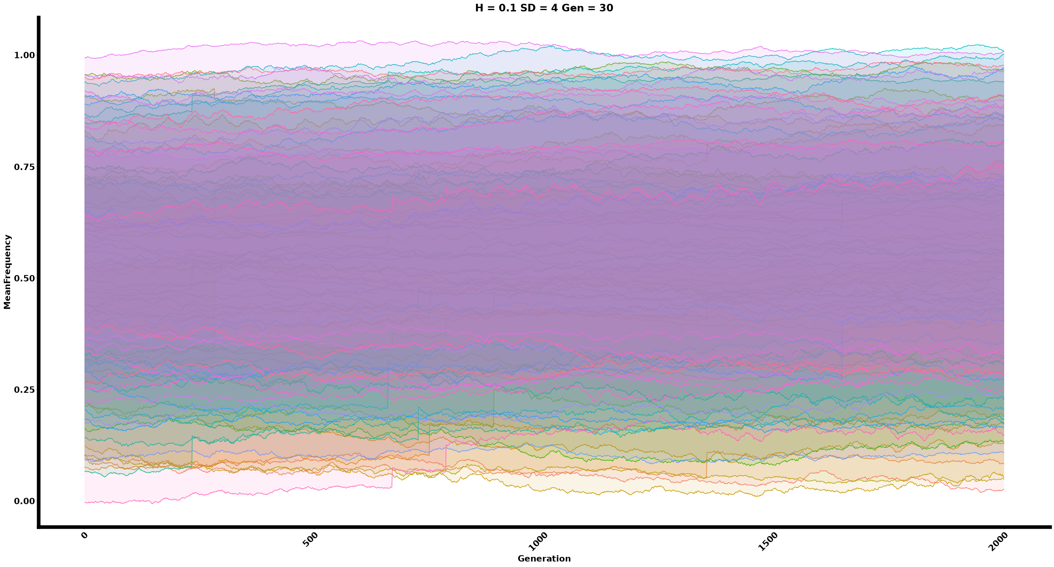

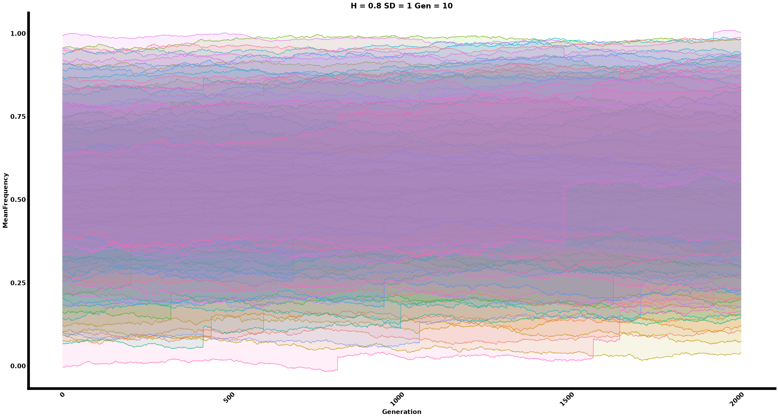

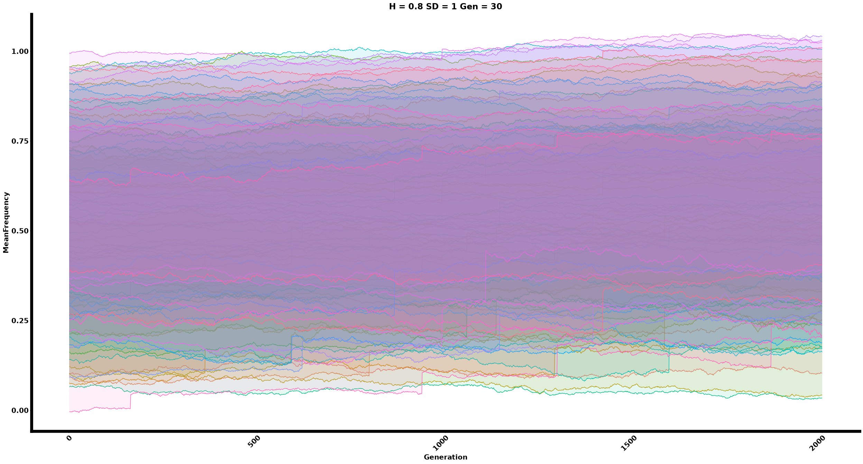

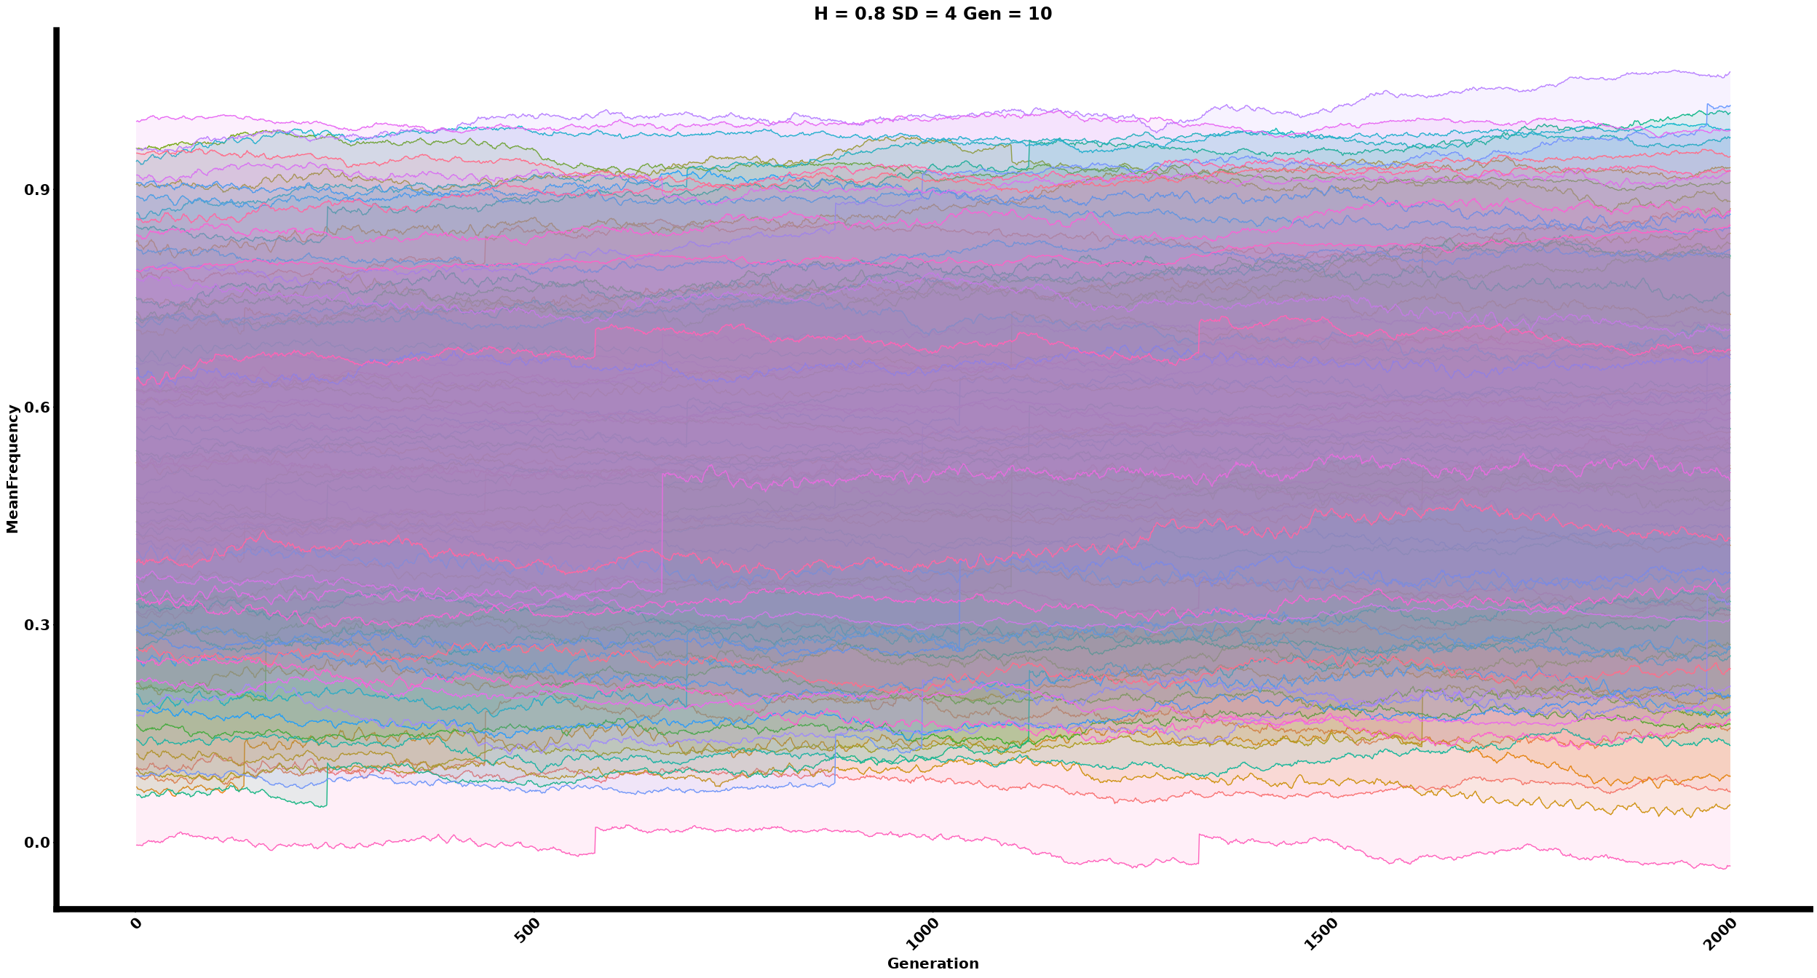

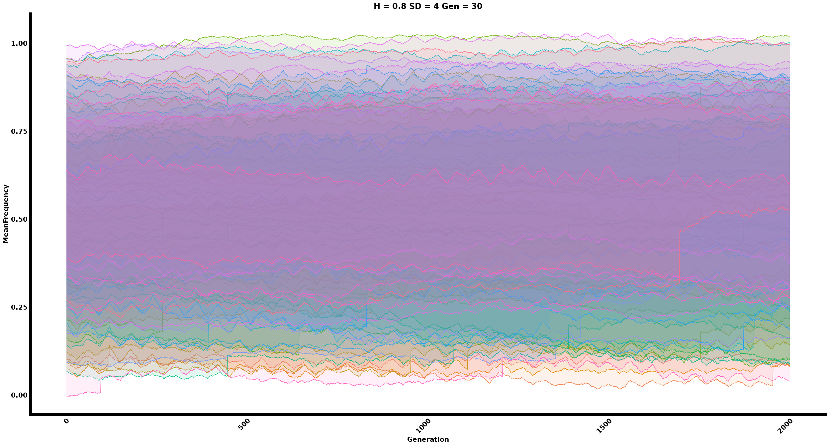

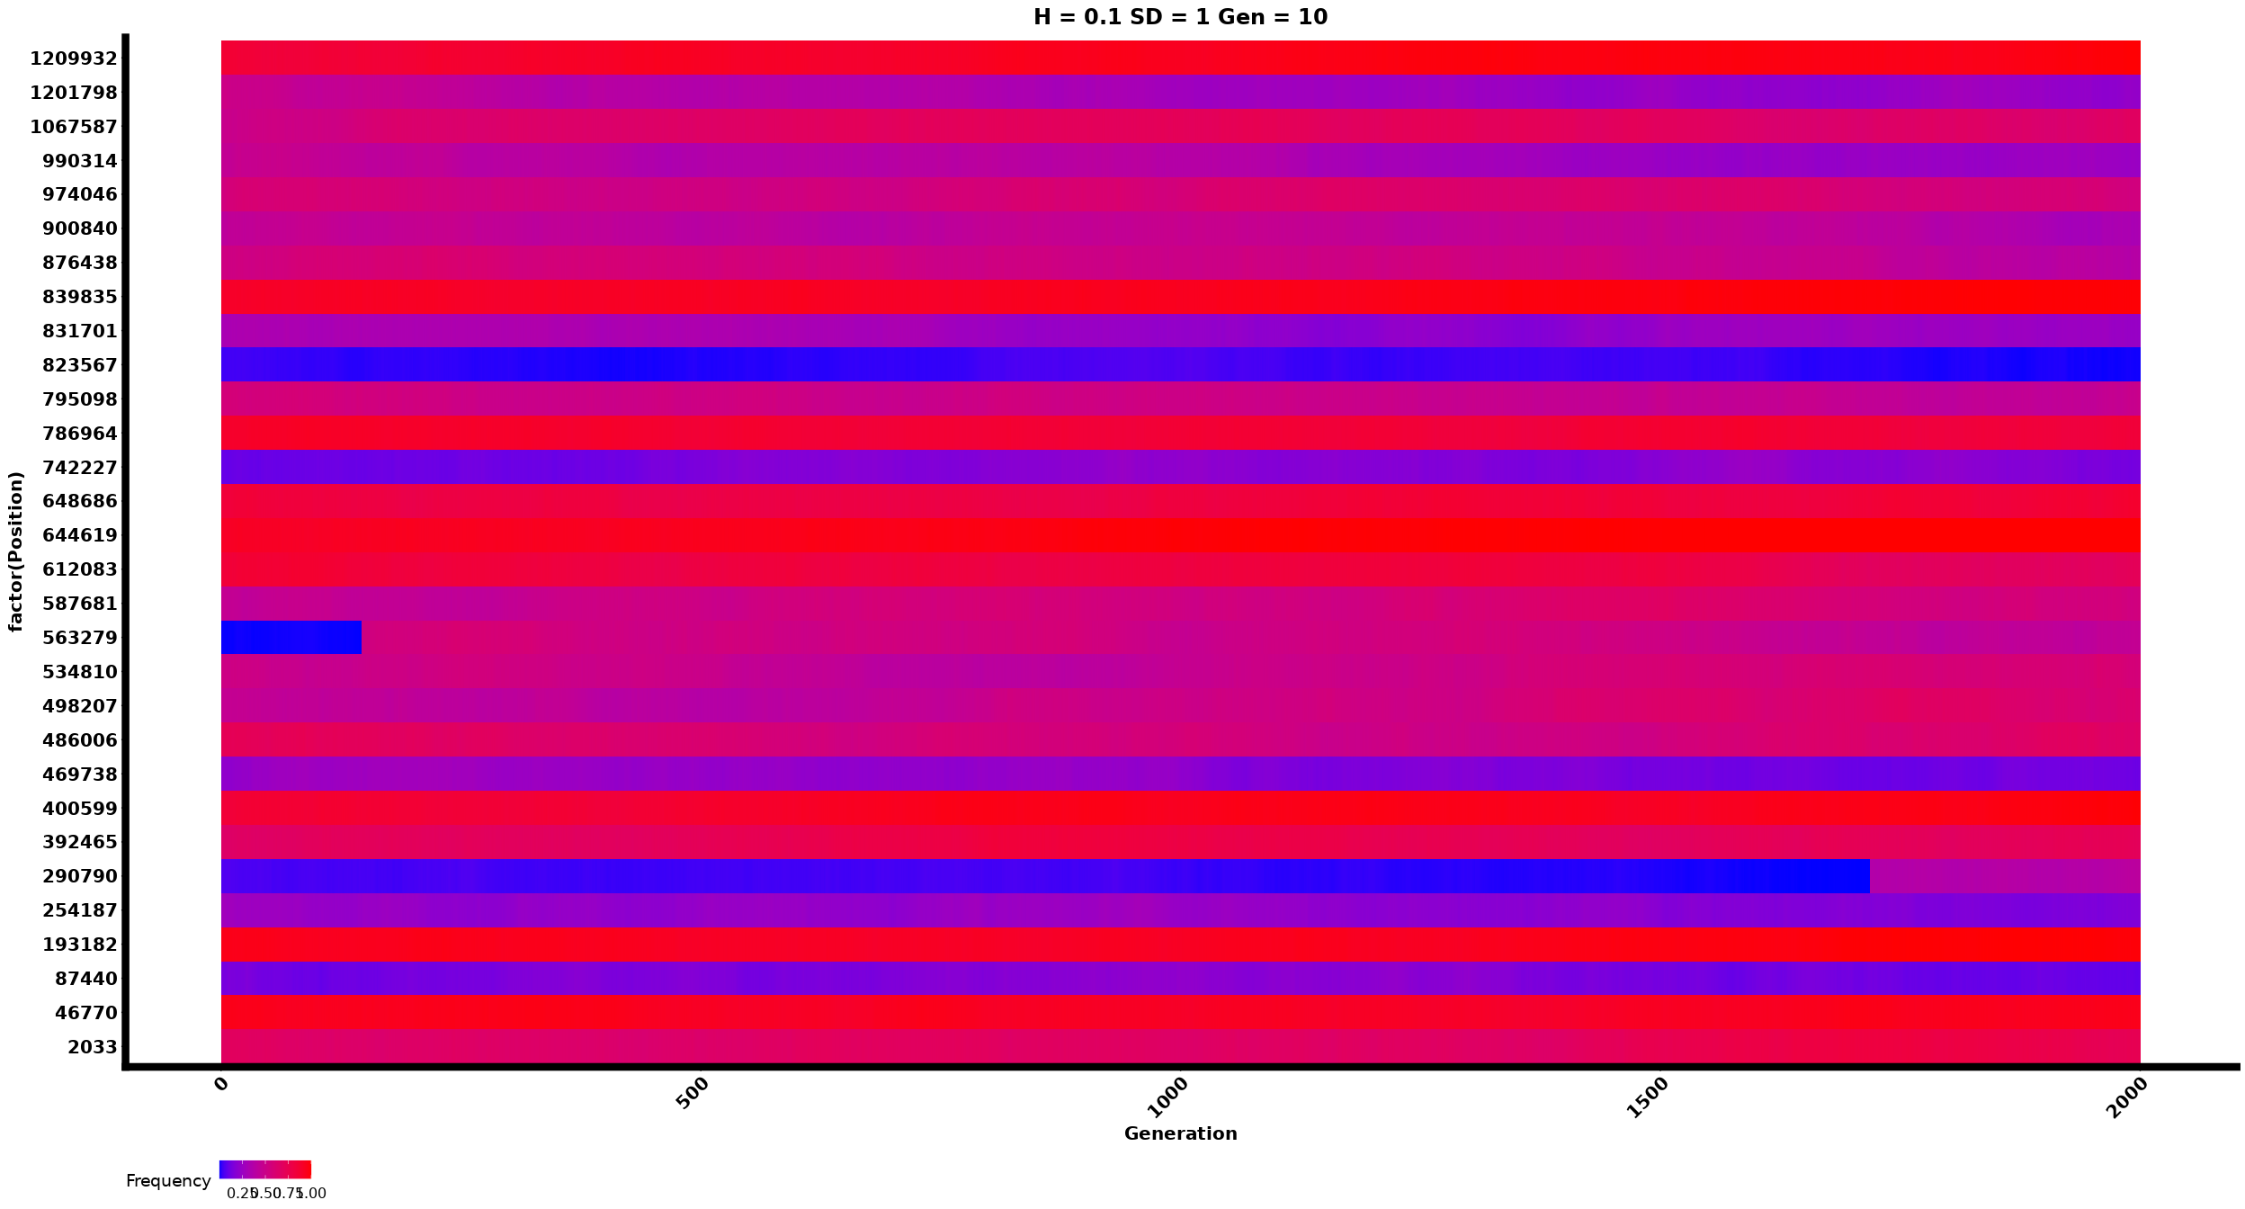

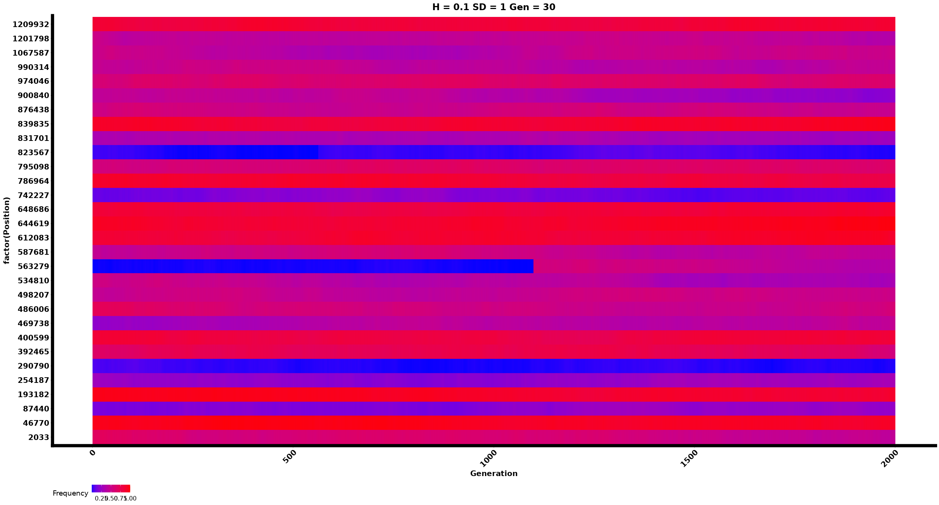

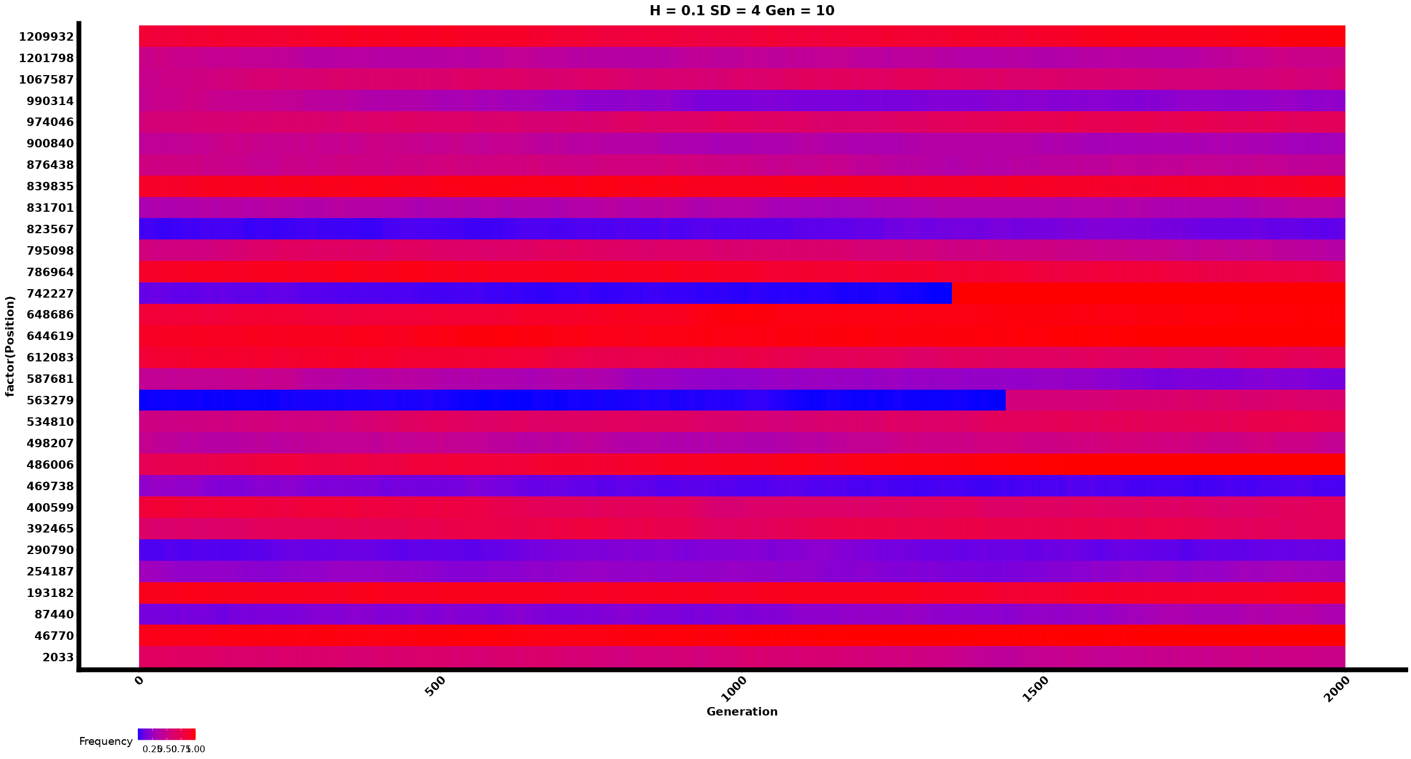

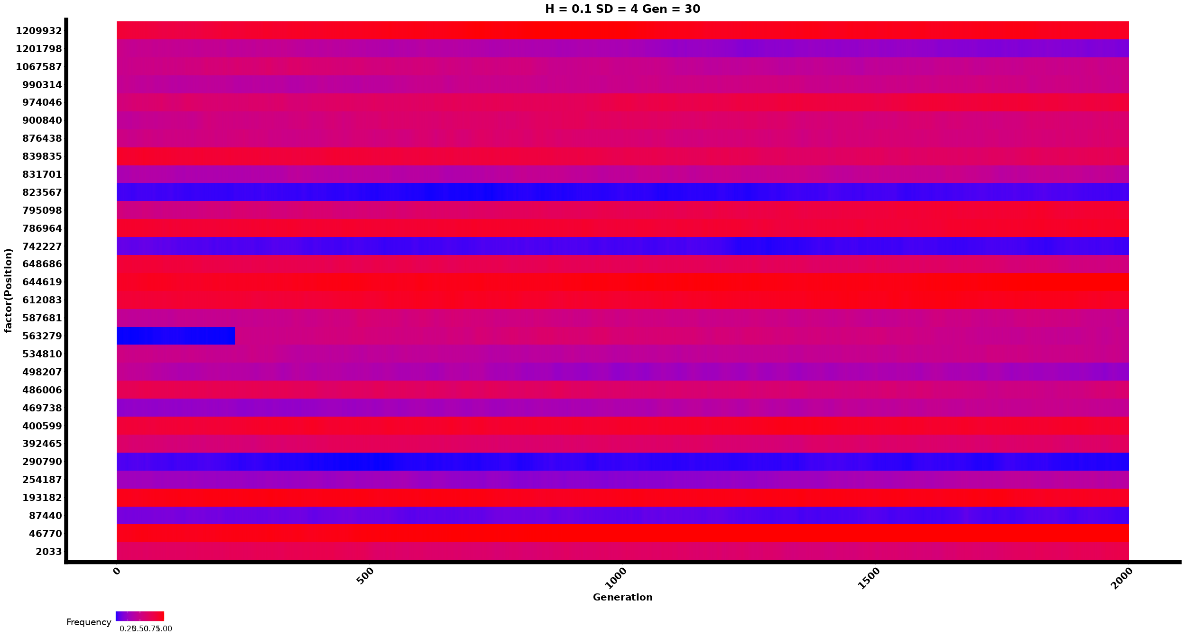

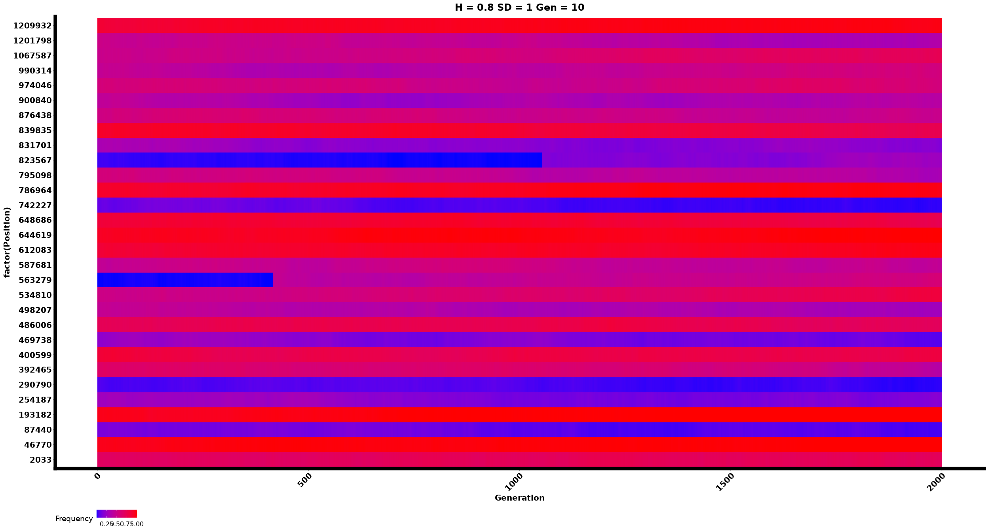

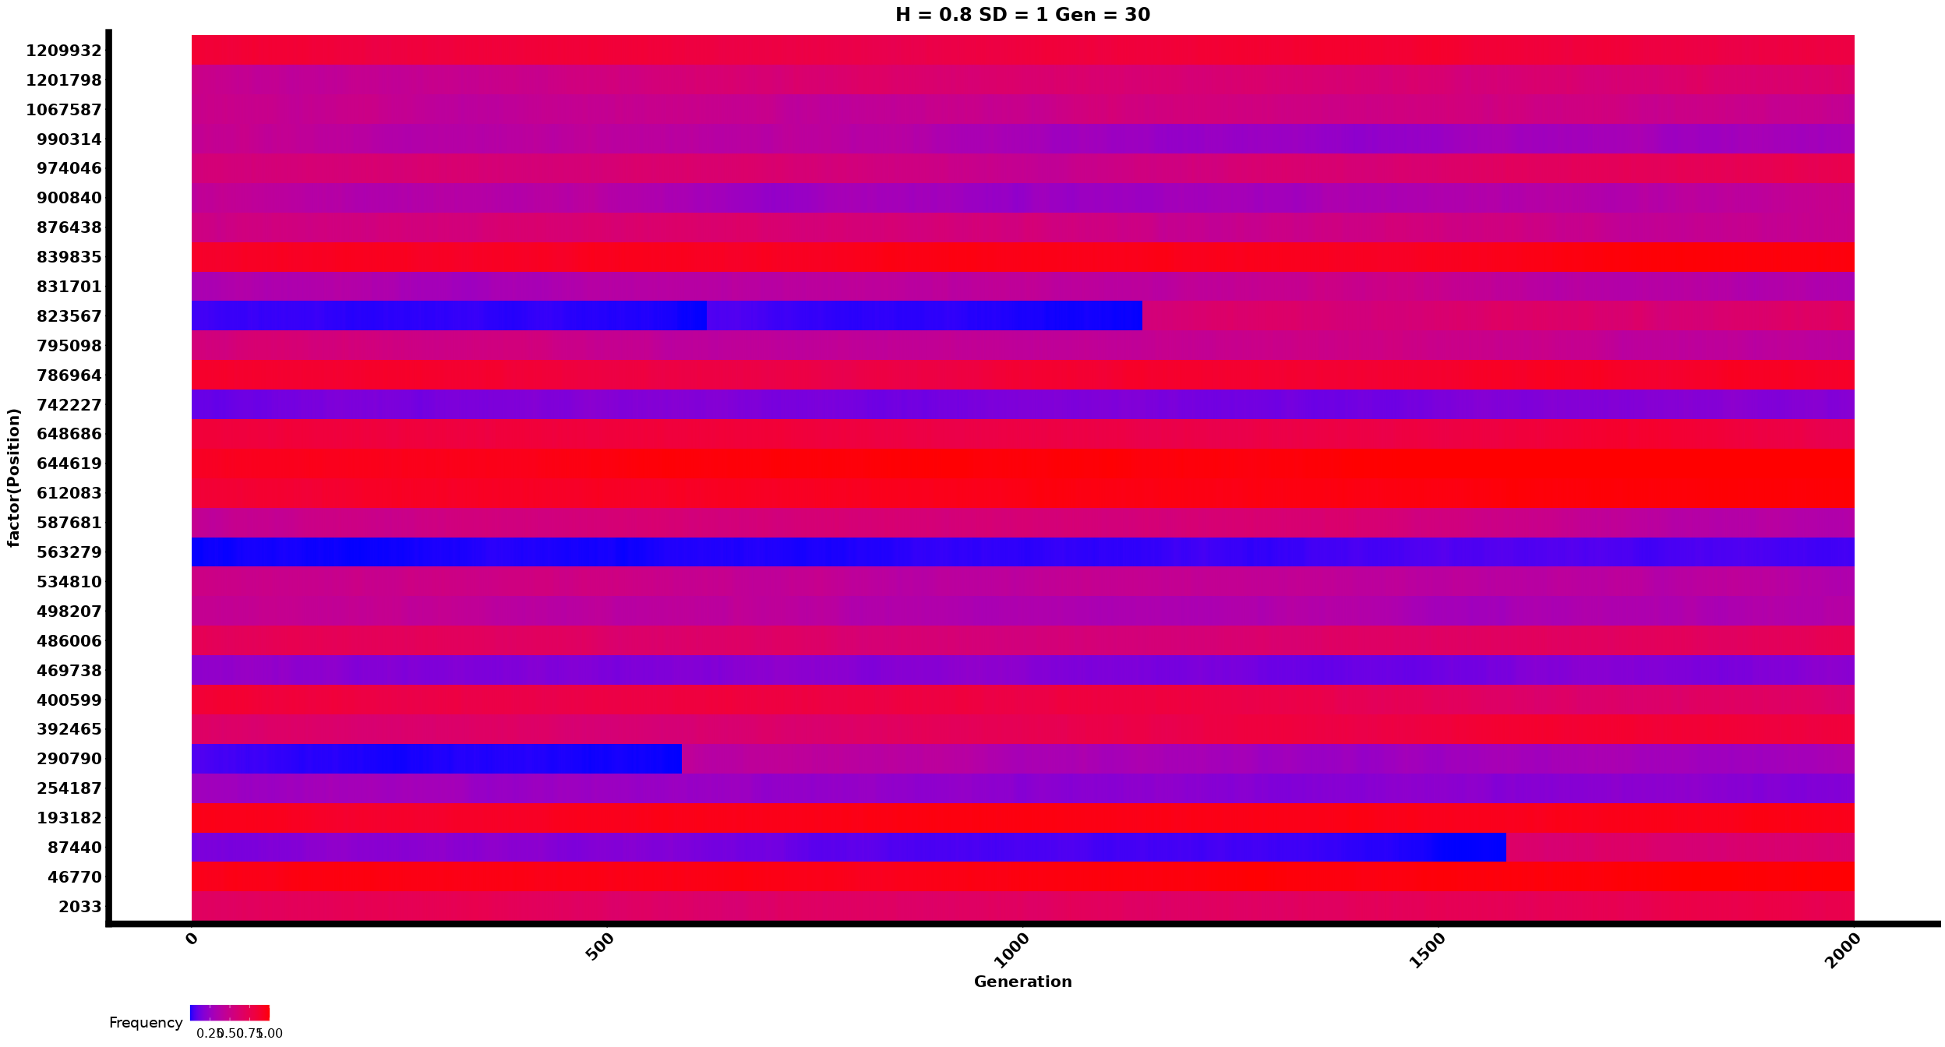

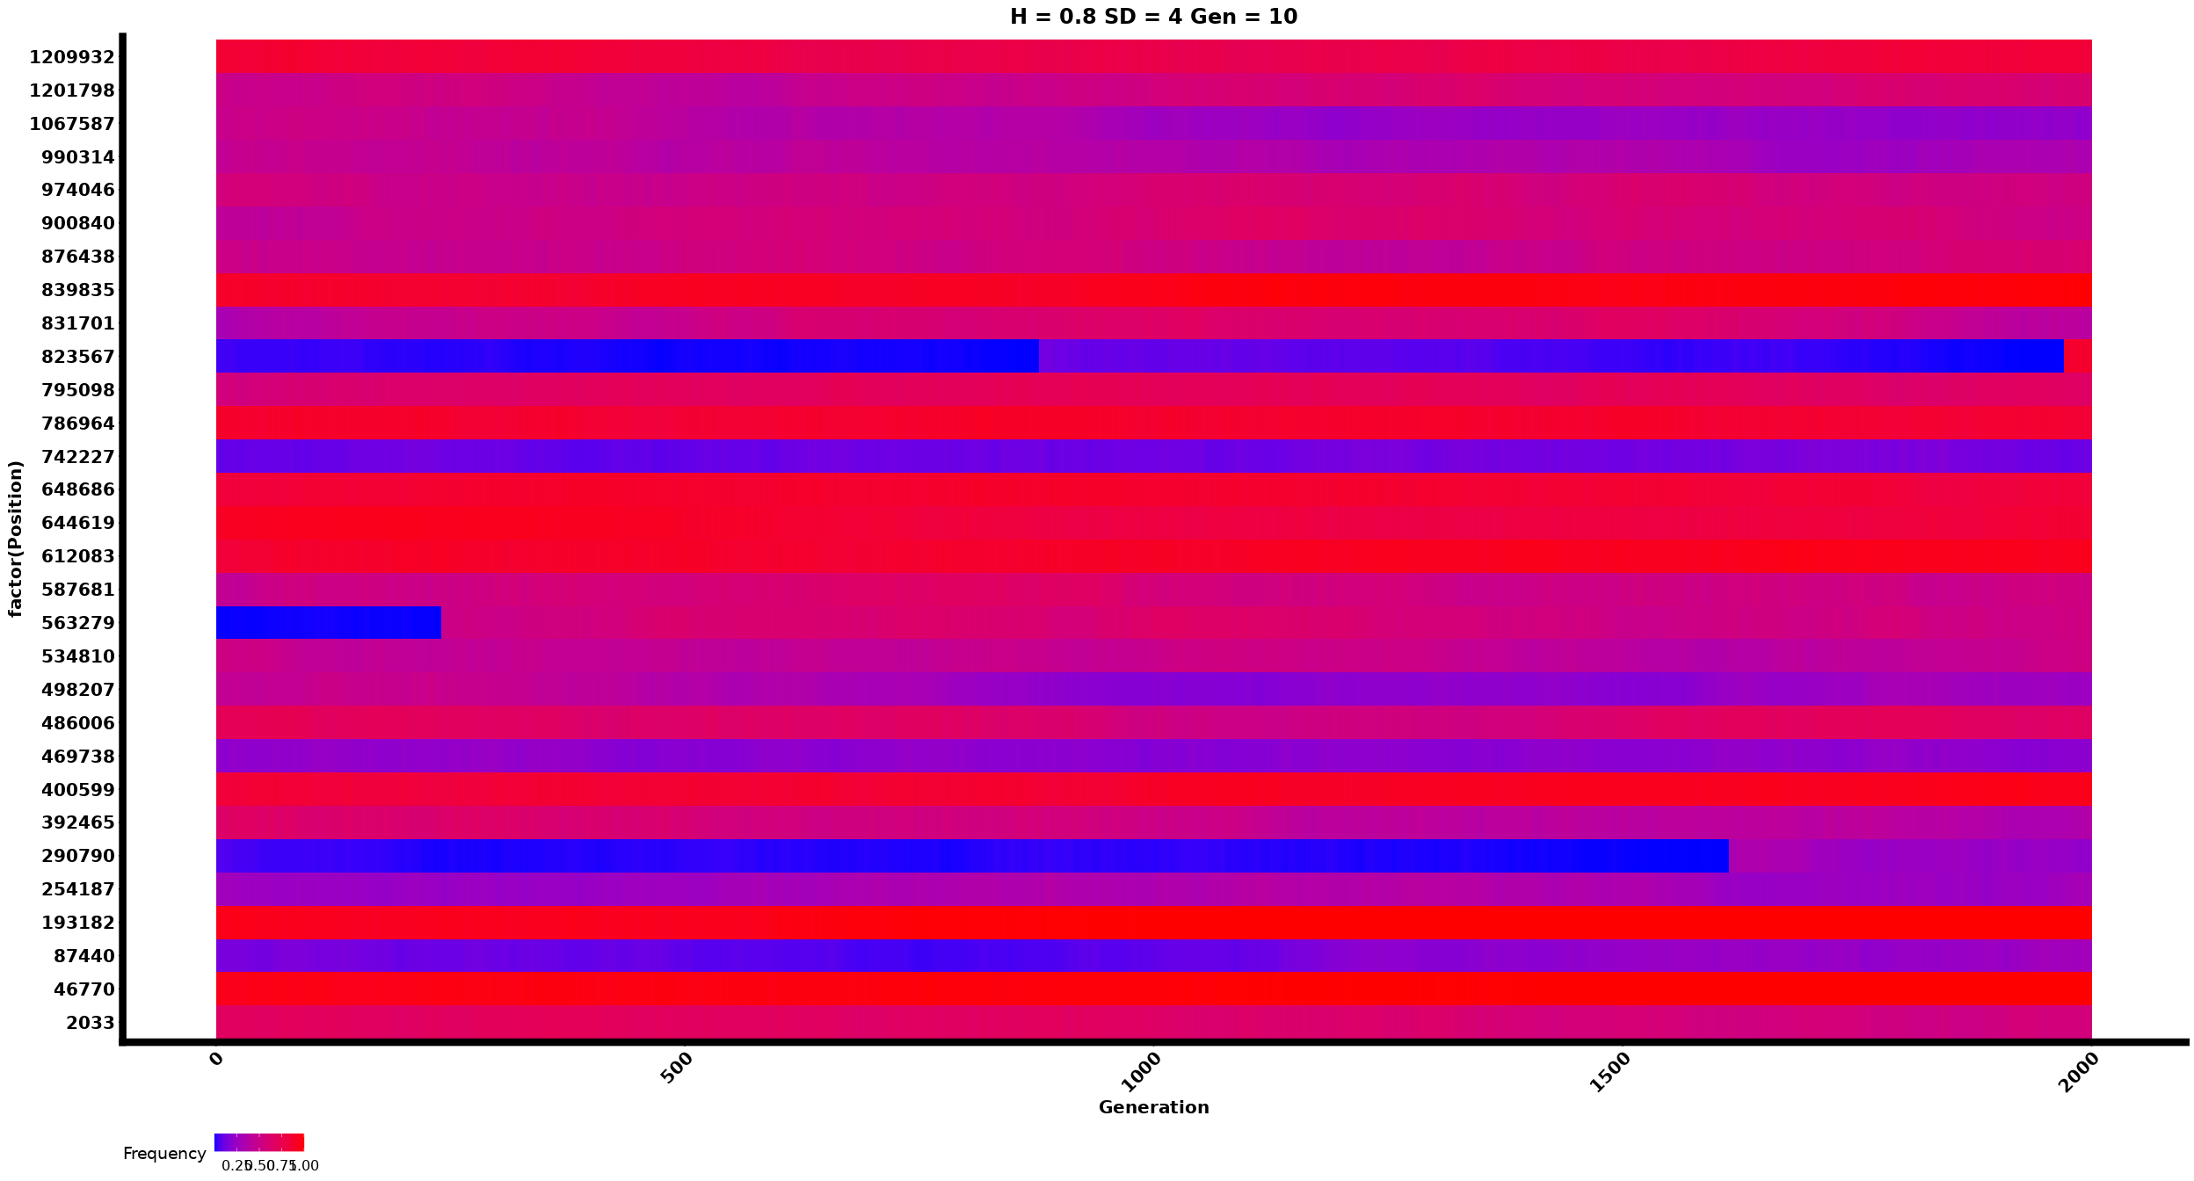

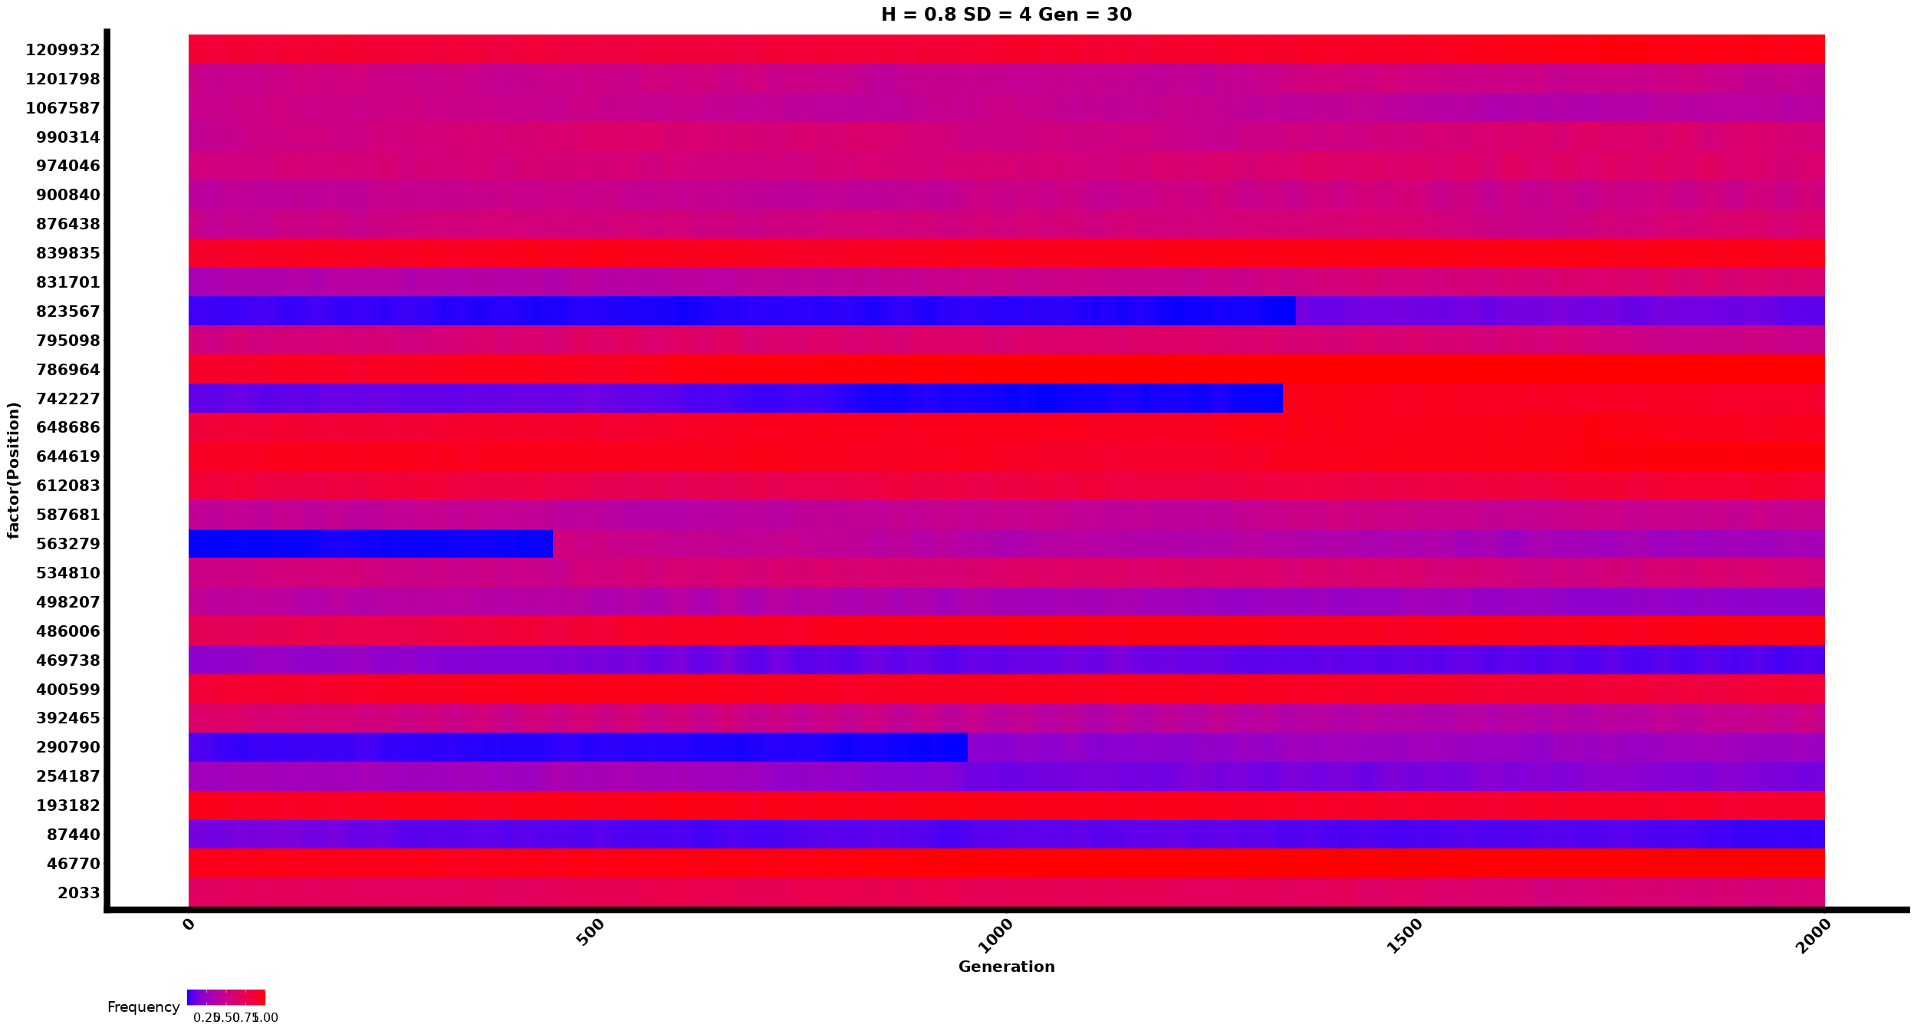

### Phenotypes

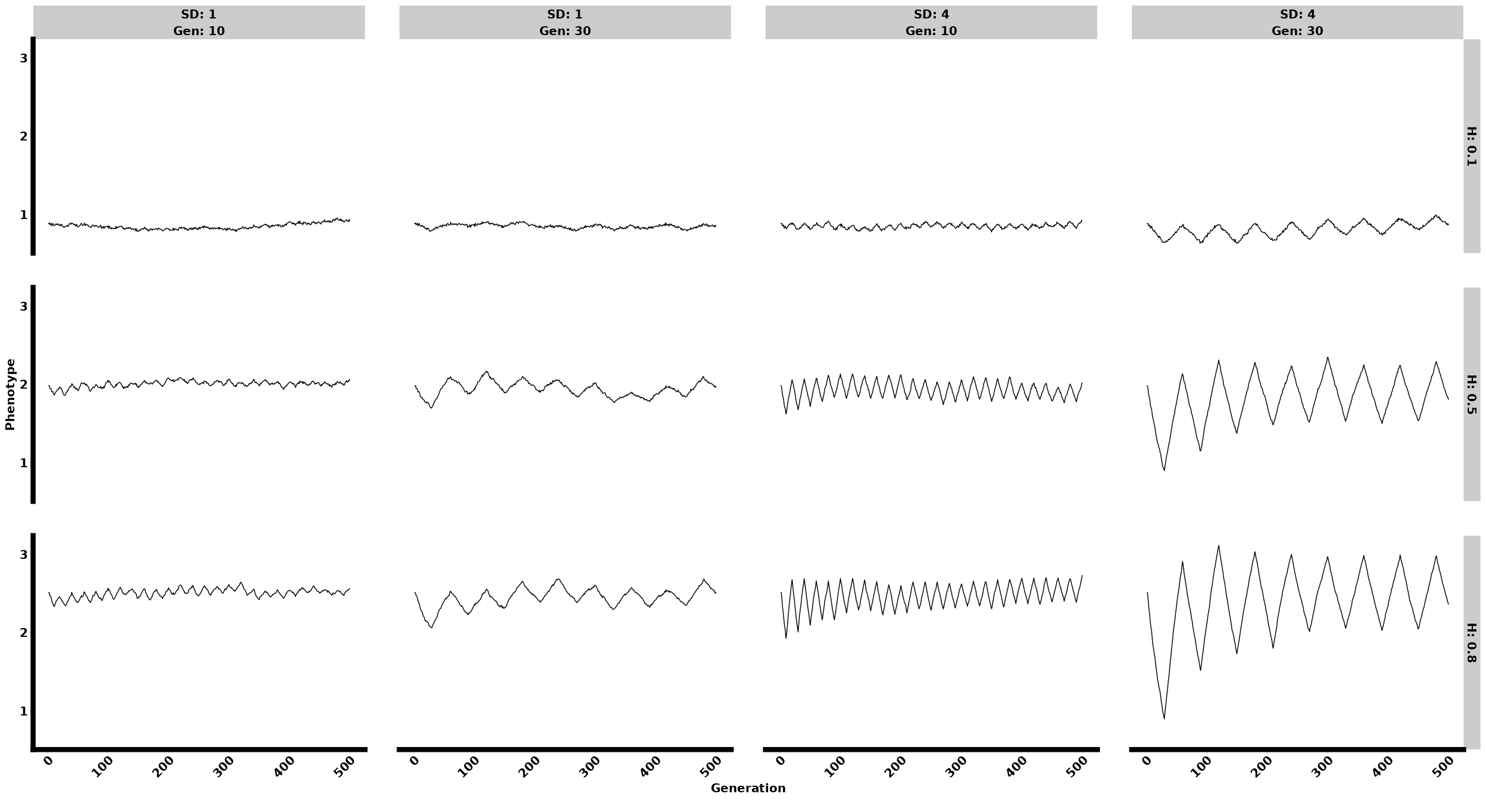

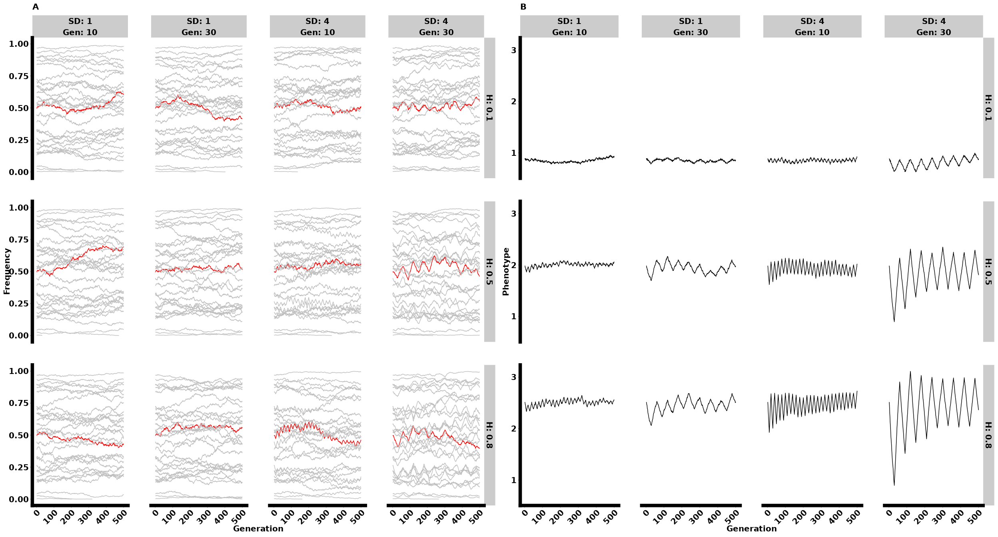

#### Monogenic model

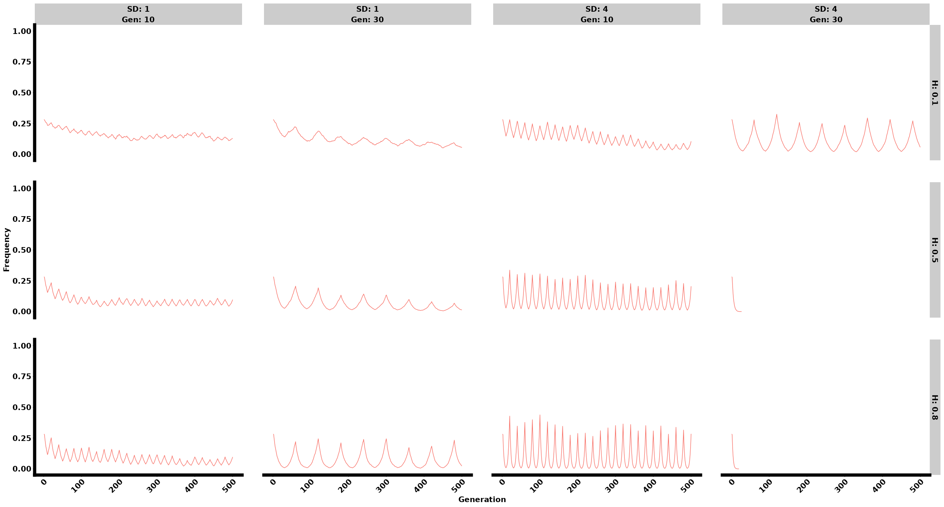

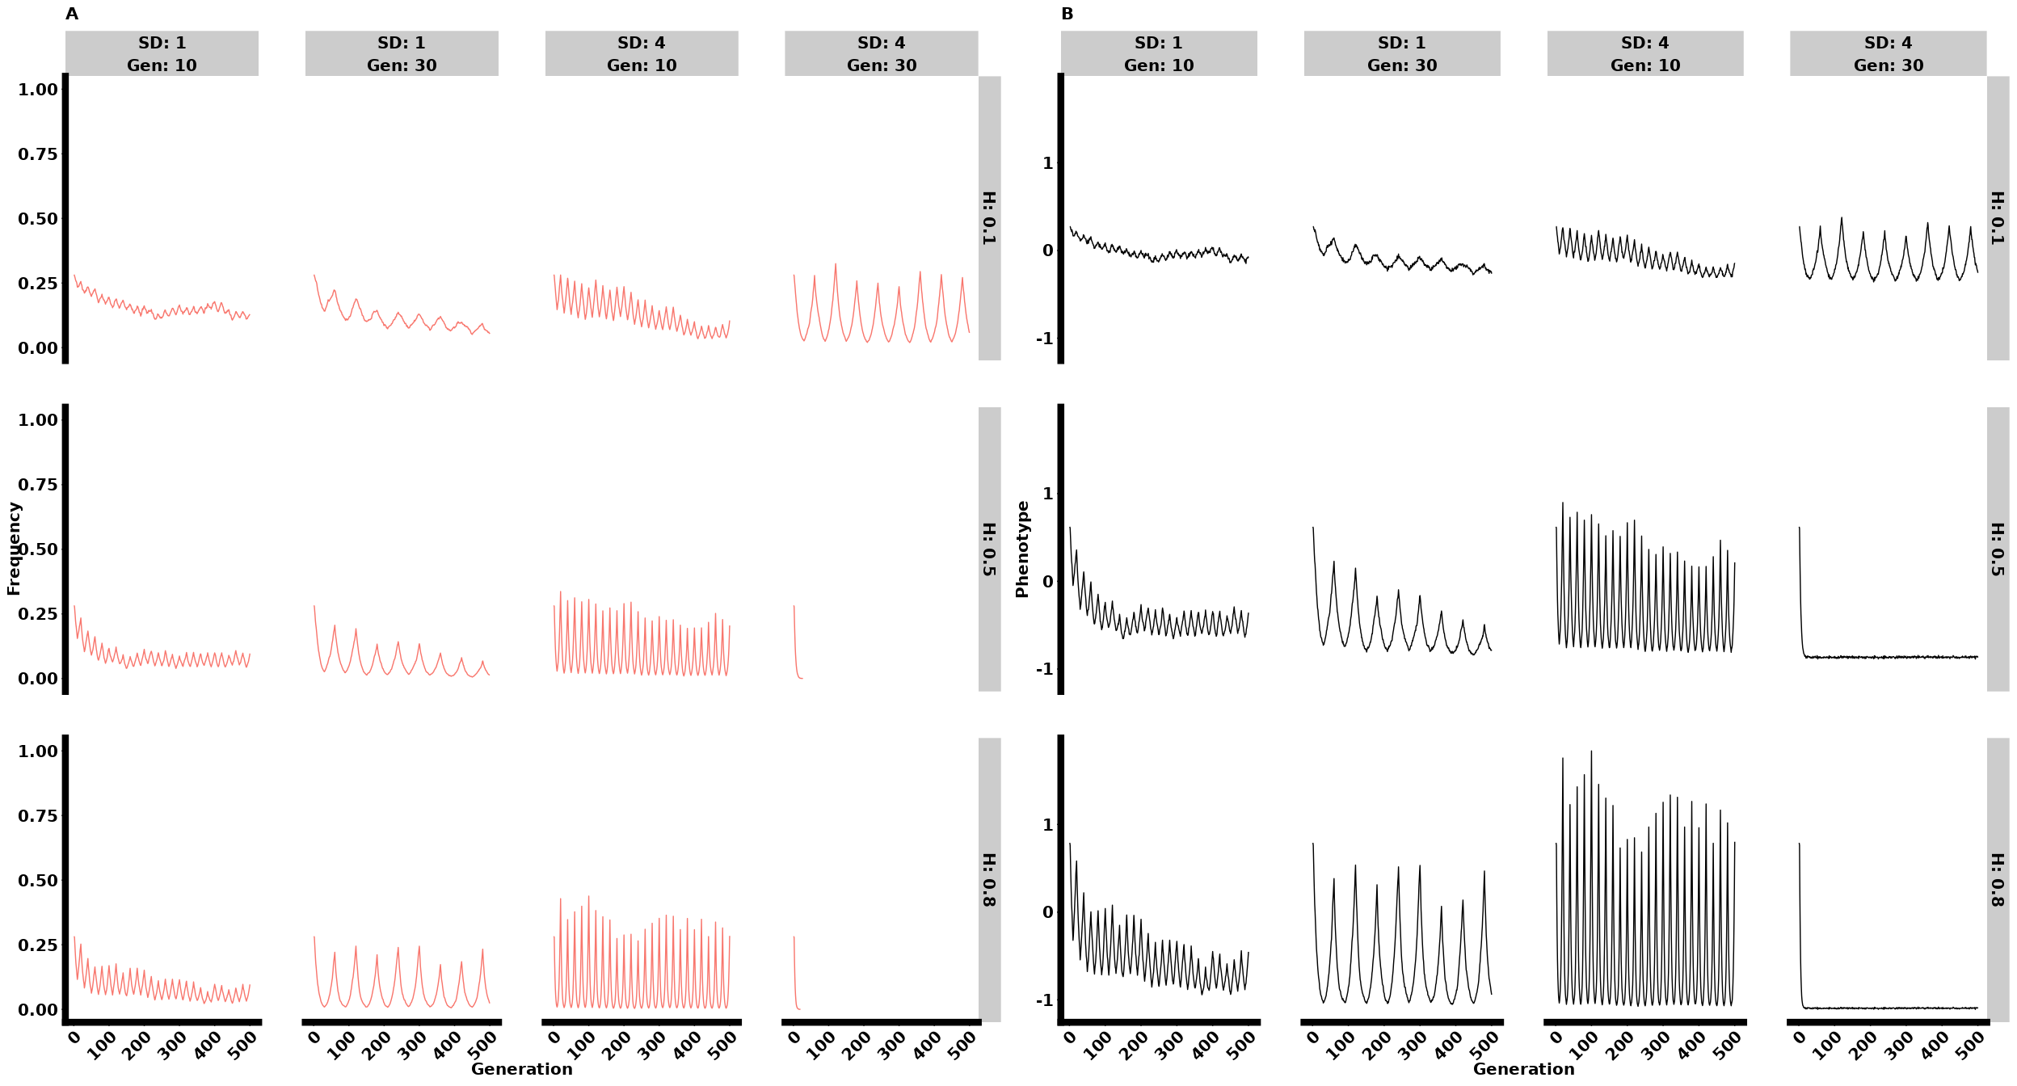

#### Oligogenic model

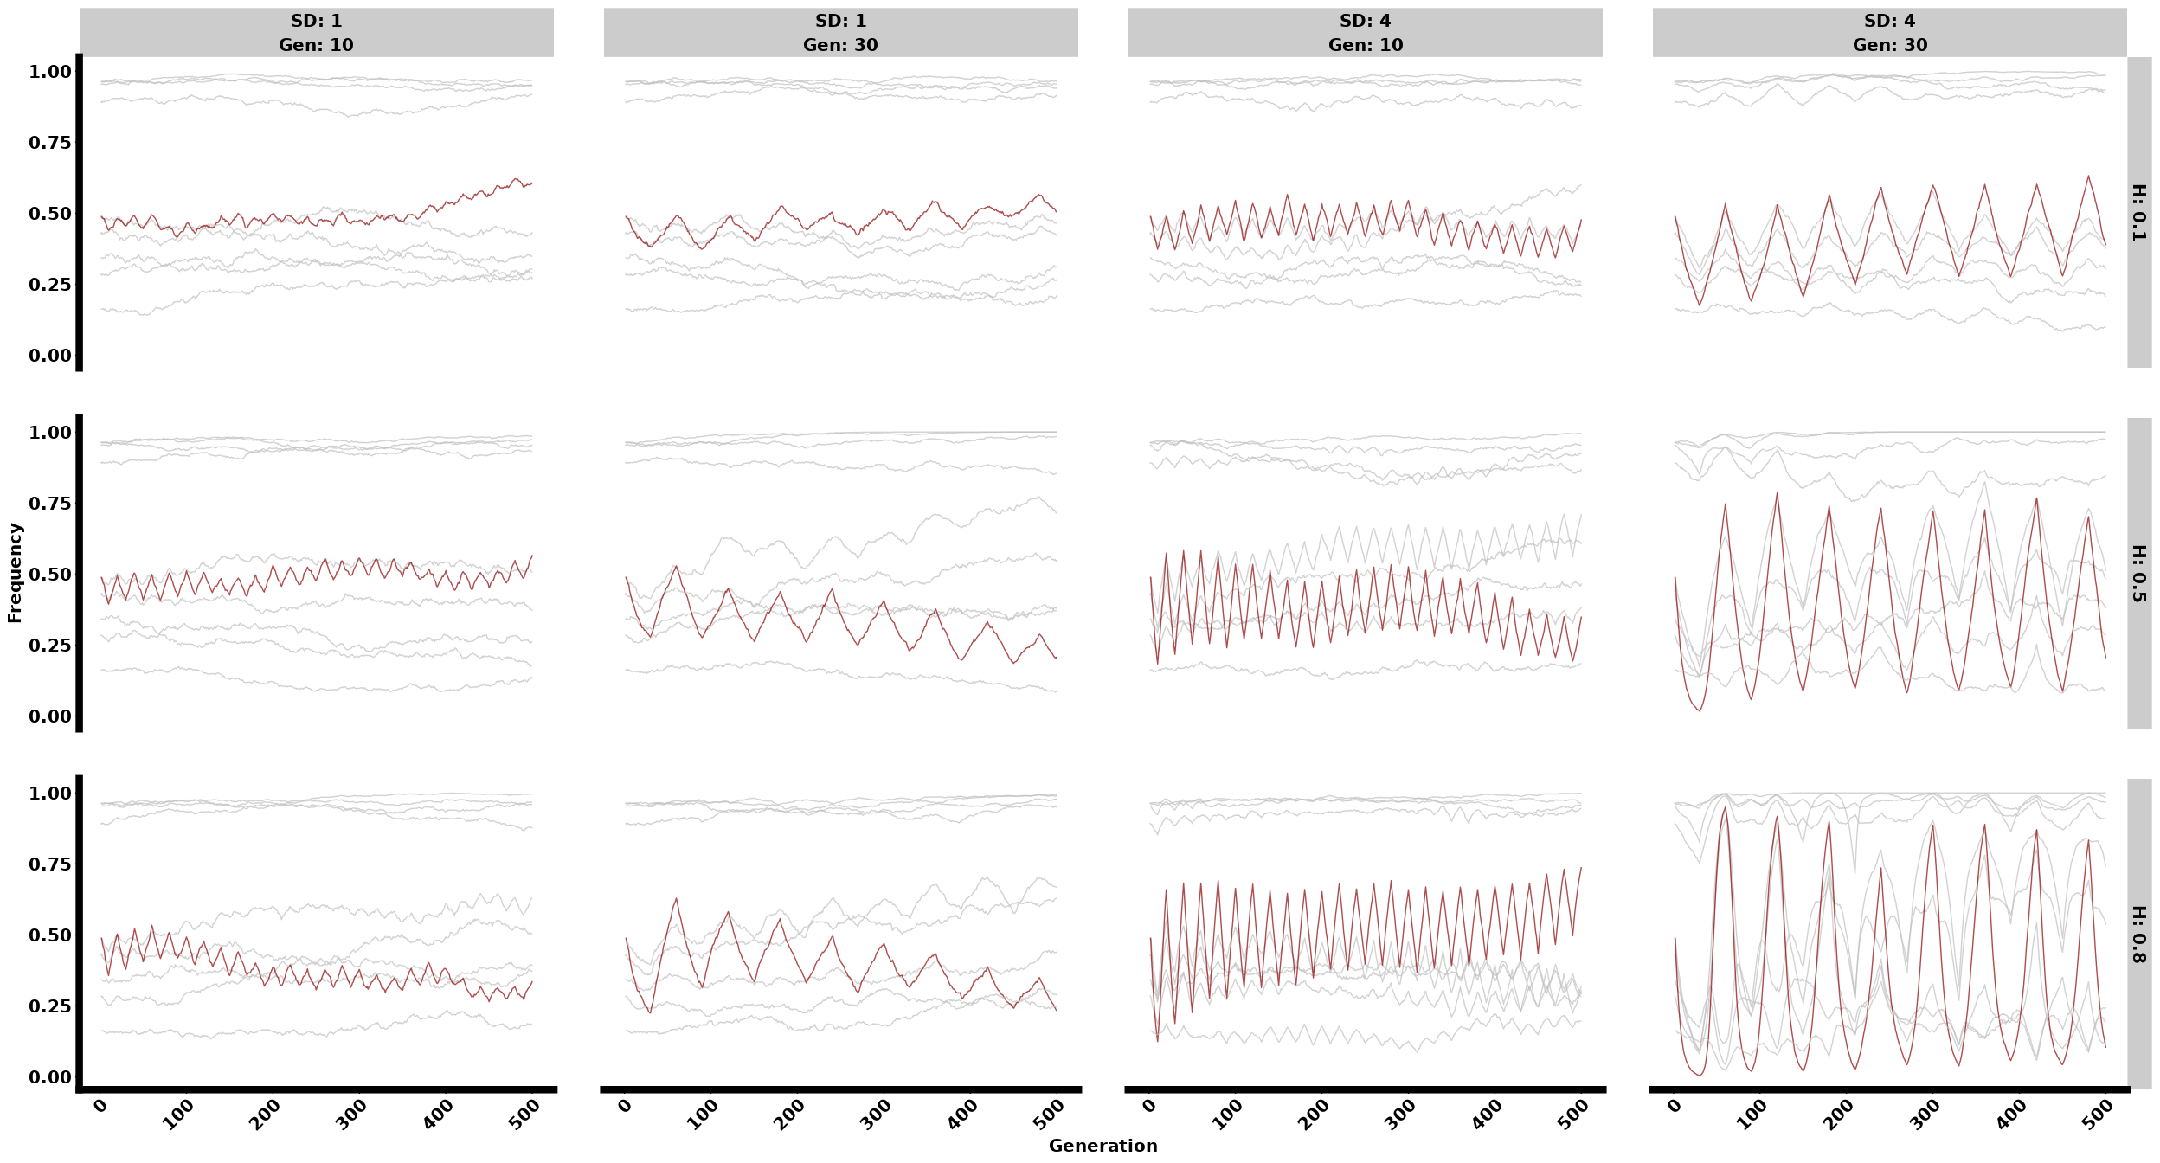

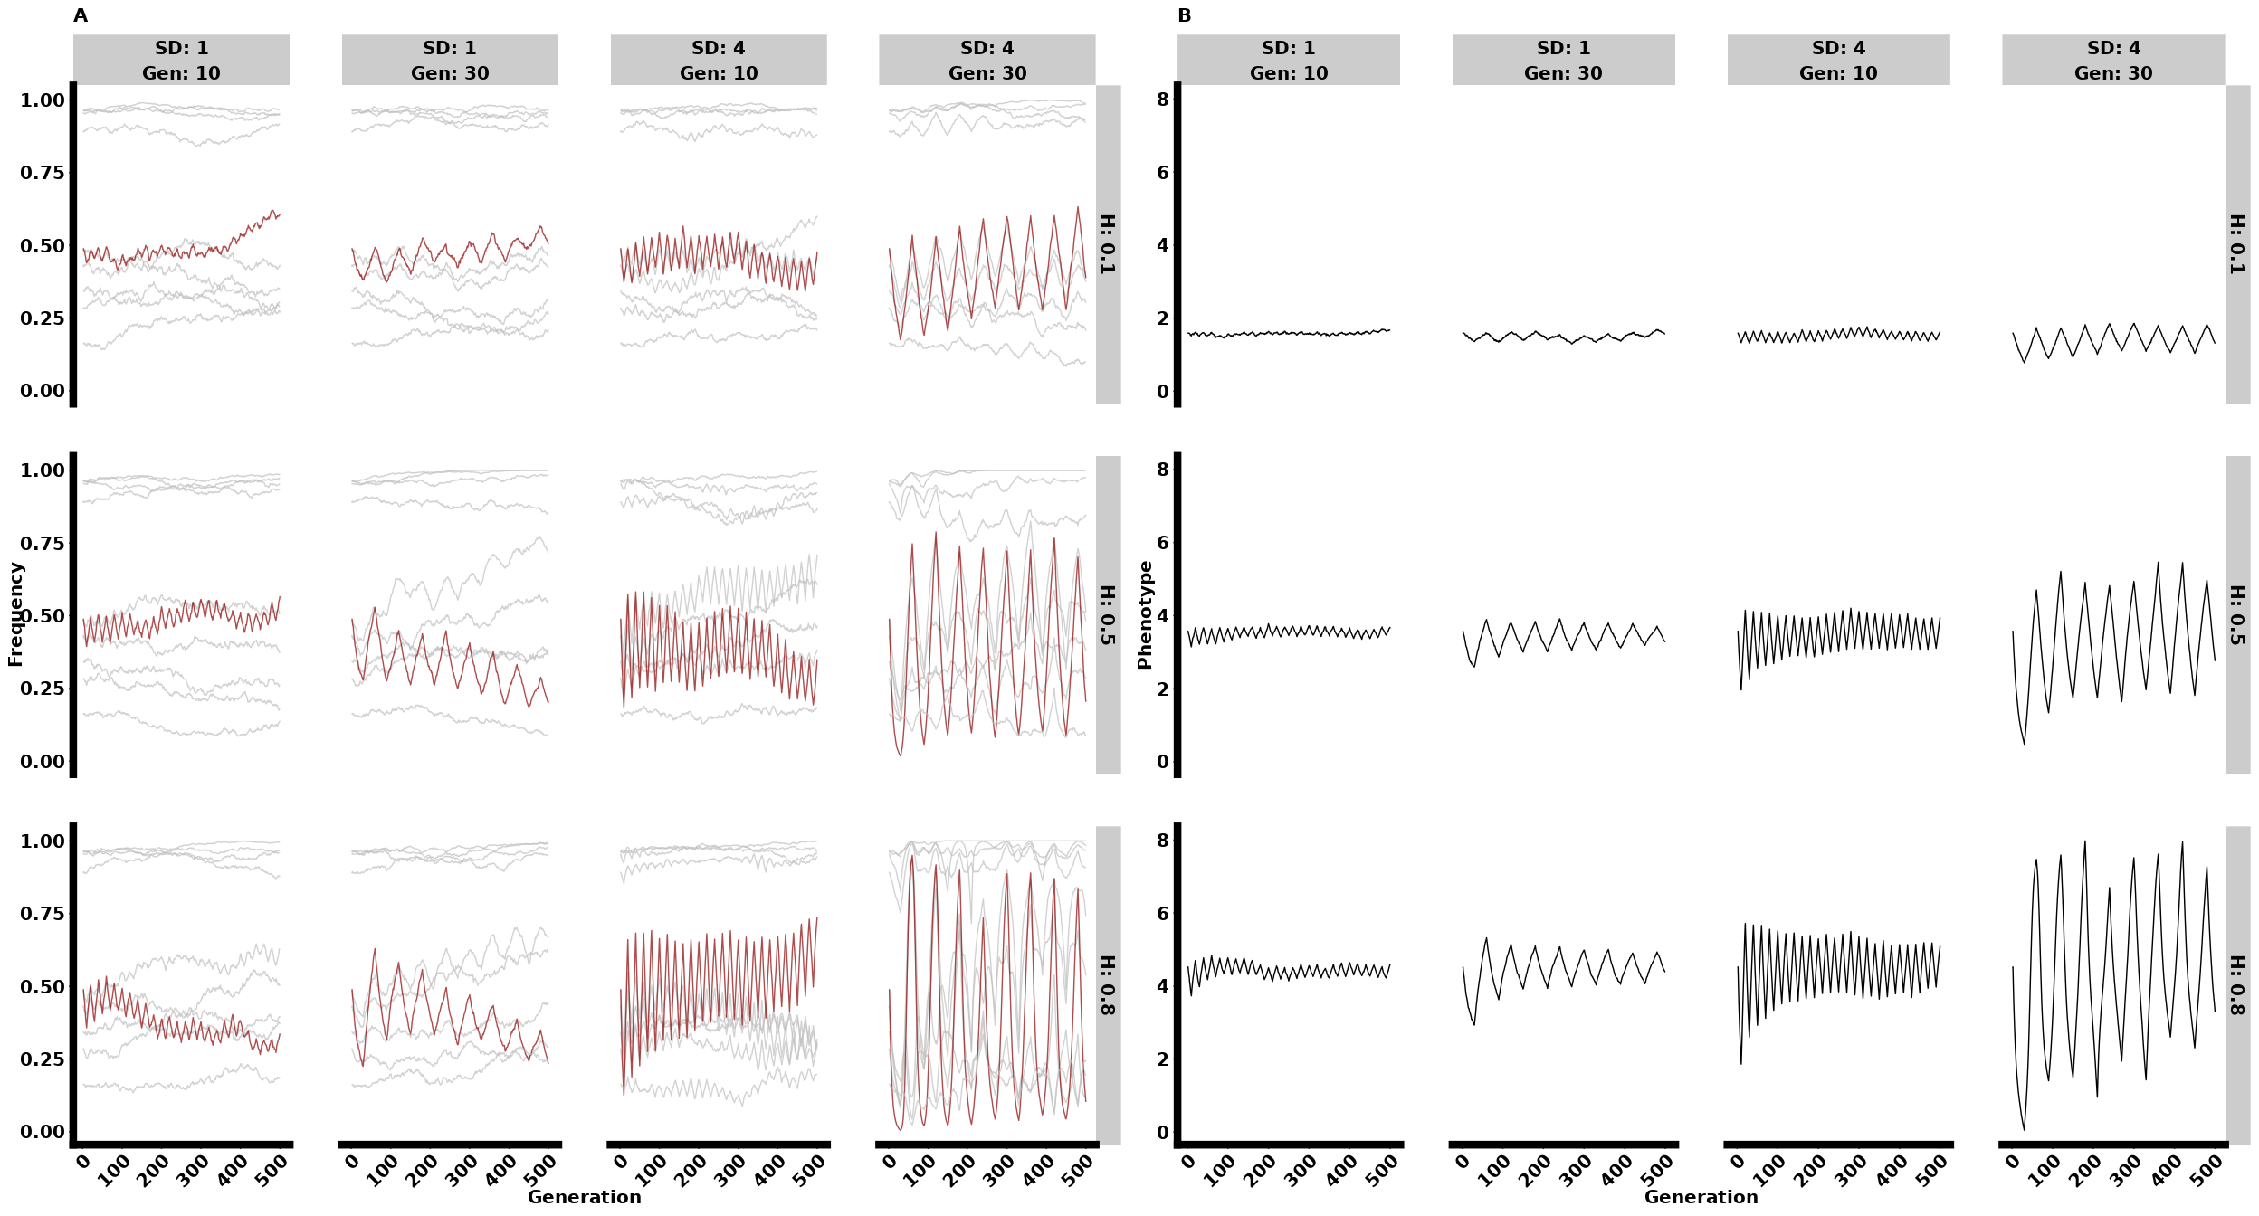

## Comparisons

### Monogenic, Oligogeni, and Polygenic

#### Allele Frequency

library(dplyr)  
library(ggplot2)  
library(forcats)  
library(cowplot)  
library(stringr)  
  
rm(list = ls())  
  
# Function to read in the files based on the specified parameters and extract Selection, H, SD, and Gen values using regex  
read_files <- function() {  
 file_list <- list.files(path = "~/YeastProj.dir/evogen-sims/ET_Yeast/output.dir/Selection_Models/WF.dir/LinFS.dir/", pattern = "genome10_n(1|10|70)_H0\\.(1|8)(SD(1|4))?Gen(10|30)\\.csv$", full.names = TRUE)  
   
 datasets <- lapply(file_list, function(file) {  
 data <- read.csv(file)  
 matches <- str_match(file, "genome10_n([0-9]+)_H([0-9\\.]+)SD([0-9]+)Gen([0-9]+)")  
 selection_type <- as.numeric(matches[2])  
 selection_label <- ifelse(selection_type == 1, "Monogenic",  
 ifelse(selection_type == 10, "Oligogenic", "Polygenic"))  
   
 data <- data %>%   
 mutate(Selection = selection_label,  
 H = as.numeric(matches[3]),  
 SD = as.numeric(matches[4]),  
 Gen = as.numeric(matches[5]))  
 return(data)  
 })  
   
 return(bind_rows(datasets))  
}  
  
# Read in the data  
Genome_dataset <- read_files() %>%   
 filter(Generation <= 500) %>%   
 mutate(Selection = fct_relevel(Selection,   
 "Monogenic",   
 "Oligogenic",   
 "Polygenic"))  
  
# Set seed for reproducibility  
set.seed(8450)  
  
# Group by Selection and select up to 30 unique positions for each group  
selected_positions <- Genome_dataset %>%  
 group_by(Selection) %>%  
 group_map(~ {  
 positions <- unique(.x$Position)  
 if (length(positions) > 10) {  
 sample(positions, 10)  
 } else {  
 positions  
 }  
 }) %>%  
 unlist()  
  
# Filter dataset to include only selected positions  
filtered_dataset <- Genome_dataset %>%  
 filter(Position %in% selected_positions)  
  
# Assign specific positions to be highlighted  
highlighted_positions <- c("915217", "644619")  
filtered_dataset <- filtered_dataset %>%  
 mutate(Color = case_when(  
 Selection == "Monogenic" ~ "red",  
 Selection == "Oligogenic" & Position == "915217" ~ "red",  
 Selection == "Polygenic" & Position == "1054696" ~ "red",  
 TRUE ~ "black"  
 ),  
 LineSize = case_when(  
 Color == "darkred" ~ 1.5,  
 TRUE ~ 0.5  
 ))  
  
# Create the plot  
freqplot <- filtered_dataset %>%  
 filter(Generation <= 500) %>%  
 ggplot(aes(x = Generation, y = Frequency, group = factor(Position), color = Color, linewidth = LineSize)) +  
 geom_line(alpha = 1) +  
 scale_color_identity() +  
 scale_linewidth_identity() +  
 facet_grid(Selection ~ H + SD + Gen, labeller = labeller(  
 Selection = function(x) x,  
 H = label_both,  
 SD = label_both,  
 Gen = label_both  
 )) +  
 theme_cowplot() +  
 theme(legend.position = "none",  
 axis.text.x = element_text(angle = 45, hjust = 1, size = 20, face = "bold"),  
 axis.text.y = element_text(size = 20, face = "bold"),  
 axis.line = element_line(linewidth = 5),  
 axis.title = element_text(size = 20, face = "bold"),  
 strip.text = element_text(size = 20, face = "bold"),  
 panel.spacing = unit(3, "lines"),  
 panel.grid = element_blank())  
  
# Print the plot  
print(freqplot)

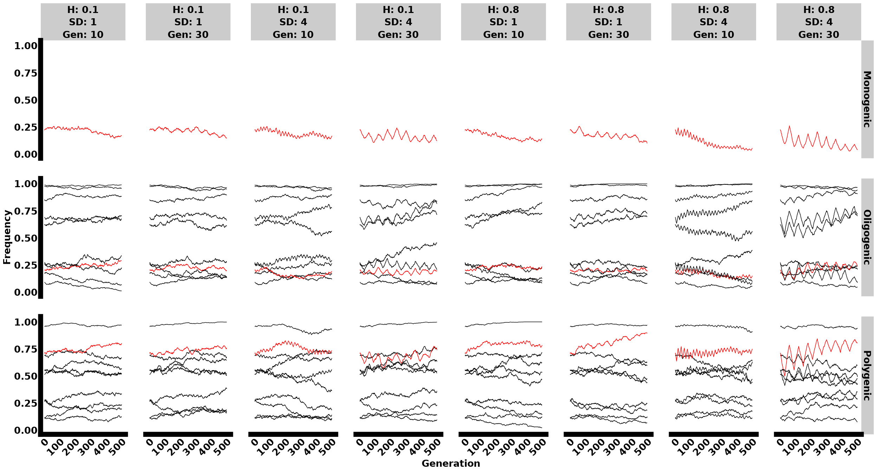

##### Small, intermediate, and high values

library(dplyr)  
library(ggplot2)  
library(forcats)  
library(cowplot)  
library(stringr)  
  
rm(list = ls())  
  
# Function to read in the files based on the specified parameters and extract Selection, H, SD, and Gen values using regex  
read_files <- function() {  
 file_list <- list.files(path = "~/YeastProj.dir/evogen-sims/ET_Yeast/output.dir/Selection_Models/WF.dir/LinFS.dir/", pattern = "genome10_n(1|10|70)_H0\\.(1|8|5)(SD(1|2|4))?Gen(10|20|30)\\.csv$", full.names = TRUE)  
   
 datasets <- lapply(file_list, function(file) {  
 data <- read.csv(file)  
 matches <- str_match(file, "genome10_n([0-9]+)_H([0-9\\.]+)SD([0-9]+)Gen([0-9]+)")  
 selection_type <- as.numeric(matches[2])  
 selection_label <- ifelse(selection_type == 1, "Monogenic",  
 ifelse(selection_type == 10, "Oligogenic", "Polygenic"))  
   
 data <- data %>%   
 mutate(Selection = selection_label,  
 H = as.numeric(matches[3]),  
 SD = as.numeric(matches[4]),  
 Gen = as.numeric(matches[5]))  
 return(data)  
 })  
   
 return(bind_rows(datasets))  
}  
  
# Read in the data  
Genome_dataset <- read_files() %>%   
 filter(Generation <= 500) %>%   
 mutate(Selection = fct_relevel(Selection,   
 "Monogenic",   
 "Oligogenic",   
 "Polygenic"))  
  
# Set seed for reproducibility  
set.seed(8450)  
  
# Group by Selection and select up to 30 unique positions for each group  
selected_positions <- Genome_dataset %>%  
 group_by(Selection) %>%  
 group_map(~ {  
 positions <- unique(.x$Position)  
 if (length(positions) > 10) {  
 sample(positions, 10)  
 } else {  
 positions  
 }  
 }) %>%  
 unlist()  
  
# Filter dataset to include only selected positions  
filtered_dataset <- Genome_dataset %>%  
 filter(Position %in% selected_positions)  
  
filtered_dataset <- filtered_dataset %>%  
 filter((H == 0.1 & SD == 1 & Gen == 10) |  
 (H == 0.5 & SD == 2 & Gen == 20) |  
 (H == 0.8 & SD == 4 & Gen == 30))  
  
# Assign specific positions to be highlighted  
highlighted_positions <- c("915217", "644619")  
filtered_dataset <- filtered_dataset %>%  
 mutate(Color = case_when(  
 Selection == "Monogenic" ~ "red",  
 Selection == "Oligogenic" & Position == "915217" ~ "red",  
 Selection == "Polygenic" & Position == "1054696" ~ "red",  
 TRUE ~ "black"  
 ),  
 LineSize = case_when(  
 Color == "darkred" ~ 1.5,  
 TRUE ~ 0.5  
 ))  
  
# Create the plot  
freqplot <- filtered_dataset %>%  
 filter(Generation <= 500) %>%  
 ggplot(aes(x = Generation, y = Frequency, group = factor(Position), color = Color, linewidth = LineSize)) +  
 geom_line(alpha = 1) +  
 scale_color_identity() +  
 scale_linewidth_identity() +  
 facet_grid(Selection ~ H + SD + Gen, labeller = labeller(  
 Selection = function(x) x,  
 H = label_both,  
 SD = label_both,  
 Gen = label_both  
 )) +  
 theme_cowplot() +  
 theme(legend.position = "none",  
 axis.text.x = element_text(angle = 45, hjust = 1, size = 20, face = "bold"),  
 axis.text.y = element_text(size = 20, face = "bold"),  
 axis.line = element_line(linewidth = 5),  
 axis.title.x = element_text(size = 20, face = "bold", margin = margin(t = 25)),  
 axis.title.y = element_text(size = 20, face = "bold", margin = margin(r = 25)),  
 strip.text = element_text(size = 20, face = "bold"),  
 panel.spacing = unit(3, "lines"),  
 panel.grid = element_blank())  
  
# Print the plot  
print(freqplot)

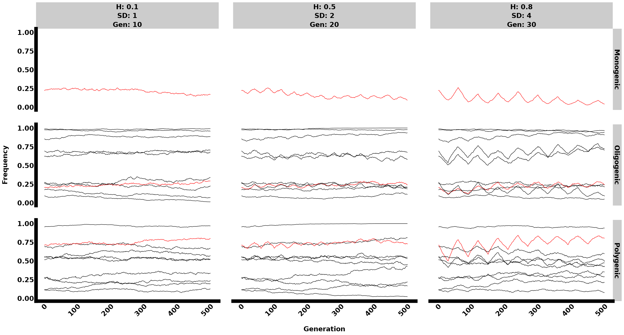

#### Phenotypes:

Here, use boxplot with somegeneration intervals

library(dplyr)  
library(ggplot2)  
library(forcats)  
library(cowplot)  
library(stringr)  
library(plotly)

Attaching package: 'plotly'

The following object is masked from 'package:ggplot2':  
  
 last_plot

The following object is masked from 'package:stats':  
  
 filter

The following object is masked from 'package:graphics':  
  
 layout

library(patchwork)  
library(purrr)  
library(doParallel)  
  
# Custom theme for plots  
mytheme <- function(){  
 theme(axis.text = element_text(size = 17, face = "bold"),  
 axis.line = element_line(size = 2),  
 axis.title = element_text(size = 17, face = "bold"),  
 strip.text = element_text(size = 17, face = "bold"),   
 plot.title = element_text(hjust = 0.5))  
}  
  
# Function to process phenotype files  
process_files <- function(dirpath, pattern) {  
 files <- list.files(dirpath, pattern, full.names = TRUE)  
   
 dataframes <- list()  
 for(file in files){  
 replicate <- as.numeric(str_extract(file, "(?<=MeanPhenotypes)\\d+"))  
 herit <- as.numeric(str_extract(file, "(?<=H)0\\.\\d+"))  
 loci <- as.numeric(str_extract(file, "(?<=_n)\\d+"))  
 sd <- as.numeric(str_extract(file, "(?<=SD)\\d+"))  
 gen <- as.numeric(str_extract(file, "(?<=Gen)\\d+"))  
   
 selection_label <- ifelse(loci == 1, "Monogenic",  
 ifelse(loci == 10, "Oligogenic", "Polygenic"))  
   
 data <- read.csv(file, header = TRUE) %>%   
 mutate(herit = herit, loci = loci, sd = sd, gen = gen,  
 replicate = as.factor(replicate),  
 Selection = selection_label,  
 h2_sd = paste("h2 = ", herit," ", "sd = ", sd, sep = ""),  
 loci_gen = paste("loci = ", loci," ", "gen = ", gen, sep = ""),  
 Fitness = exp(-(1/125) * (Phenotype - Optimum)^2),  
 Optimum = ifelse(Optimum == max(Optimum, na.rm = TRUE), "High", "Low"))  
   
 dataframes[[file]] <- data  
 }  
 combined_data <- bind_rows(dataframes) %>%  
 filter(Generation == 0 | Generation %% 150 == 0)  
   
 return(combined_data)  
}  
  
# Directory path and pattern for files  
dirpath <- "~/YeastProj.dir/evogen-sims/ET_Yeast/output.dir/Selection_Models/WF.dir/LinFS.dir/"  
pattern <- "^MeanPhenotypes\\d+_n(1|10|300)_H0\\.(1|8)(SD(1|4))?(Gen(10|30))?\\.csv$"  
  
# Process the files and get combined data  
combined_data <- process_files(dirpath, pattern)  
  
# Ensure the gen variable is included in the data and facets  
combined_data <- combined_data %>%  
 mutate(gen = factor(gen, levels = unique(gen)))  
  
# Plotting phenotypes  
phenotype_plots <- combined_data %>%  
 ggplot(aes(x = Generation, y = Phenotype)) +  
 geom_boxplot(aes(group = Generation, color = Optimum), size = 1, varwidth = TRUE, alpha = 0.5) +  
 facet_grid(Selection ~ herit + sd + gen, labeller = labeller(  
 Selection = function(x) x,  
 herit = label_both,  
 sd = label_both,  
 gen = label_both)) +  
 ylim(0,6)+  
 theme_cowplot()+  
 theme(legend.position = "none",  
 axis.text.x = element_text(angle = 45, hjust = 1, size = 15, face = "bold"),  
 axis.text.y = element_text(size = 15, face = "bold"),  
 axis.line = element_line(linewidth = 3),  
 axis.title = element_text(size = 15, face = "bold"),  
 strip.text = element_text(size = 15, face = "bold"),  
 panel.spacing = unit(3, "lines"),  
 panel.grid = element_blank())  
  
# Print the plot  
print(phenotype_plots)

Warning: Removed 4302 rows containing non-finite outside the scale range  
(`stat_boxplot()`).

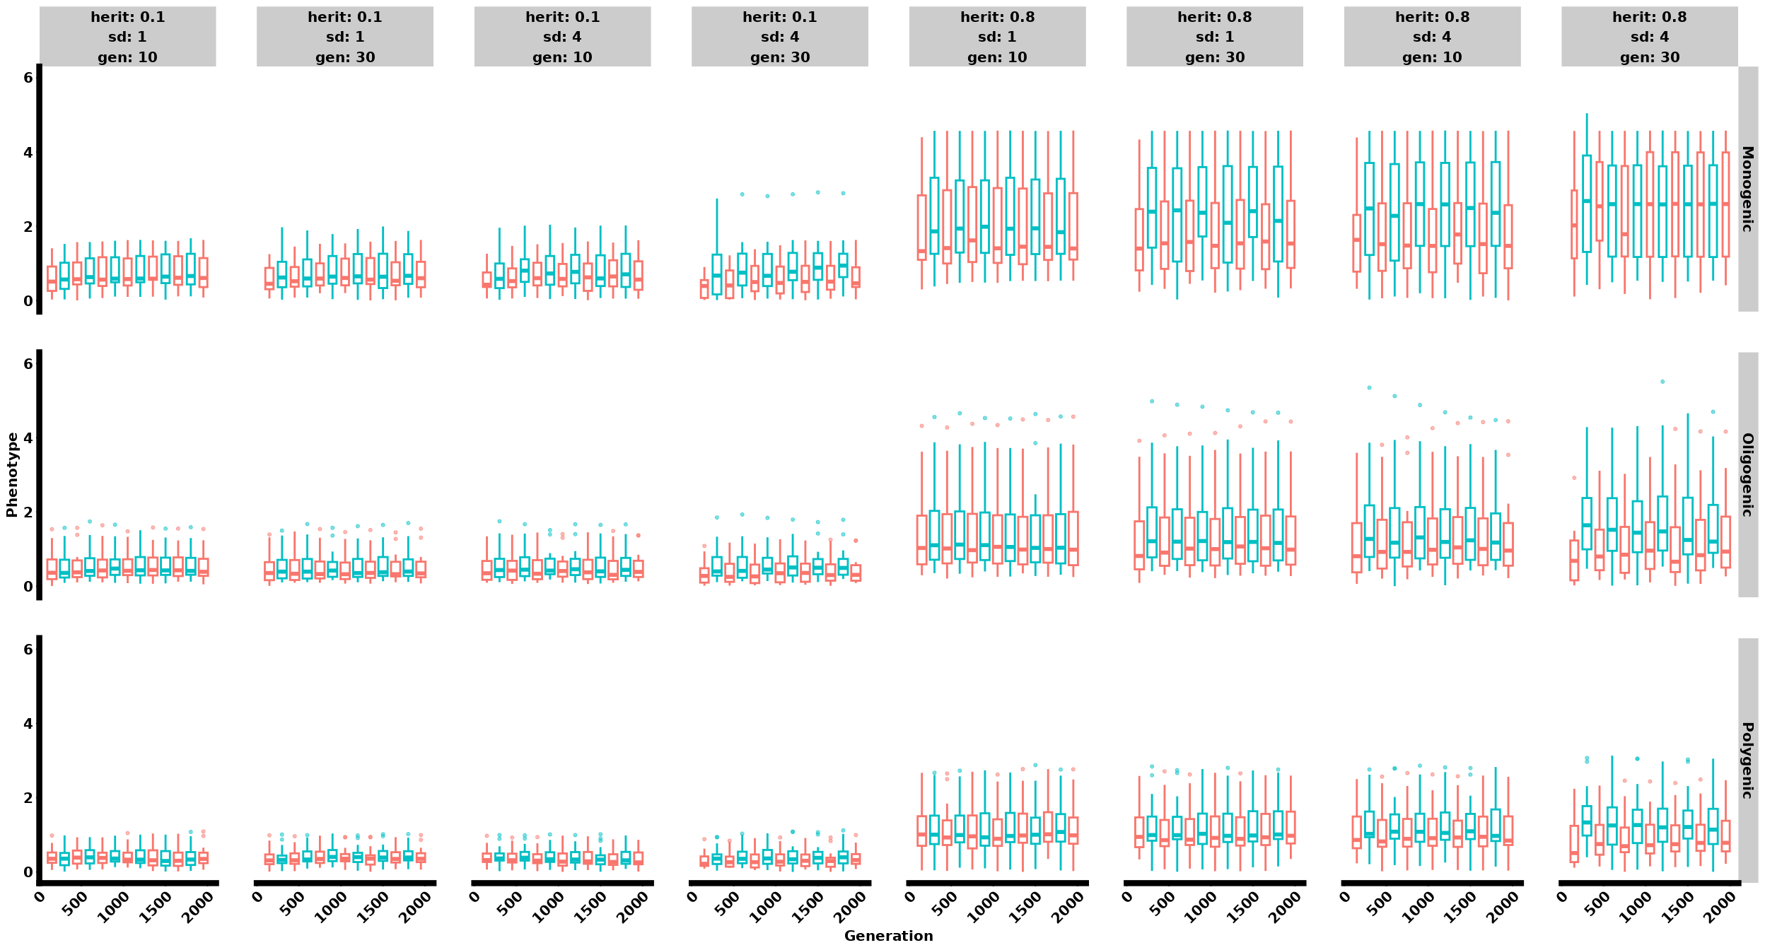

library(dplyr)  
library(ggplot2)  
library(forcats)  
library(cowplot)  
library(stringr)  
library(plotly)  
library(patchwork)  
library(purrr)  
library(doParallel)  
  
# Custom theme for plots  
mytheme <- function(){  
 theme(axis.text = element_text(size = 17, face = "bold"),  
 axis.line = element_line(size = 2),  
 axis.title = element_text(size = 17, face = "bold"),  
 strip.text = element_text(size = 17, face = "bold"),   
 plot.title = element_text(hjust = 0.5))  
}  
  
# Function to process phenotype files  
process_files <- function(dirpath, pattern) {  
 files <- list.files(dirpath, pattern, full.names = TRUE)  
   
 dataframes <- list()  
 for(file in files){  
 replicate <- as.numeric(str_extract(file, "(?<=MeanPhenotypes)\\d+"))  
 H <- as.numeric(str_extract(file, "(?<=H)0\\.\\d+"))  
 loci <- as.numeric(str_extract(file, "(?<=_n)\\d+"))  
 SD <- as.numeric(str_extract(file, "(?<=SD)\\d+"))  
 Gen <- as.numeric(str_extract(file, "(?<=Gen)\\d+"))  
   
 selection_label <- ifelse(loci == 1, "Monogenic",  
 ifelse(loci == 10, "Oligogenic", "Polygenic"))  
   
 data <- read.csv(file, header = TRUE) %>%   
 mutate(H = H, loci = loci, SD = SD, Gen = Gen,  
 replicate = as.factor(replicate),  
 Selection = selection_label,  
 h2_sd = paste("h2 = ", H," ", "sd = ", SD, sep = ""),  
 loci_gen = paste("loci = ", loci," ", "gen = ", Gen, sep = ""),  
 Fitness = exp(-(1/125) * (Phenotype - Optimum)^2),  
 Optimum = ifelse(Optimum == max(Optimum, na.rm = TRUE), "High", "Low"))  
   
 dataframes[[file]] <- data  
 }  
 combined_data <- bind_rows(dataframes) %>%  
 filter(Generation == 0 | Generation %% 30 == 0 & Generation <=500)  
   
 return(combined_data)  
}  
  
# Directory path and pattern for files  
dirpath <- "~/YeastProj.dir/evogen-sims/ET_Yeast/output.dir/Selection_Models/WF.dir/LinFS.dir/"  
pattern <- "^MeanPhenotypes\\d+_n(1|10|300)_H0\\.(1|5|8)(SD(1|2|4))?(Gen(10|20|30))?\\.csv$"  
  
# Process the files and get combined data  
combined_data <- process_files(dirpath, pattern)  
  
# Filter data to include only specific combinations of H, SD, and Gen  
filtered_data <- combined_data %>%  
 filter((H == 0.1 & SD == 1 & Gen == 10) |  
 (H == 0.5 & SD == 2 & Gen == 20)|  
 (H == 0.8 & SD == 4 & Gen == 30))  
  
# Ensure the gen variable is included in the data and facets  
filtered_data <- filtered_data %>%  
 mutate(Gen = factor(Gen, levels = unique(Gen)))  
  
# Plotting phenotypes  
  
phenotype_plots <- filtered_data %>%  
 ggplot(aes(x = Generation, y = Phenotype)) +  
 geom_boxplot(aes(group = Generation, color = Optimum), size = 1, varwidth = TRUE, alpha = 0.5) +  
 facet_grid(Selection ~ H + SD + Gen, labeller = labeller(  
 Selection = function(x) x,  
 H = label_both,  
 SD = label_both,  
 Gen = label_both)) +  
 theme_cowplot() +  
 theme(legend.position = "none",  
 axis.text.x = element_text(angle = 45, hjust = 1, size = 20, face = "bold"),  
 axis.text.y = element_text(size = 20, face = "bold"),  
 axis.line = element_line(linewidth = 5),  
 axis.title.x = element_text(size = 20, face = "bold", margin = margin(t = 25)),  
 axis.title.y = element_text(size = 20, face = "bold", margin = margin(r = 5)),  
 strip.text = element_text(size = 20, face = "bold"),  
 panel.spacing = unit(3, "lines"),  
 panel.grid = element_blank())  
  
phenotype_plots

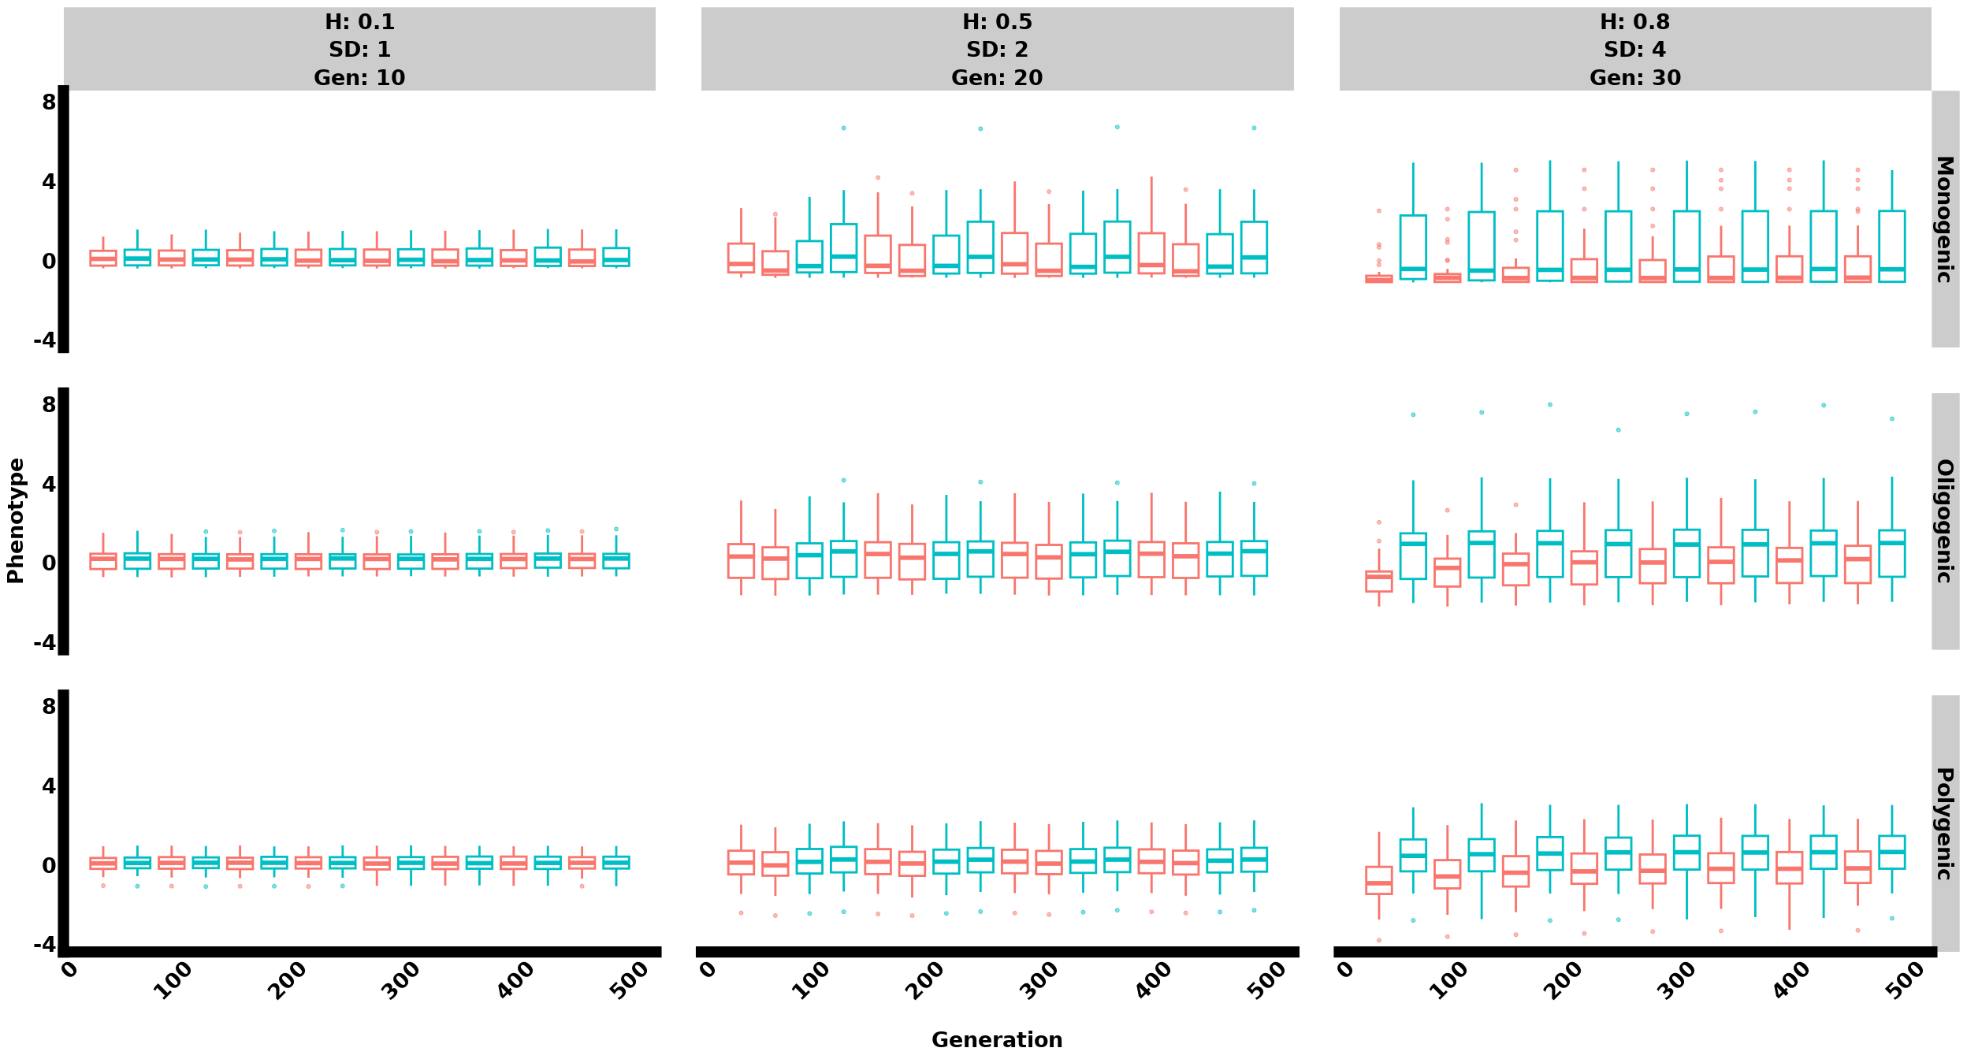

#### Displaying Phenotype and Frequency

library(cowplot)  
  
# Assuming freqplot and phenotype_plots are your ggplot objects  
plot_A <- ggdraw() +   
 draw_label("A", x = 0, y = 1, hjust = 0, vjust = 1, size = 25, fontface = "bold") +  
 draw_plot(freqplot)  
  
plot_B <- ggdraw() +   
 draw_label("B", x = 0, y = 1, hjust = 0, vjust = 1, size = 25, fontface = "bold") +  
 draw_plot(phenotype_plots)  
  
# Combine the plots  
final_plot <- plot_grid(plot_A, plot_B)  
  
# Print the final plot  
print(final_plot)

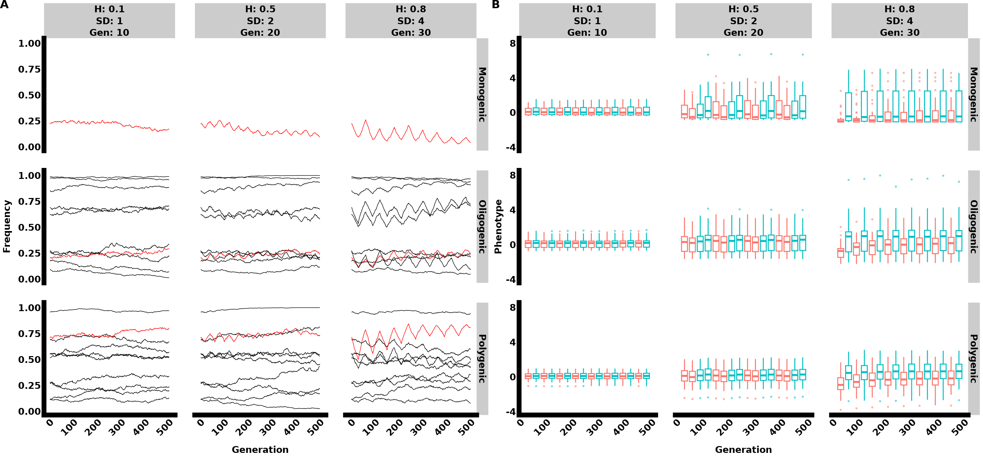

#### Agregated Allele Frequency

library(dplyr)  
library(ggplot2)  
library(forcats)  
library(cowplot)  
library(stringr)  
library(plotly)  
library(patchwork)  
library(purrr)  
library(doParallel)  
  
# Custom theme for plots  
mytheme <- function(){  
 theme(axis.text = element_text(size = 17, face = "bold"),  
 axis.line = element_line(size = 2),  
 axis.title = element_text(size = 17, face = "bold"),  
 strip.text = element_text(size = 17, face = "bold"),   
 plot.title = element_text(hjust = 0.5))  
}  
  
# Function to read in the files based on the specified parameters and extract Selection, H, SD, and Gen values using regex  
read_files <- function() {  
 file_list <- list.files(path = "~/YeastProj.dir/evogen-sims/ET_Yeast/output.dir/Selection_Models/WF.dir/LinFS.dir/", pattern = "genome([0-9]+)_n(1|10|300)_H0\\.(1|8)(SD(1|4))?Gen(10|30)\\.csv$", full.names = TRUE)  
   
 datasets <- lapply(file_list, function(file) {  
 data <- read.csv(file)  
 matches <- str_match(file, "genome([0-9]+)_n([0-9]+)_H0\\.([0-9]+)SD([0-9]+)Gen([0-9]+)")  
 replicate <- as.numeric(matches[2])  
 selection_type <- as.numeric(matches[3])  
 selection_label <- ifelse(selection_type == 1, "Monogenic",  
 ifelse(selection_type == 10, "Oligogenic", "Polygenic"))  
   
 data <- data %>%   
 mutate(Selection = selection_label,  
 H = as.numeric(matches[4]),  
 SD = as.numeric(matches[5]),  
 Gen = as.numeric(matches[6]),  
 replicate = replicate)  
 return(data)  
 })  
   
 return(bind_rows(datasets))  
}  
  
# Read in the data  
Genome_dataset <- read_files() %>%   
 filter(Generation <= 500) %>%   
 mutate(Selection = fct_relevel(Selection,   
 "Monogenic",   
 "Oligogenic",   
 "Polygenic"))  
  
# Set seed for reproducibility  
set.seed(8450)  
  
# Group by Selection and select up to 30 unique positions for each group  
selected_positions <- Genome_dataset %>%  
 group_by(Selection) %>%  
 group_map(~ {  
 positions <- unique(.x$Position)  
 if (length(positions) > 10) {  
 sample(positions, 10)  
 } else {  
 positions  
 }  
 }) %>%  
 unlist()  
  
# Filter dataset to include only selected positions  
filtered_dataset <- Genome_dataset %>%  
 filter(Position %in% selected_positions)  
  
# Aggregate data to calculate mean and standard deviation of frequency among replicates  
aggregated_dataset <- filtered_dataset %>%  
 group_by(Generation, Selection, H, SD, Gen, Position) %>%  
 summarize(mean_frequency = mean(Frequency),   
 sd_frequency = sd(Frequency),  
 .groups = 'drop')  
  
# Assign specific positions to be highlighted  
highlighted_positions <- c("915217", "644619")  
aggregated_dataset <- aggregated_dataset %>%  
 mutate(Color = case_when(  
 Selection == "Monogenic" ~ "darkred",  
 Selection == "Oligogenic" & Position == "915217" ~ "darkred",  
 Selection == "Polygenic" & Position == "1054696" ~ "darkred",  
 TRUE ~ "black"  
 ),  
 LineSize = case_when(  
 Color == "darkred" ~ 1.5,  
 TRUE ~ 0.5  
 ))  
  
# Create the plot with mean and standard deviation  
freqplot <- aggregated_dataset %>%  
 filter(Generation <= 500) %>%  
 ggplot(aes(x = Generation, y = mean_frequency, group = Position, color = Color, size = LineSize)) +  
 geom_line(alpha = 0.2) +  
 geom_ribbon(aes(ymin = mean_frequency - sd_frequency, ymax = mean_frequency + sd_frequency, fill = Color), alpha = 0.2) +  
 scale_color_identity() +  
 scale_fill_identity() +  
 scale_linewidth_identity() +  
 facet_grid(Selection ~ H + SD + Gen, labeller = label_both) +  
 mytheme() +  
 theme(legend.position = "none",  
 axis.text.x = element_text(angle = 45, hjust = 1, size = 15, face = "bold"),  
 axis.text.y = element_text(size = 15, face = "bold"),  
 axis.line = element_line(linewidth = 3),  
 axis.title = element_text(size = 15, face = "bold"),  
 strip.text = element_text(size = 15, face = "bold"),  
 panel.spacing = unit(3, "lines"),  
 panel.grid = element_blank())  
  
# Print the plot  
print(freqplot)

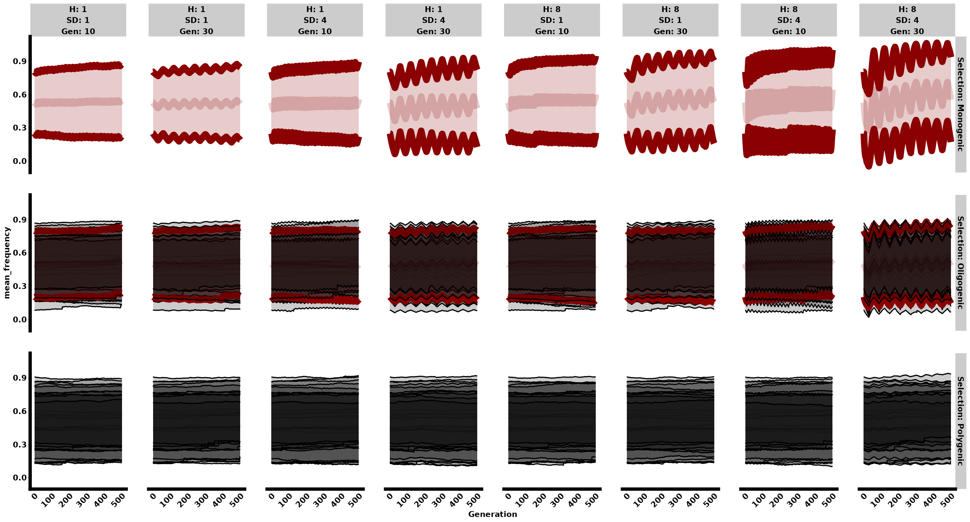

library(dplyr)  
library(ggplot2)  
library(forcats)  
library(cowplot)  
library(stringr)  
library(plotly)  
library(patchwork)  
library(purrr)  
library(doParallel)  
  
# Custom theme for plots  
mytheme <- function(){  
 theme(axis.text = element_text(size = 17, face = "bold"),  
 axis.line = element_line(size = 2),  
 axis.title = element_text(size = 17, face = "bold"),  
 strip.text = element_text(size = 17, face = "bold"),   
 plot.title = element_text(hjust = 0.5))  
}  
  
# Function to read in the files based on the specified parameters and extract Selection, H, SD, and Gen values using regex  
read_files <- function() {  
 file_list <- list.files(path = "~/YeastProj.dir/evogen-sims/ET_Yeast/output.dir/Selection_Models/WF.dir/LinFS.dir/", pattern = "genome([0-9]+)_n(1|10|300)_H0\\.(1|8)(SD(1|4))?Gen(10|30)\\.csv$", full.names = TRUE)  
   
 datasets <- lapply(file_list, function(file) {  
 data <- read.csv(file)  
 matches <- str_match(file, "genome([0-9]+)_n([0-9]+)_H0\\.([0-9]+)SD([0-9]+)Gen([0-9]+)")  
 replicate <- as.numeric(matches[2])  
 selection_type <- as.numeric(matches[3])  
 selection_label <- ifelse(selection_type == 1, "Monogenic",  
 ifelse(selection_type == 10, "Oligogenic", "Polygenic"))  
   
 data <- data %>%   
 mutate(Selection = selection_label,  
 H = as.numeric(matches[4]),  
 SD = as.numeric(matches[5]),  
 Gen = as.numeric(matches[6]),  
 replicate = replicate)  
 return(data)  
 })  
   
 return(bind_rows(datasets))  
}  
  
# Read in the data  
Genome_dataset <- read_files() %>%   
 #filter(Generation %% 90 == 0) %>%   
 mutate(Selection = fct_relevel(Selection,   
 "Monogenic",   
 "Oligogenic",   
 "Polygenic"))  
  
# Set seed for reproducibility  
set.seed(8450)  
  
# Group by Selection and select up to 30 unique positions for each group  
selected_positions <- Genome_dataset %>%  
 group_by(Selection) %>%  
 group_map(~ {  
 positions <- unique(.x$Position)  
 if (length(positions) > 10) {  
 sample(positions, 10)  
 } else {  
 positions  
 }  
 }) %>%  
 unlist()  
  
# Filter dataset to include only selected positions  
filtered_dataset <- Genome_dataset %>%  
 filter(Position %in% selected_positions)  
  
# Aggregate data to calculate mean and standard deviation of frequency among replicates  
aggregated_dataset <- filtered_dataset %>%  
 group_by(Generation, Selection, H, SD, Gen, Position) %>%  
 summarize(mean_frequency = mean(Frequency),   
 sd_frequency = sd(Frequency),  
 .groups = 'drop')  
  
# Assign specific positions to be highlighted  
highlighted_positions <- c("915217", "644619")  
aggregated_dataset <- aggregated_dataset %>%  
 mutate(Color = case_when(  
 Selection == "Monogenic" ~ "red",  
 Selection == "Oligogenic" & Position == "915217" ~ "red",  
 Selection == "Polygenic" & Position == "1054696" ~ "red",  
 TRUE ~ "black"  
 ),  
 LineSize = case_when(  
 Color == "darkred" ~ 1.5,  
 TRUE ~ 0.5  
 ))  
  
# Create the plot with mean and standard deviation  
freqplot <- aggregated_dataset %>%  
 filter(Generation==1 | Generation %% 90 == 0) %>%  
 ggplot(aes(x = Generation, y = mean_frequency,   
 group = Position, color = Color, size = LineSize)) +  
 geom_line(alpha = 0.2) +  
 geom_ribbon(aes(ymin = mean_frequency - sd_frequency,   
 ymax = mean_frequency + sd_frequency,   
 fill = Color), alpha = 0.5) +  
 scale_color_identity() +  
 scale_fill_identity() +  
 scale_linewidth_identity() +  
 facet_grid(Selection ~ H + SD + Gen, labeller = label_both) +  
 mytheme() +  
 theme(legend.position = "none",  
 axis.text.x = element_text(angle = 45, hjust = 1, size = 15, face = "bold"),  
 axis.text.y = element_text(size = 15, face = "bold"),  
 axis.line = element_line(linewidth = 3),  
 axis.title = element_text(size = 15, face = "bold"),  
 strip.text = element_text(size = 15, face = "bold"),  
 panel.spacing = unit(3, "lines"),  
 panel.grid = element_blank())  
  
# Print the plot  
print(freqplot)

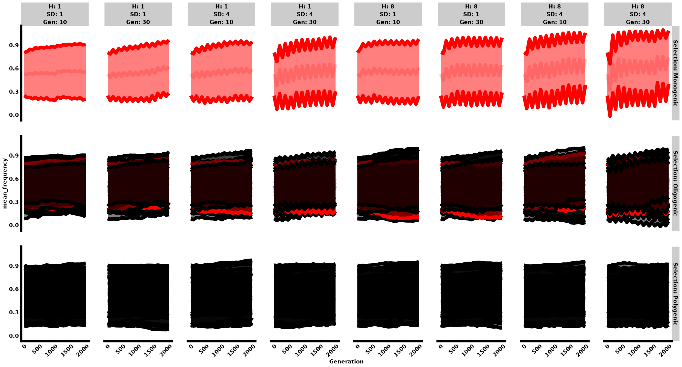

library(dplyr)  
library(ggplot2)  
library(forcats)  
library(cowplot)  
library(stringr)  
library(plotly)  
library(patchwork)  
library(purrr)  
library(doParallel)  
  
# Custom theme for plots  
mytheme <- function(){  
 theme(axis.text = element_text(size = 17, face = "bold"),  
 axis.line = element_line(size = 2),  
 axis.title = element_text(size = 17, face = "bold"),  
 strip.text = element_text(size = 17, face = "bold"),   
 plot.title = element_text(hjust = 0.5))  
}  
  
# Function to read in the files based on the specified parameters and extract Selection, H, SD, and Gen values using regex  
read_files <- function() {  
 file_list <- list.files(path = "~/YeastProj.dir/evogen-sims/ET_Yeast/output.dir/Selection_Models/WF.dir/LinFS.dir/", pattern = "genome([0-9]+)_n(1|10|300)_H0\\.(1|8)(SD(1|4))?Gen(10|30)\\.csv$", full.names = TRUE)  
   
 datasets <- lapply(file_list, function(file) {  
 data <- read.csv(file)  
 matches <- str_match(file, "genome([0-9]+)_n([0-9]+)_H0\\.([0-9]+)SD([0-9]+)Gen([0-9]+)")  
 replicate <- as.numeric(matches[2])  
 selection_type <- as.numeric(matches[3])  
 selection_label <- ifelse(selection_type == 1, "Monogenic",  
 ifelse(selection_type == 10, "Oligogenic", "Polygenic"))  
   
 data <- data %>%   
 mutate(Selection = selection_label,  
 H = as.numeric(matches[4]),  
 SD = as.numeric(matches[5]),  
 Gen = as.numeric(matches[6]),  
 replicate = replicate)  
 return(data)  
 })  
   
 return(bind_rows(datasets))  
}  
  
# Read in the data  
Genome_dataset <- read_files() %>%   
 filter(Generation==1 | Generation %% 90 == 0) %>%   
 mutate(Selection = fct_relevel(Selection,   
 "Monogenic",   
 "Oligogenic",   
 "Polygenic"))  
  
# Set seed for reproducibility  
set.seed(8450)  
  
# Group by Selection and select up to 30 unique positions for each group  
selected_positions <- Genome_dataset %>%  
 group_by(Selection) %>%  
 group_map(~ {  
 positions <- unique(.x$Position)  
 if (length(positions) > 10) {  
 sample(positions, 10)  
 } else {  
 positions  
 }  
 }) %>%  
 unlist()  
  
# Filter dataset to include only selected positions  
filtered_dataset <- Genome_dataset %>%  
 filter(Position %in% selected_positions)  
  
# Aggregate data to calculate mean and standard deviation of frequency among replicates  
aggregated_dataset <- filtered_dataset %>%  
 group_by(Generation, Selection, H, SD, Gen, Position) %>%  
 summarize(mean_frequency = mean(Frequency),   
 sd_frequency = sd(Frequency),  
 .groups = 'drop')  
  
# Assign specific positions to be highlighted  
highlighted_positions <- c("915217", "644619")  
aggregated_dataset <- aggregated_dataset %>%  
 mutate(Color = case_when(  
 Selection == "Monogenic" ~ "darkred",  
 Selection == "Oligogenic" & Position == "915217" ~ "darkred",  
 Selection == "Polygenic" & Position == "1054696" ~ "darkred",  
 TRUE ~ "black"  
 ),  
 LineSize = case_when(  
 Color == "darkred" ~ 1.5,  
 TRUE ~ 0.5  
 ))  
  
# Create the plot with mean and standard deviation  
freqplot <- aggregated_dataset %>%  
 ggplot(aes(x = Generation, y = mean_frequency, group = Position, color = Color, size = LineSize)) +  
 geom_line(alpha = 0.2) +  
 geom_ribbon(aes(ymin = mean_frequency - sd_frequency, ymax = mean_frequency + sd_frequency, fill = Color), alpha = 0.2) +  
 scale_color_identity() +  
 scale_fill_identity() +  
 scale_linewidth_identity() +  
 facet_grid(Selection ~ H + SD + Gen, labeller = label_both) +  
 mytheme() +  
 theme(legend.position = "none",  
 axis.text.x = element_text(angle = 45, hjust = 1, size = 15, face = "bold"),  
 axis.text.y = element_text(size = 15, face = "bold"),  
 axis.line = element_line(linewidth = 3),  
 axis.title = element_text(size = 15, face = "bold"),  
 strip.text = element_text(size = 15, face = "bold"),  
 panel.spacing = unit(3, "lines"),  
 panel.grid = element_blank())  
  
# Print the plot  
print(freqplot)

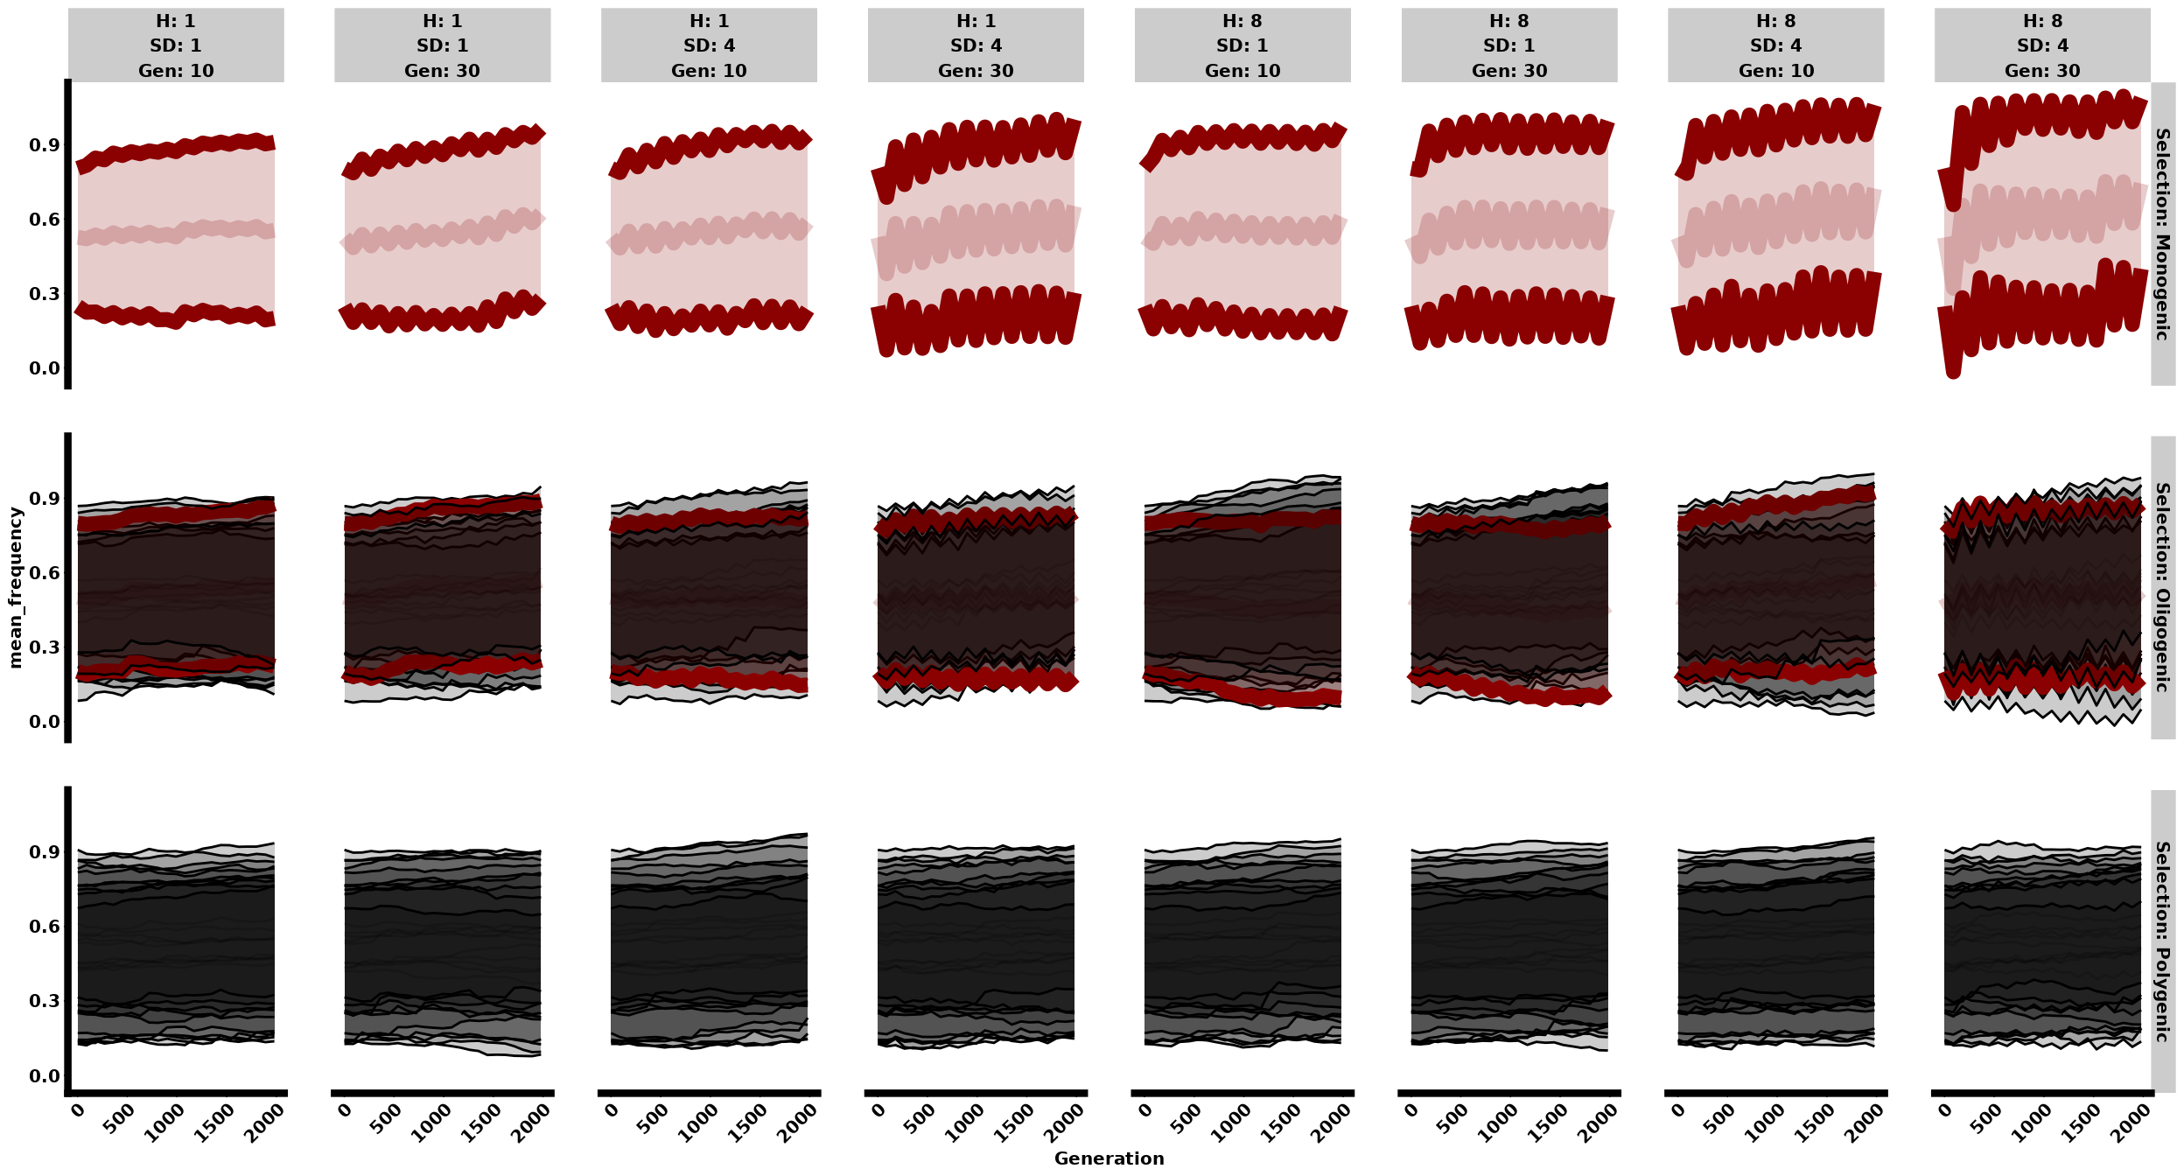

### Violin

# # Create violin plot  
# violin_plot <- filtered_dataset %>%  
# ggplot(aes(x = factor(Generation), y = Frequency, fill = H + SD + Gen)) +  
# geom_violin() +  
# facet_grid(Selection ~ H + SD + Gen, scales = "free", labeller = label_both) +  
# theme_minimal() +  
# theme(axis.text.x = element_text(angle = 45, hjust = 1, size = 15, face = "bold"),  
# axis.text.y = element_text(size = 15, face = "bold"),  
# axis.title = element_text(size = 15, face = "bold"),  
# strip.text = element_text(size = 15, face = "bold"))  
#   
# # Print the violin plot  
# print(violin_plot)

### Boxplot

# Filter dataset to include specific generations  
boxplot_data <- filtered_dataset %>%  
 filter(Generation %in% c(1, 90, 180, 270, 360, 450))  
  
# Create boxplot  
boxplot_plot <- boxplot_data %>%  
 ggplot(aes(x = factor(Generation), y = Frequency, fill = factor(H + SD + Gen))) +  
 geom_boxplot() +  
 facet_grid(Selection ~ H + SD + Gen, scales = "free", labeller = label_both) +  
 theme_minimal() +  
 theme(axis.text.x = element_text(angle = 45, hjust = 1, size = 15, face = "bold"),  
 axis.text.y = element_text(size = 15, face = "bold"),  
 axis.title = element_text(size = 15, face = "bold"),  
 strip.text = element_text(size = 15, face = "bold"))  
  
# Print the boxplot  
print(boxplot_plot)

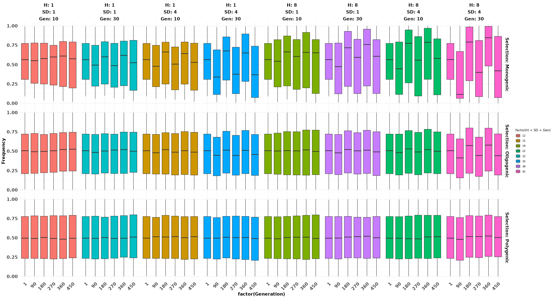

### Heatmap

# Aggregate data for heatmap  
heatmap_data <- filtered_dataset %>%  
 group_by(Generation, Selection, H, SD, Gen) %>%  
 summarize(mean_frequency = mean(Frequency),  
 .groups = 'drop')  
  
# Create heatmap plot  
heatmap_plot <- heatmap_data %>%  
 ggplot(aes(x = Generation, y = interaction(H, SD, Gen), fill = mean_frequency)) +  
 geom_tile() +  
 scale_fill_viridis_c() +  
 facet_wrap(~ Selection, scales = "free_y", labeller = label_both) +  
 theme_minimal() +  
 theme(axis.text.x = element_text(angle = 45, hjust = 1, size = 15, face = "bold"),  
 axis.text.y = element_text(size = 15, face = "bold"),  
 axis.title = element_text(size = 15, face = "bold"),  
 strip.text = element_text(size = 15, face = "bold"))  
  
# Print the heatmap plot  
print(heatmap_plot)

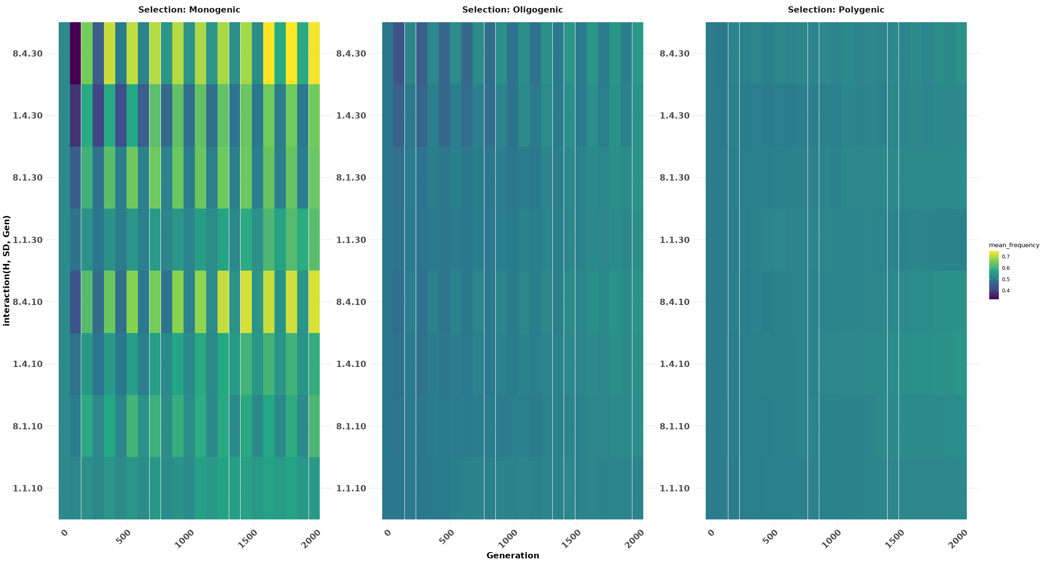

### don’t delete tho there might be no use

### Figure 1: Monogenic Two-Season

### Figure 2: Models Comparison

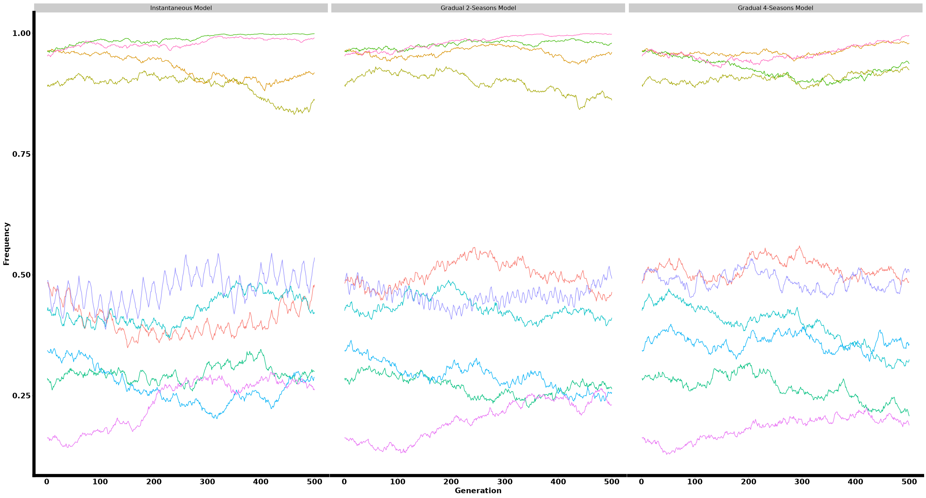

### Neutral vs Gradual 4 seasons

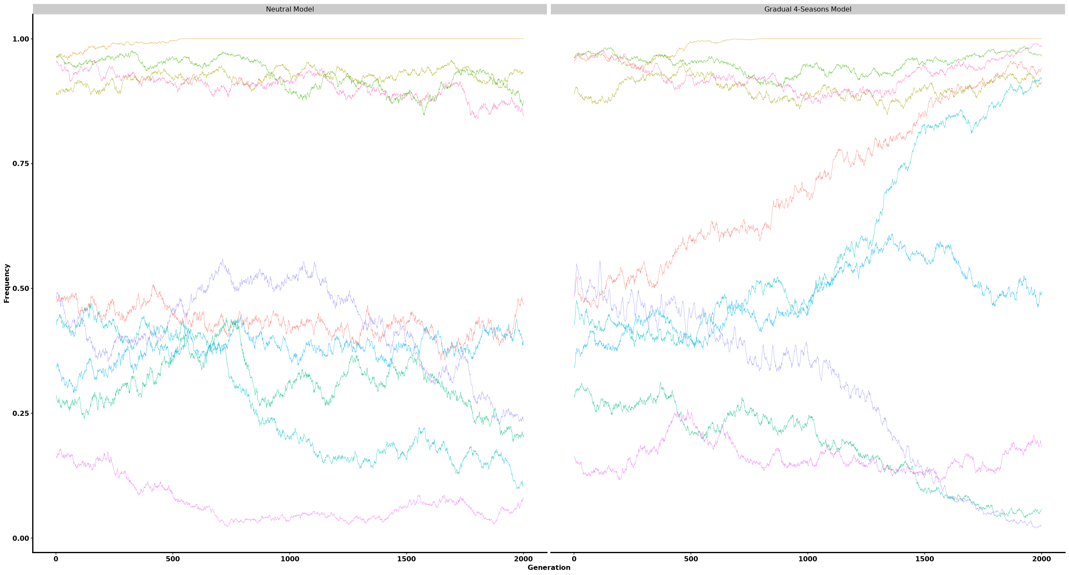

### Genome Size

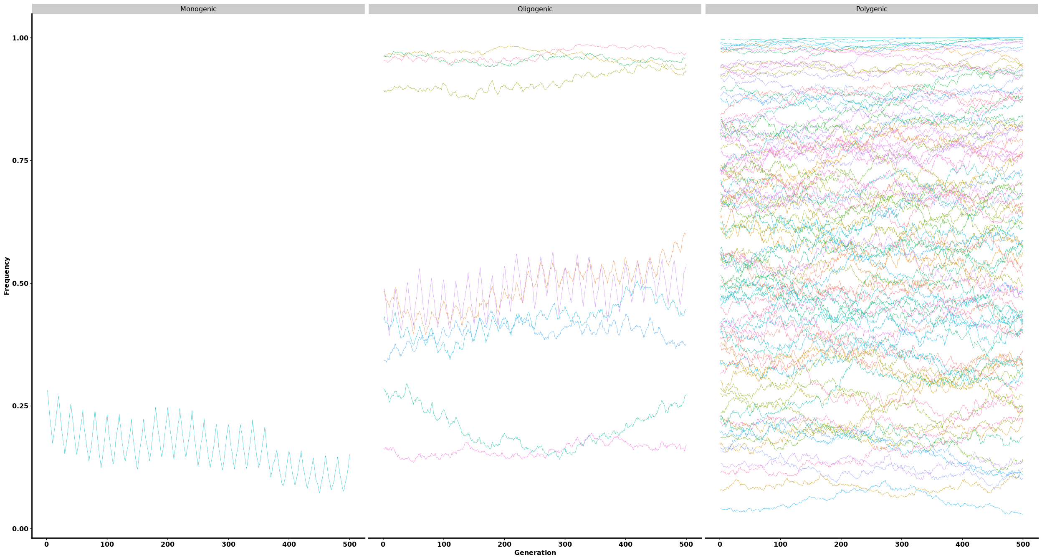

### Gradual I

#### Polygenic

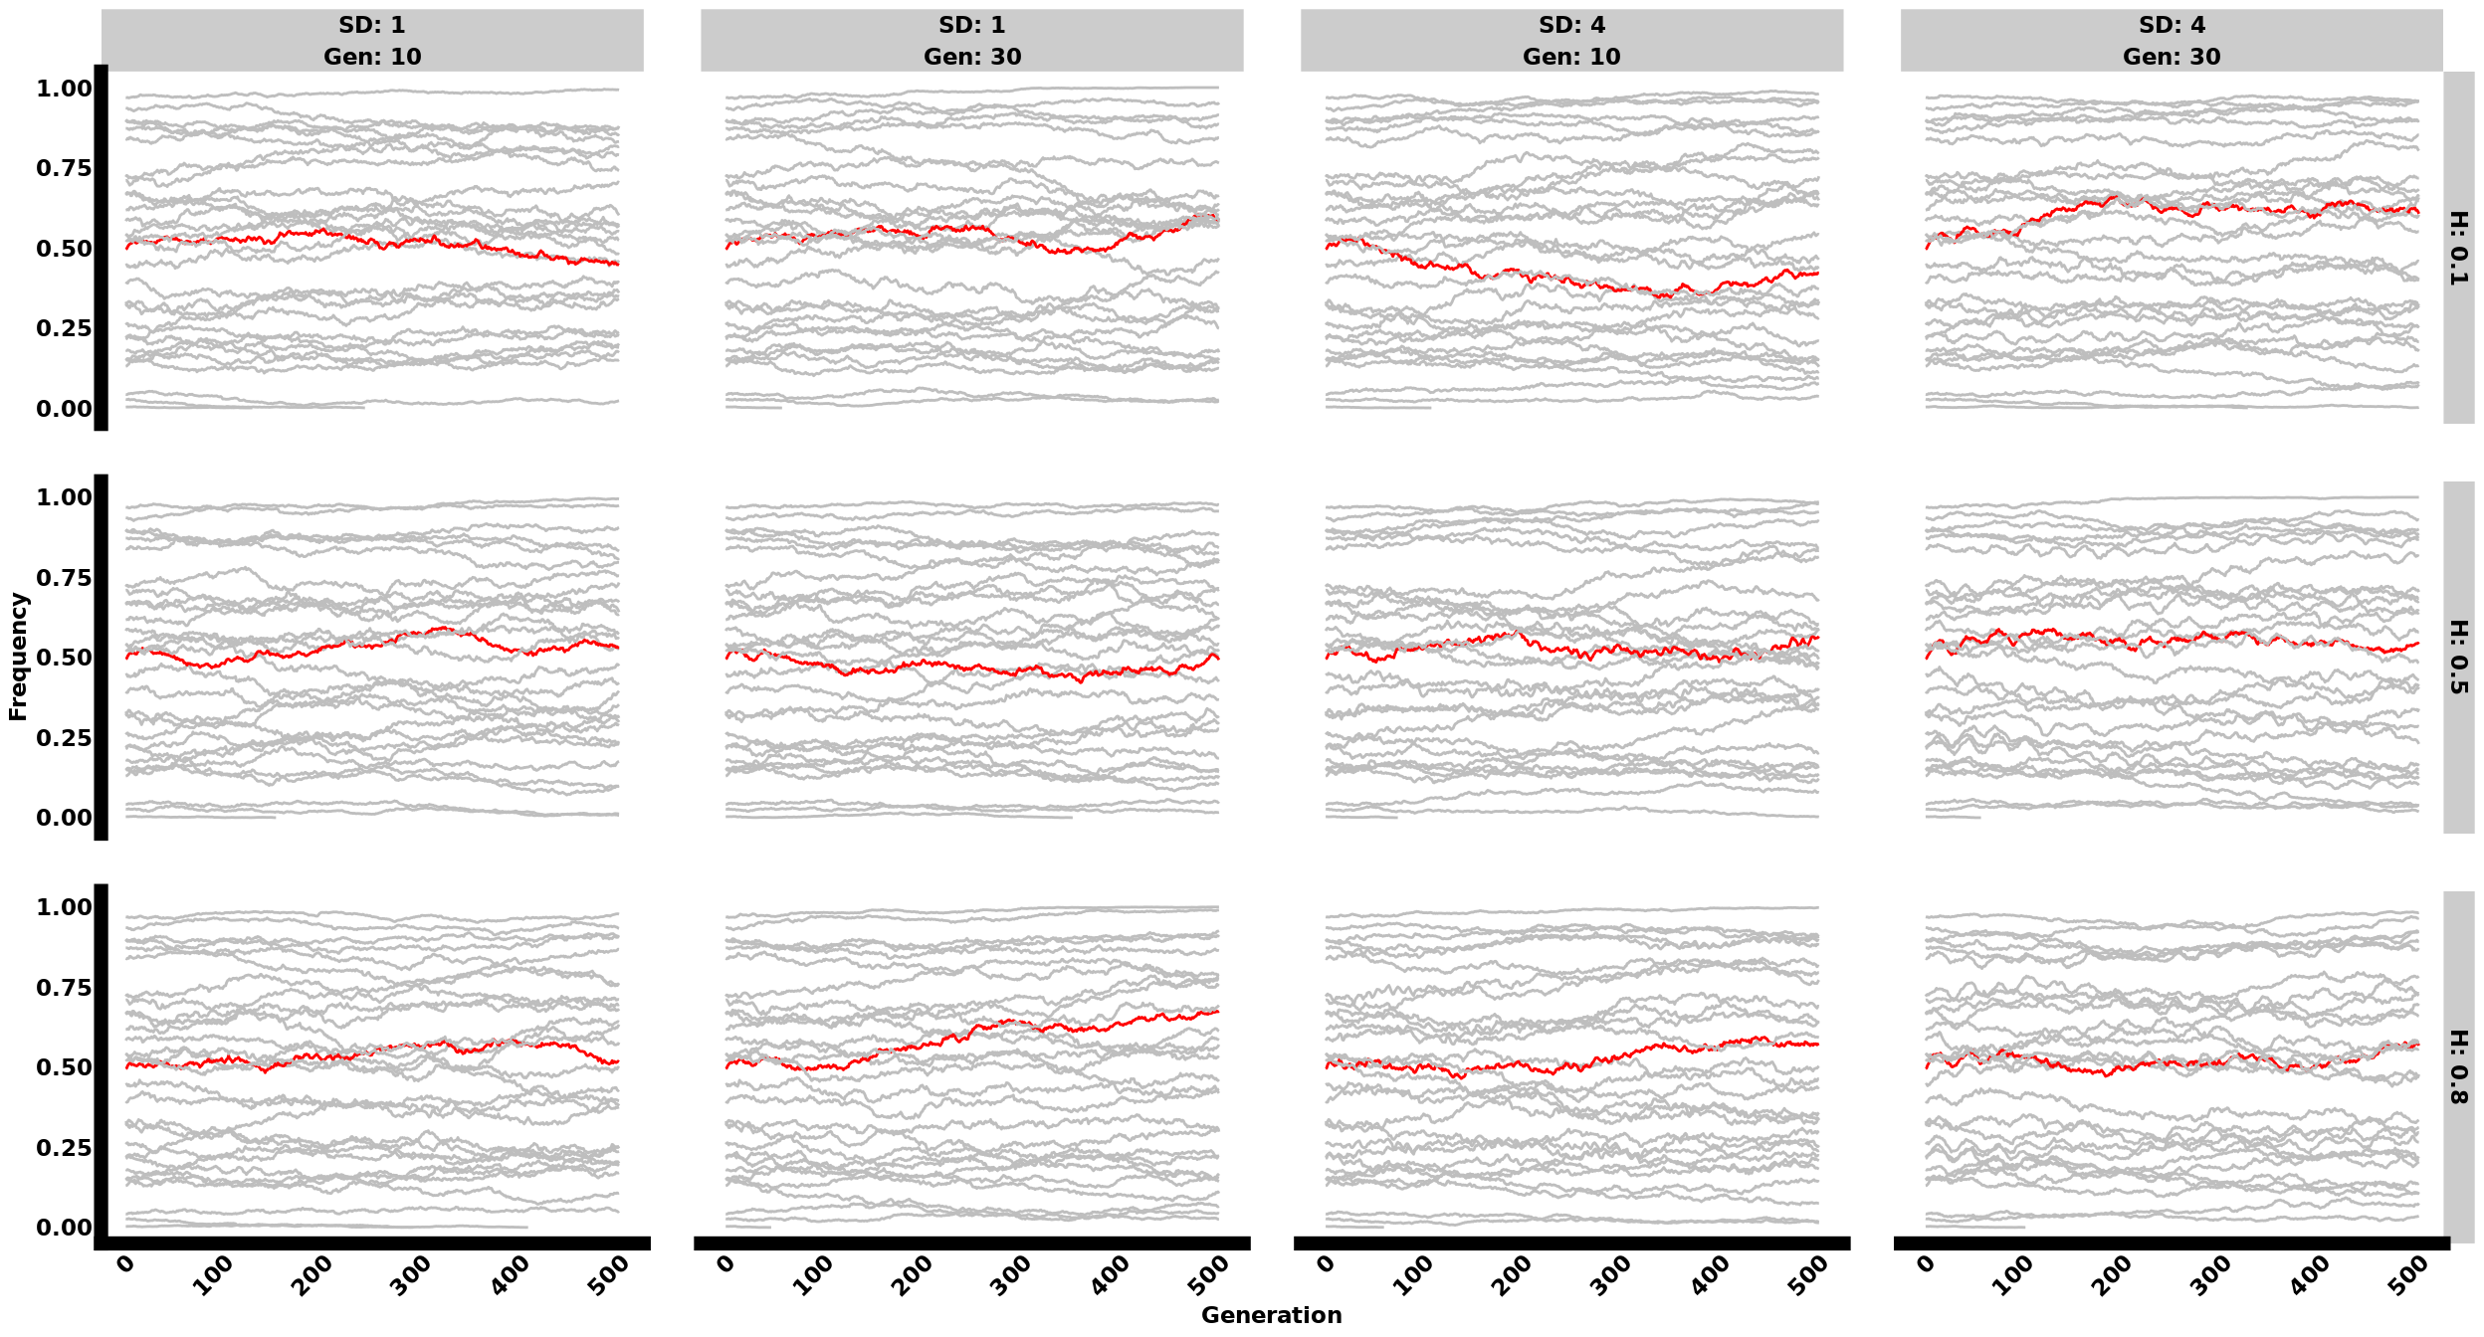

#### Oligogenic

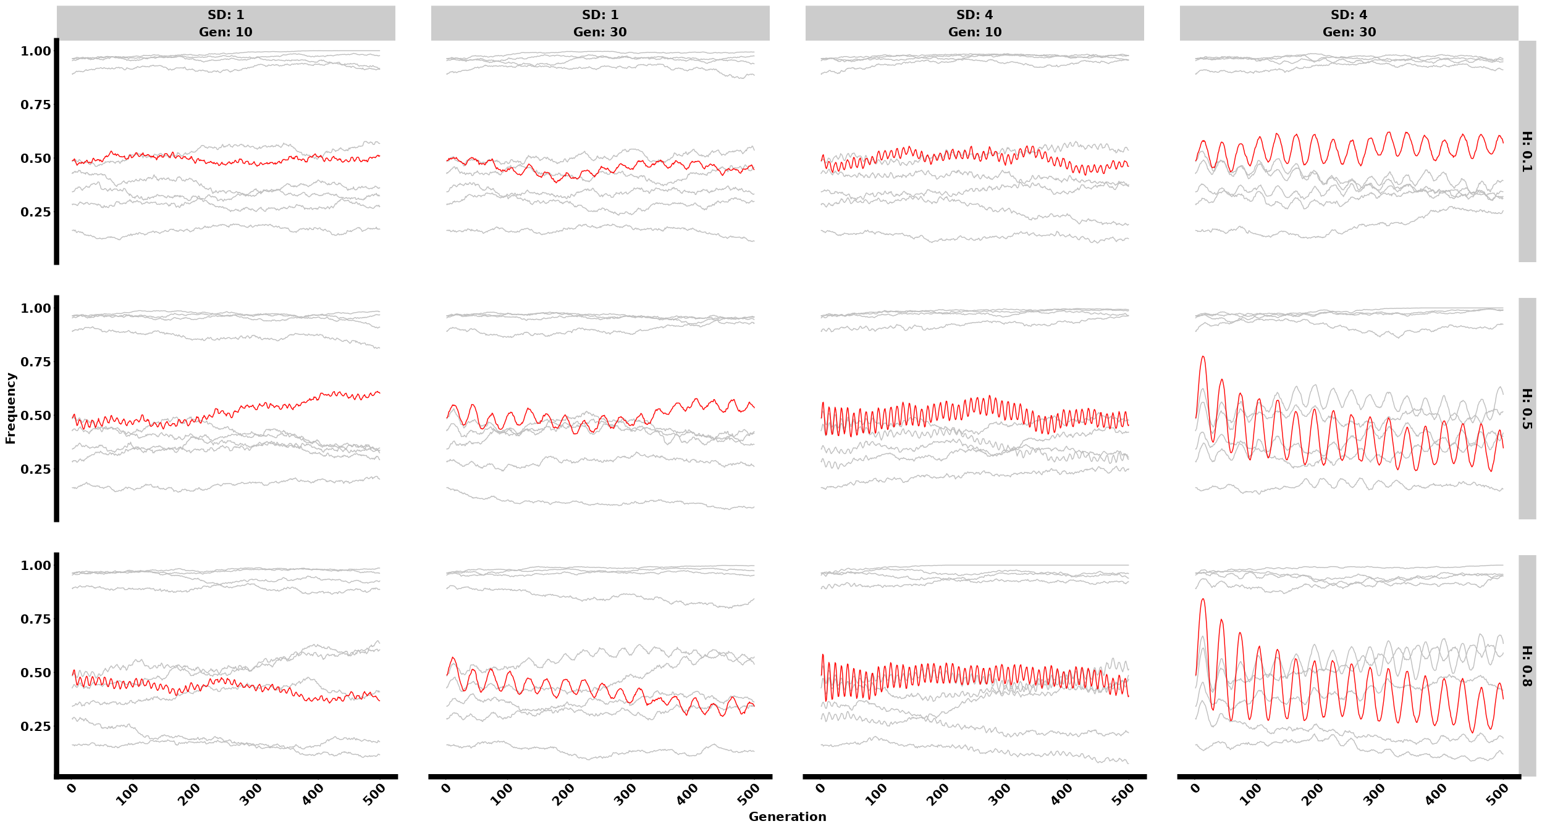

#### Monogenic

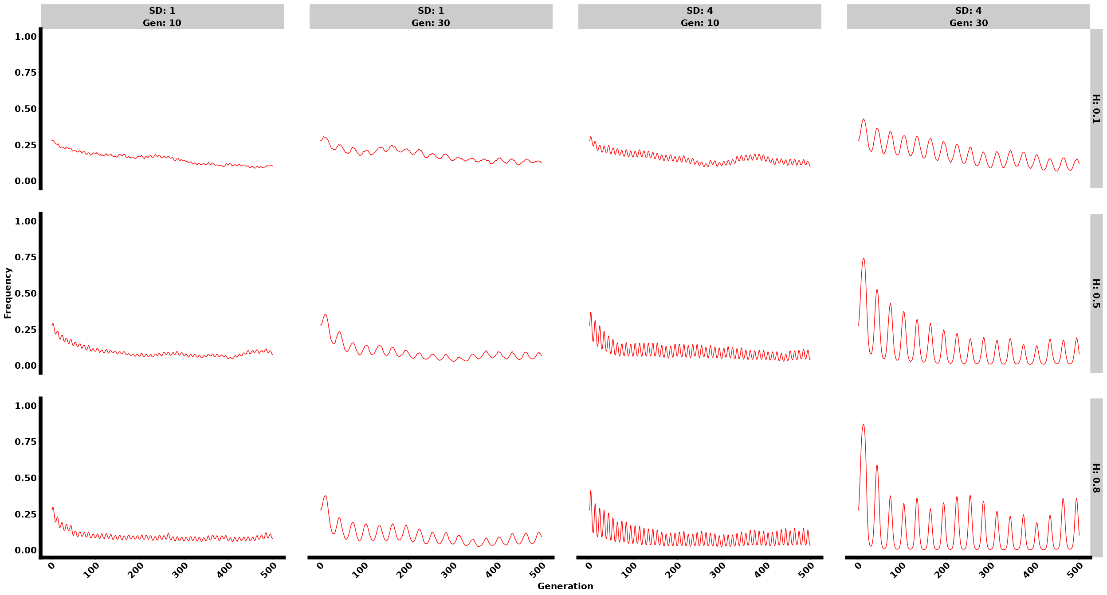

## Gradual II

### Allele Frequency

#### Polygenic

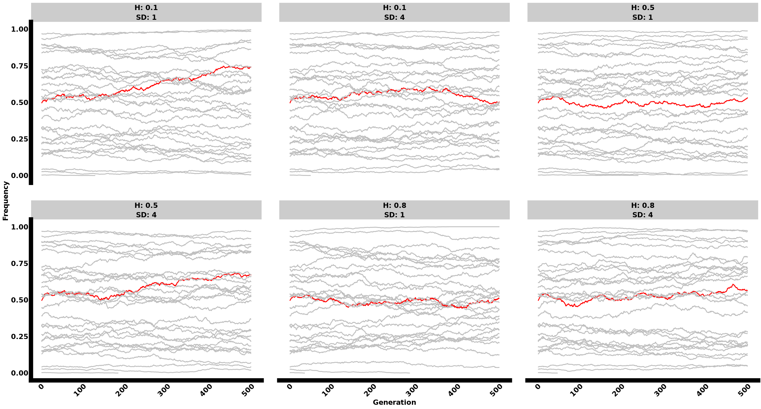

#### Oligogenic

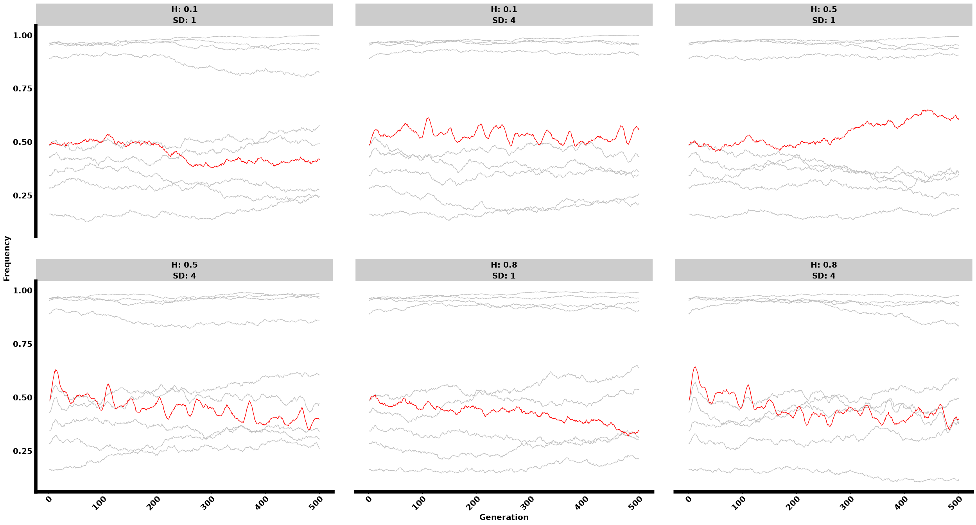

#### Monogenic

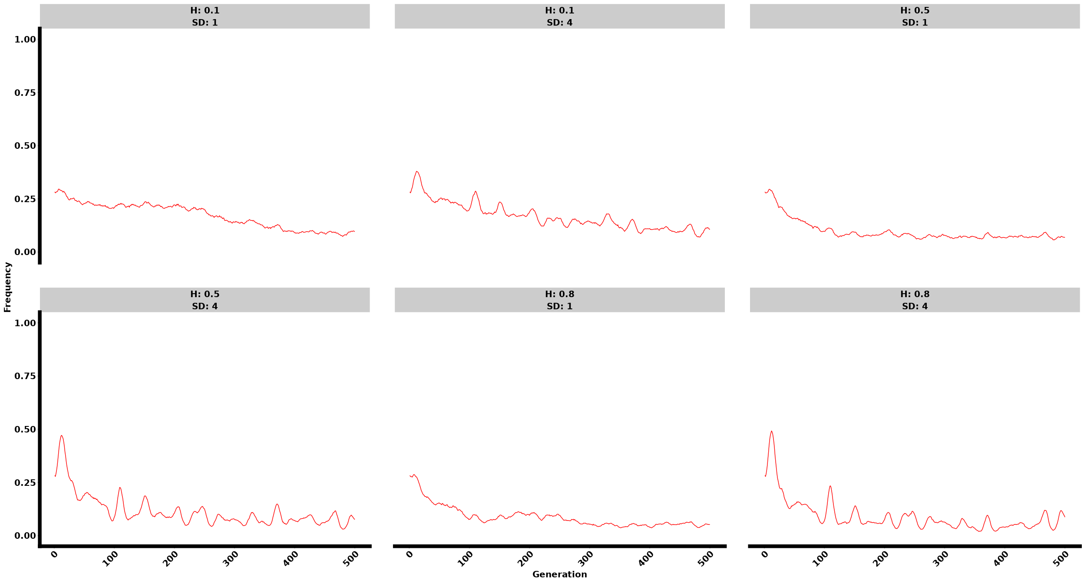

### Phenotypes

#### Polygenic

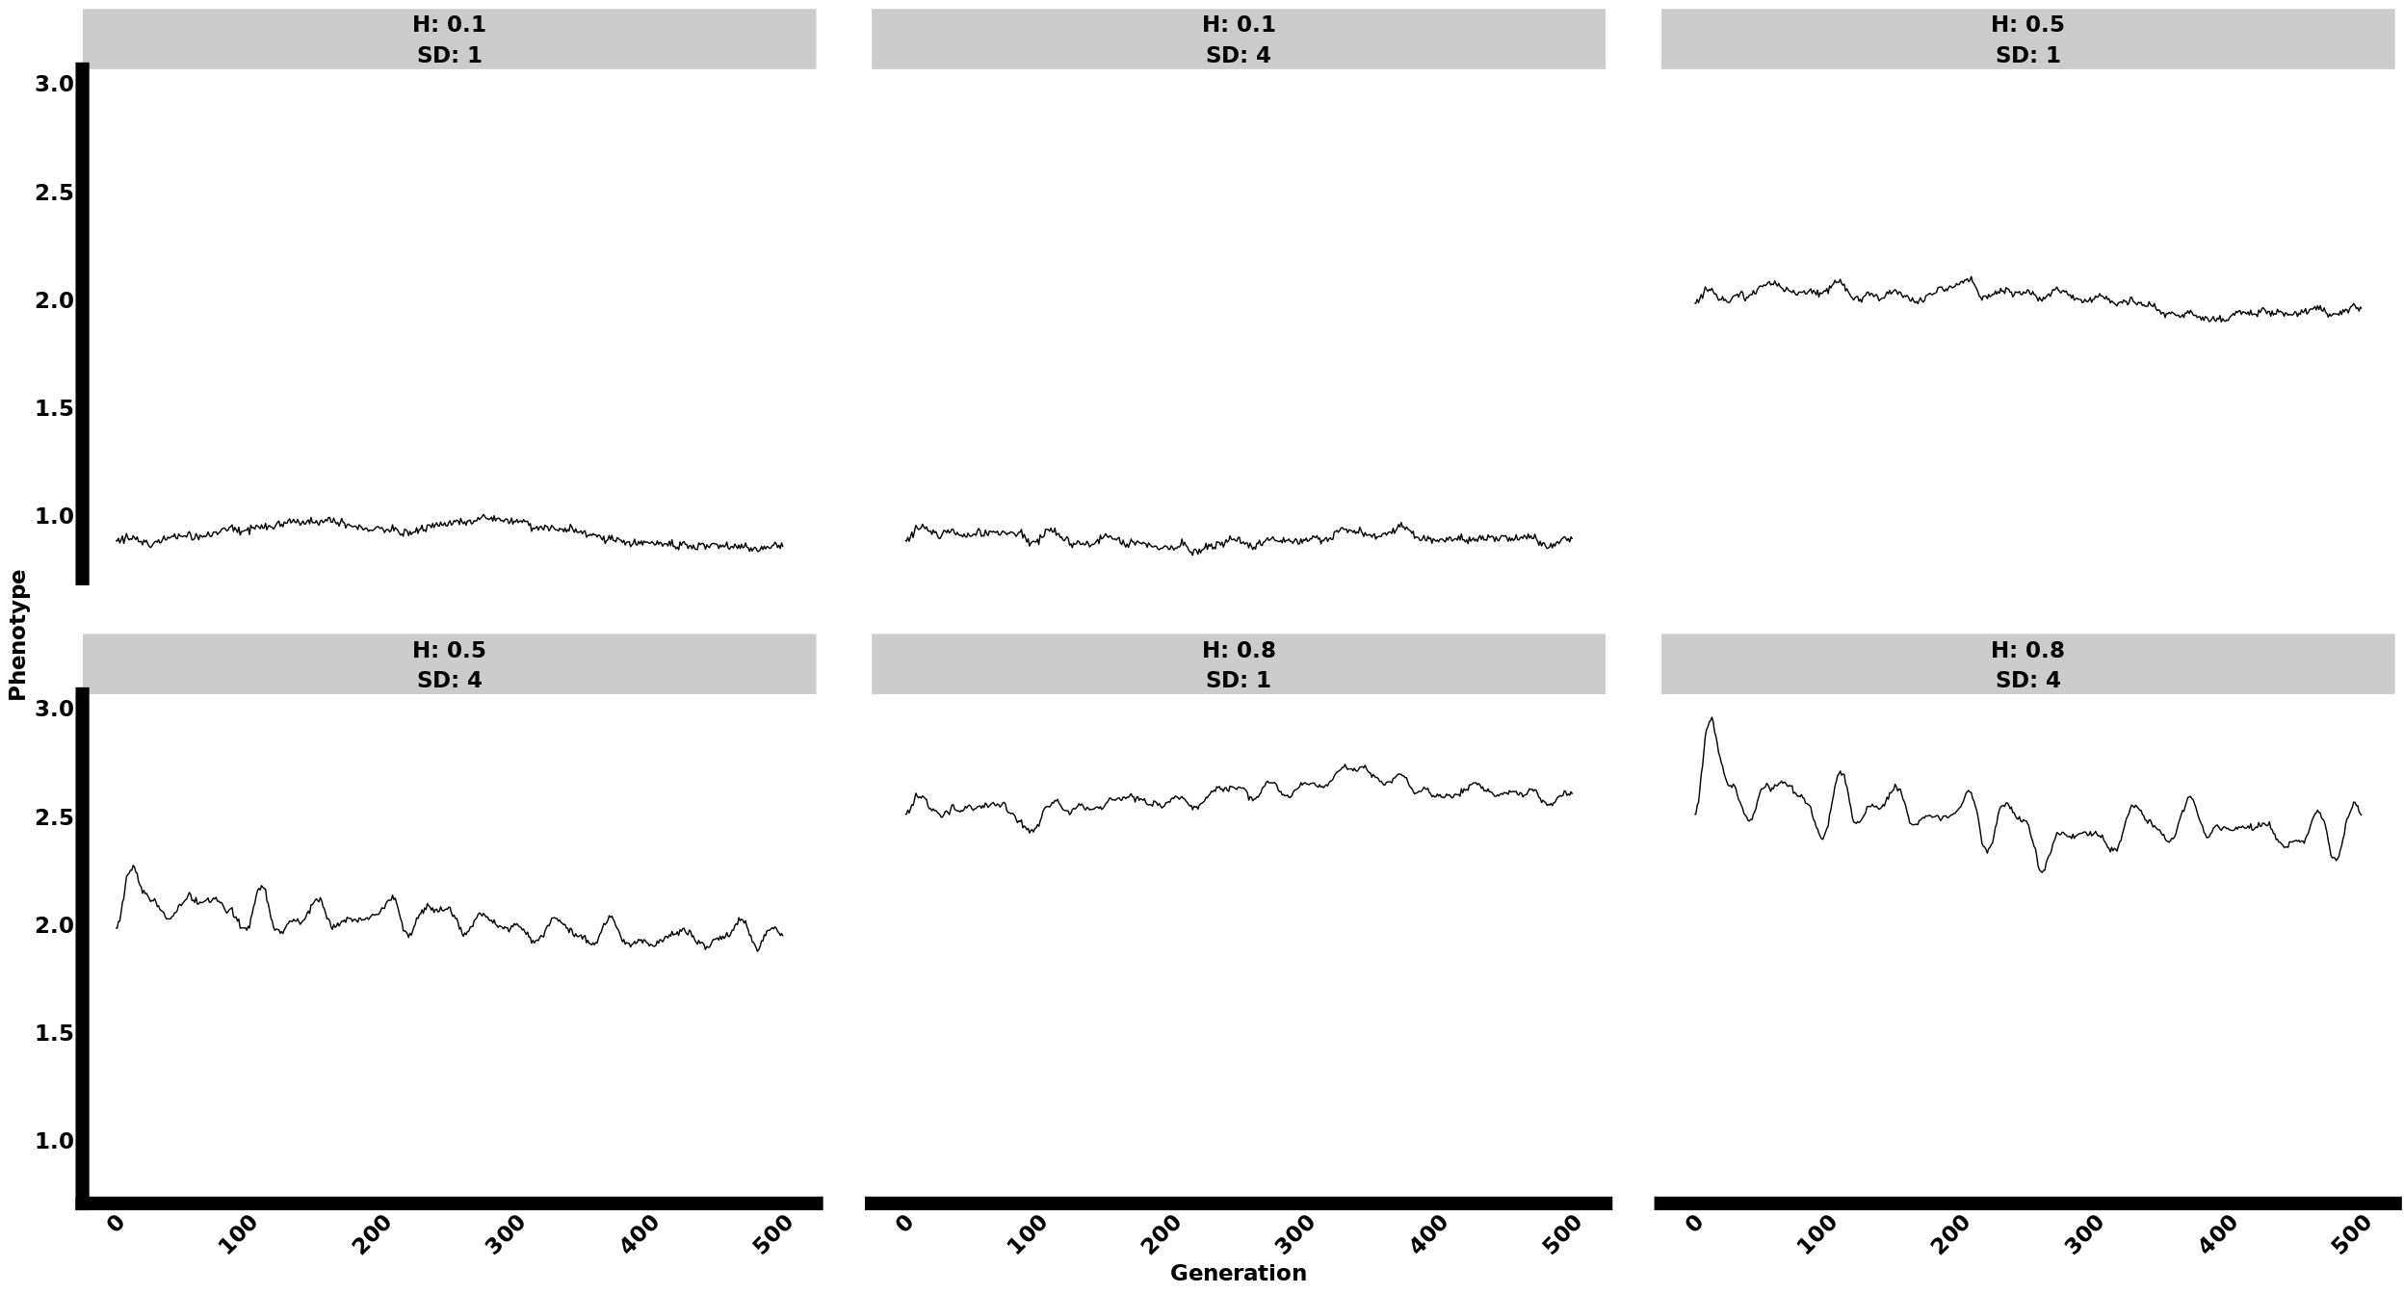

#### Oligogenic

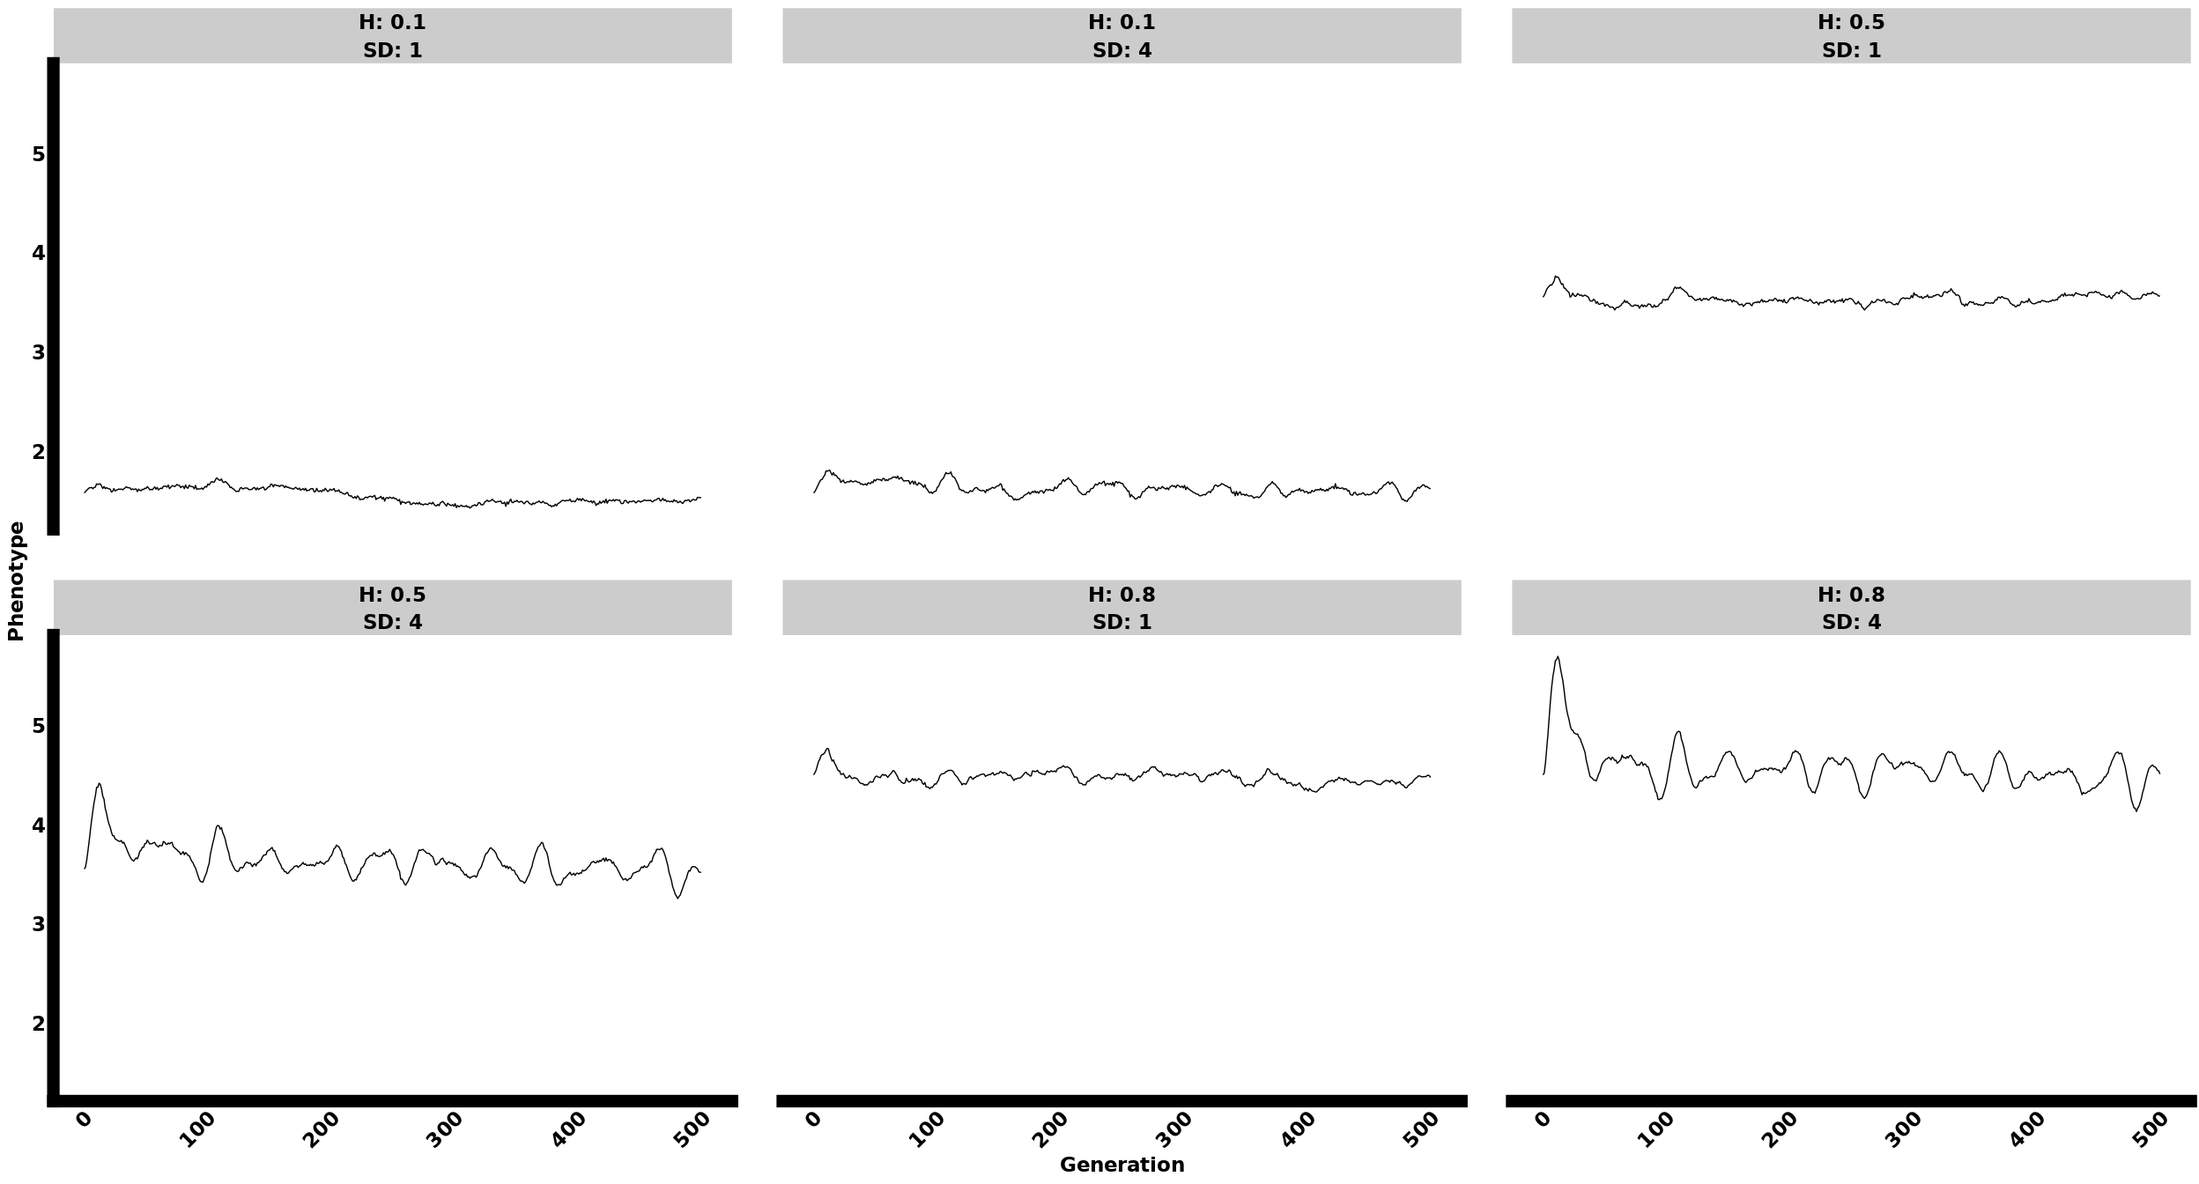

#### Monogenic

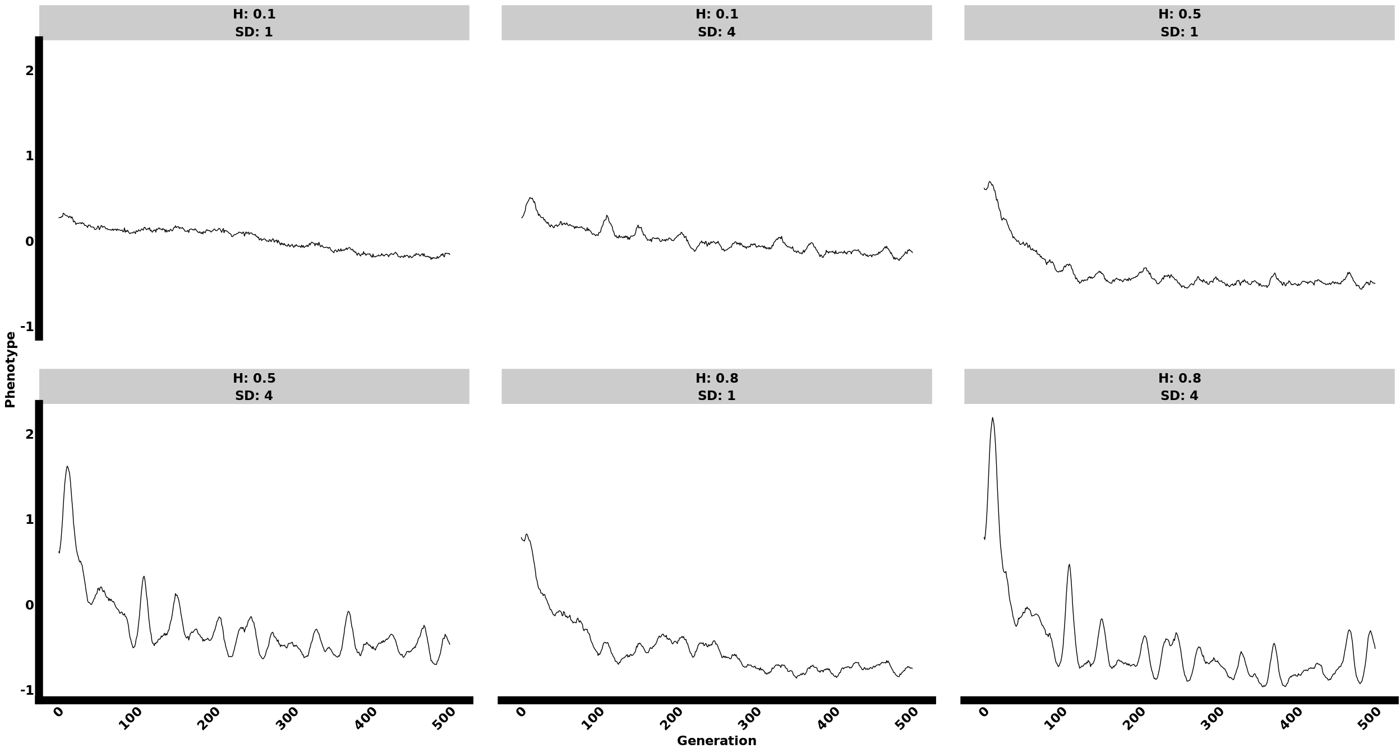

## Constant

### Allele Frequency

#### Polygenic

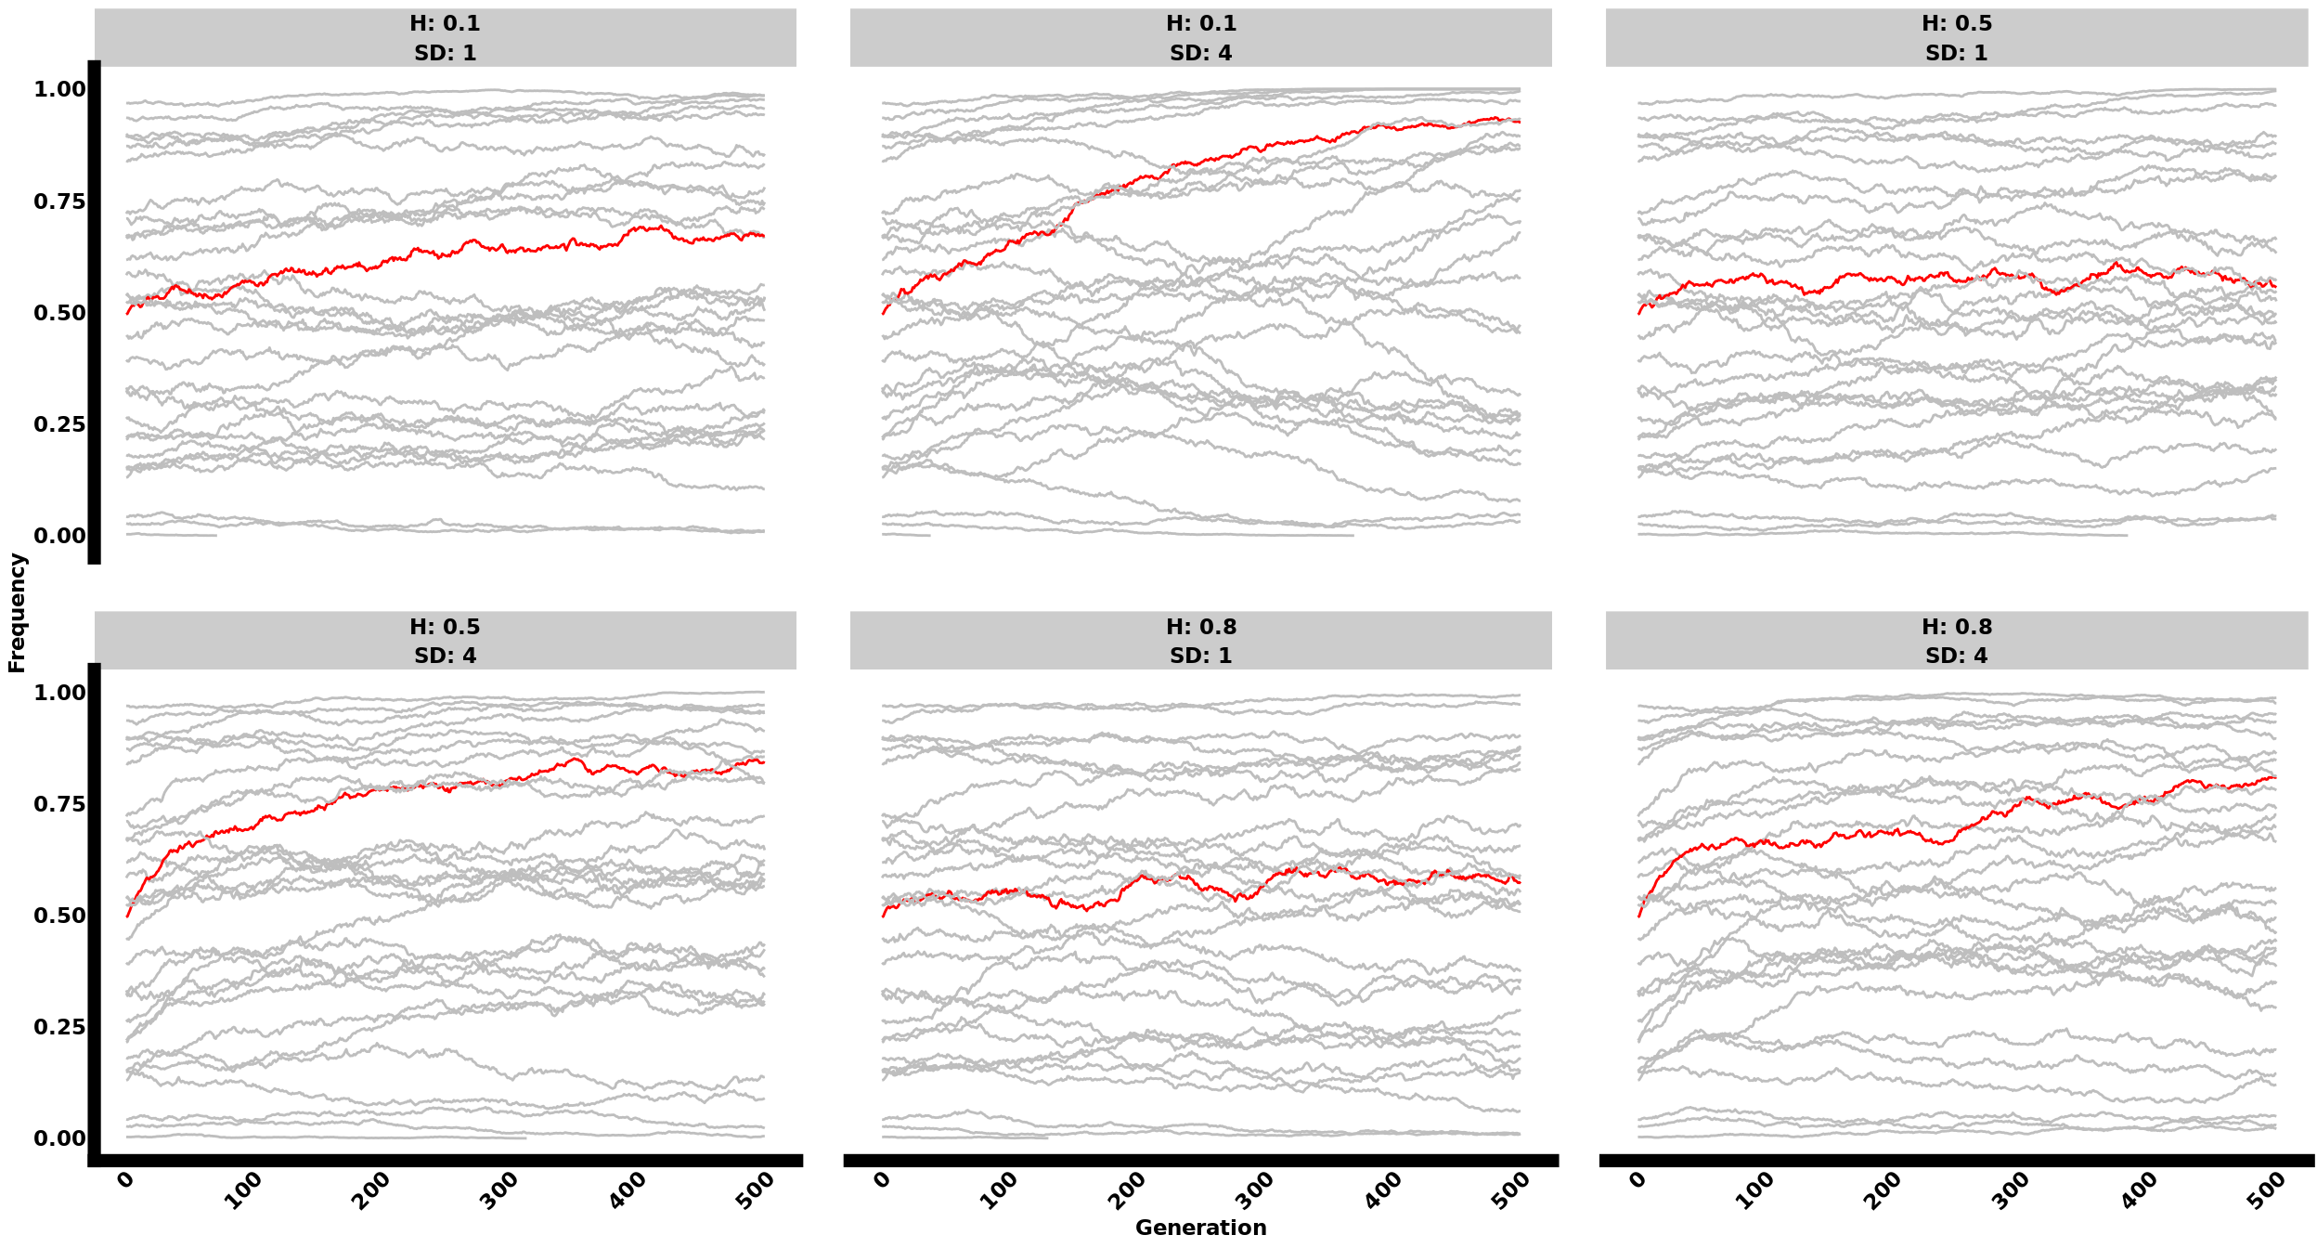

#### Oligogenic

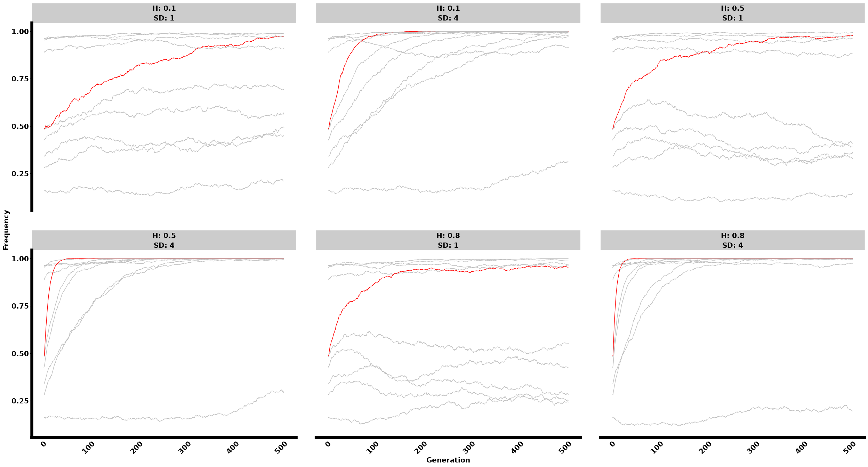

#### Monogenic

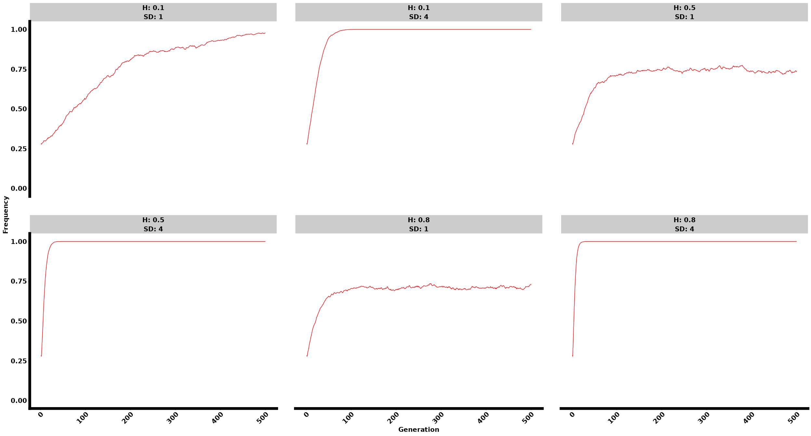

### Phenotypes

#### Polygenic

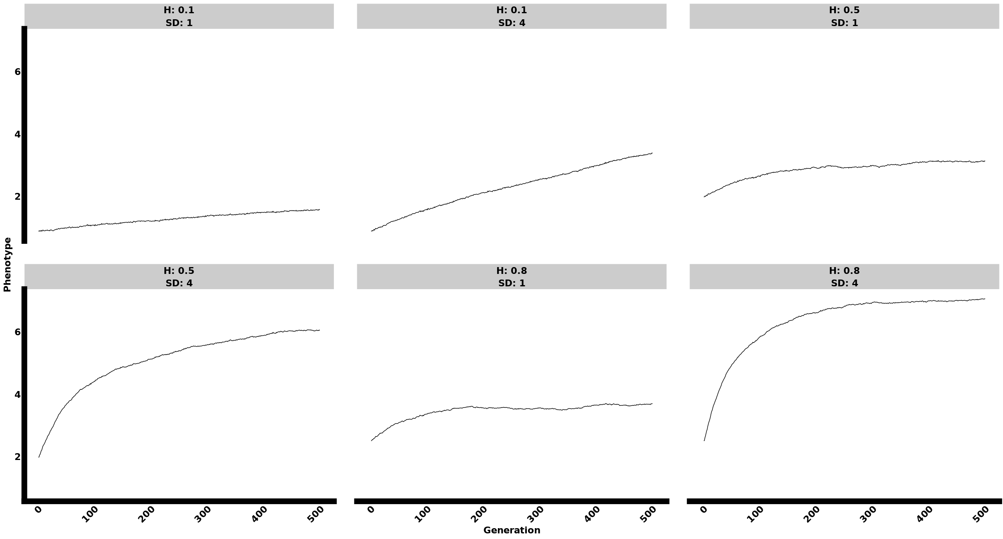

#### Oligogenic

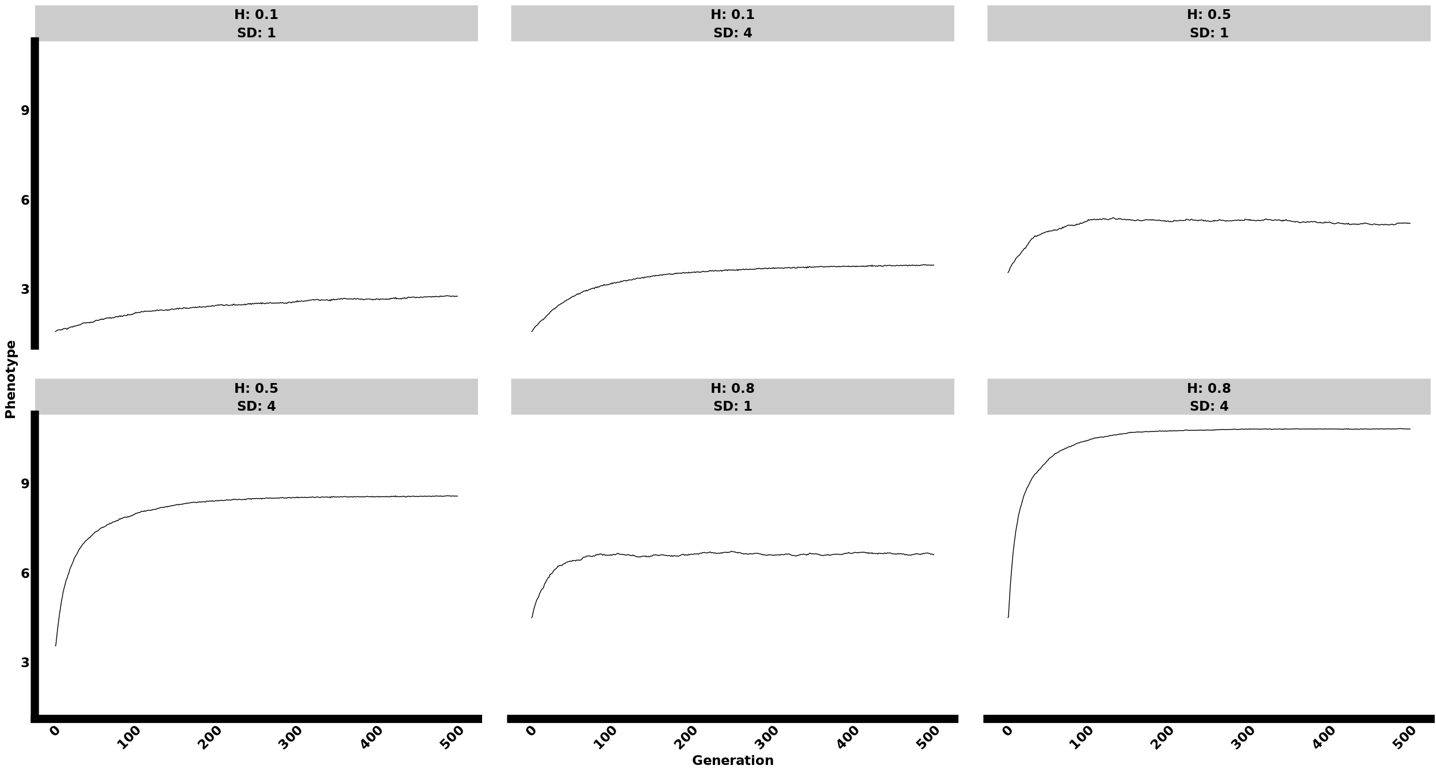

#### Monogenic

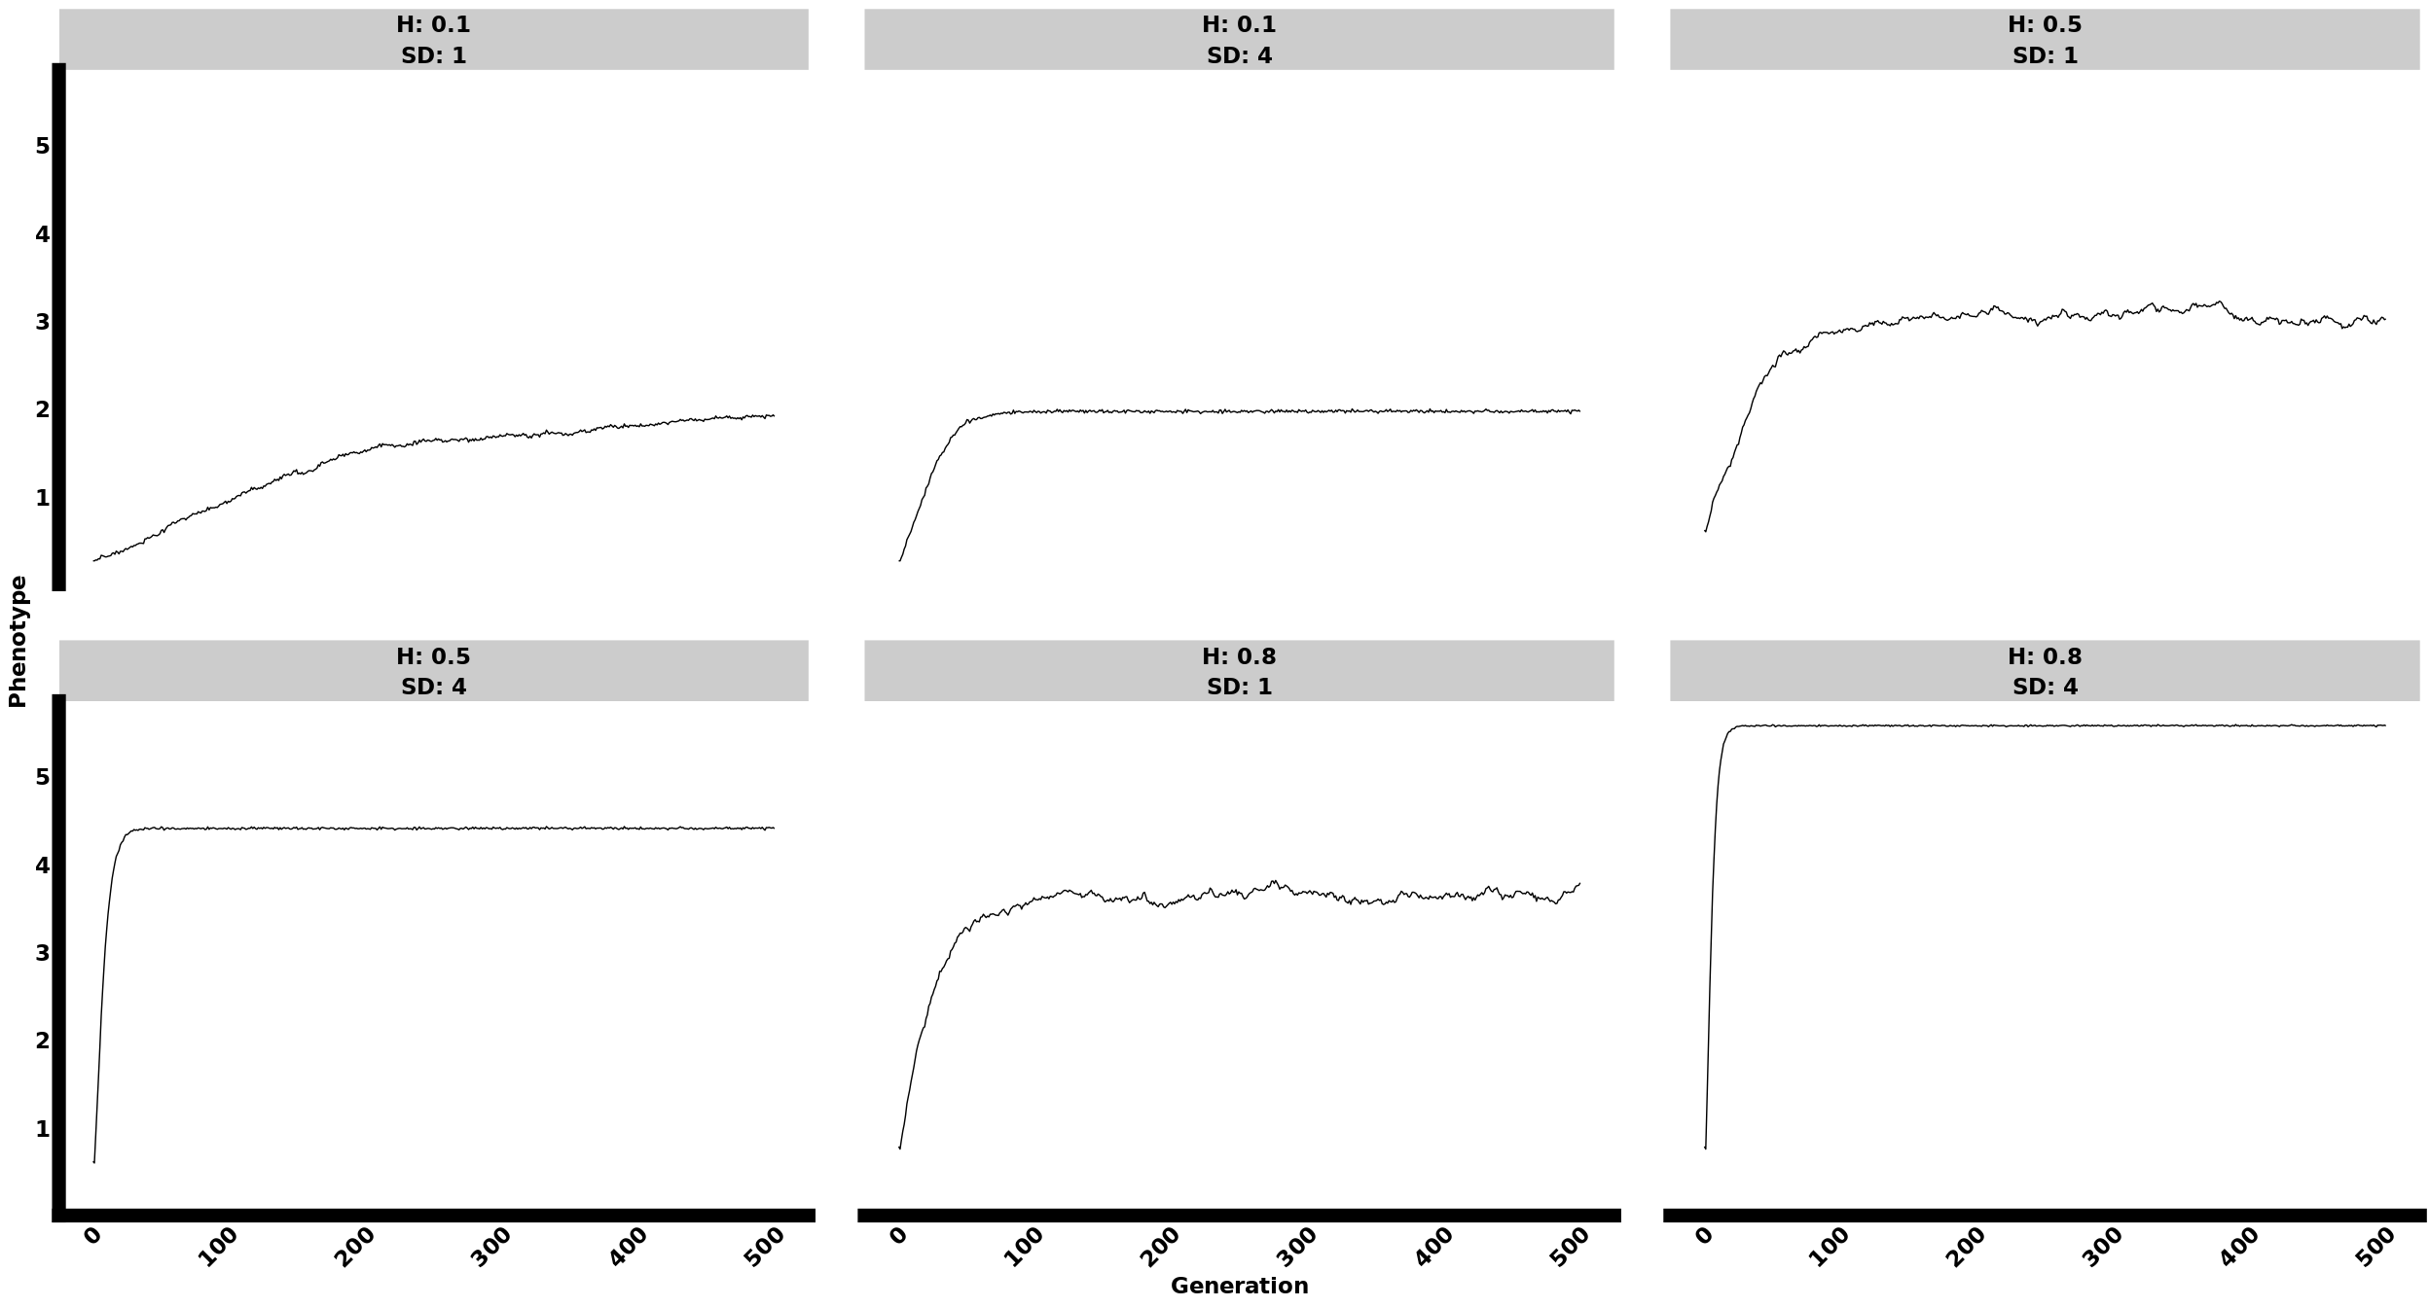

## Neutral

### Allele Frequency

#### Polygenic

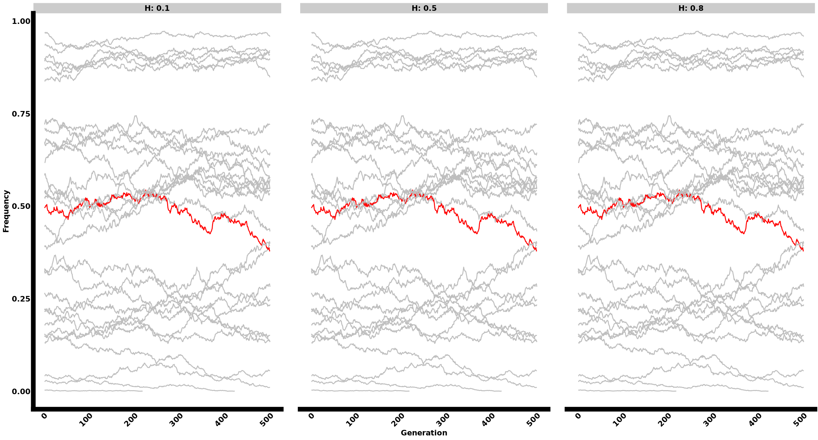

#### Oligogenic

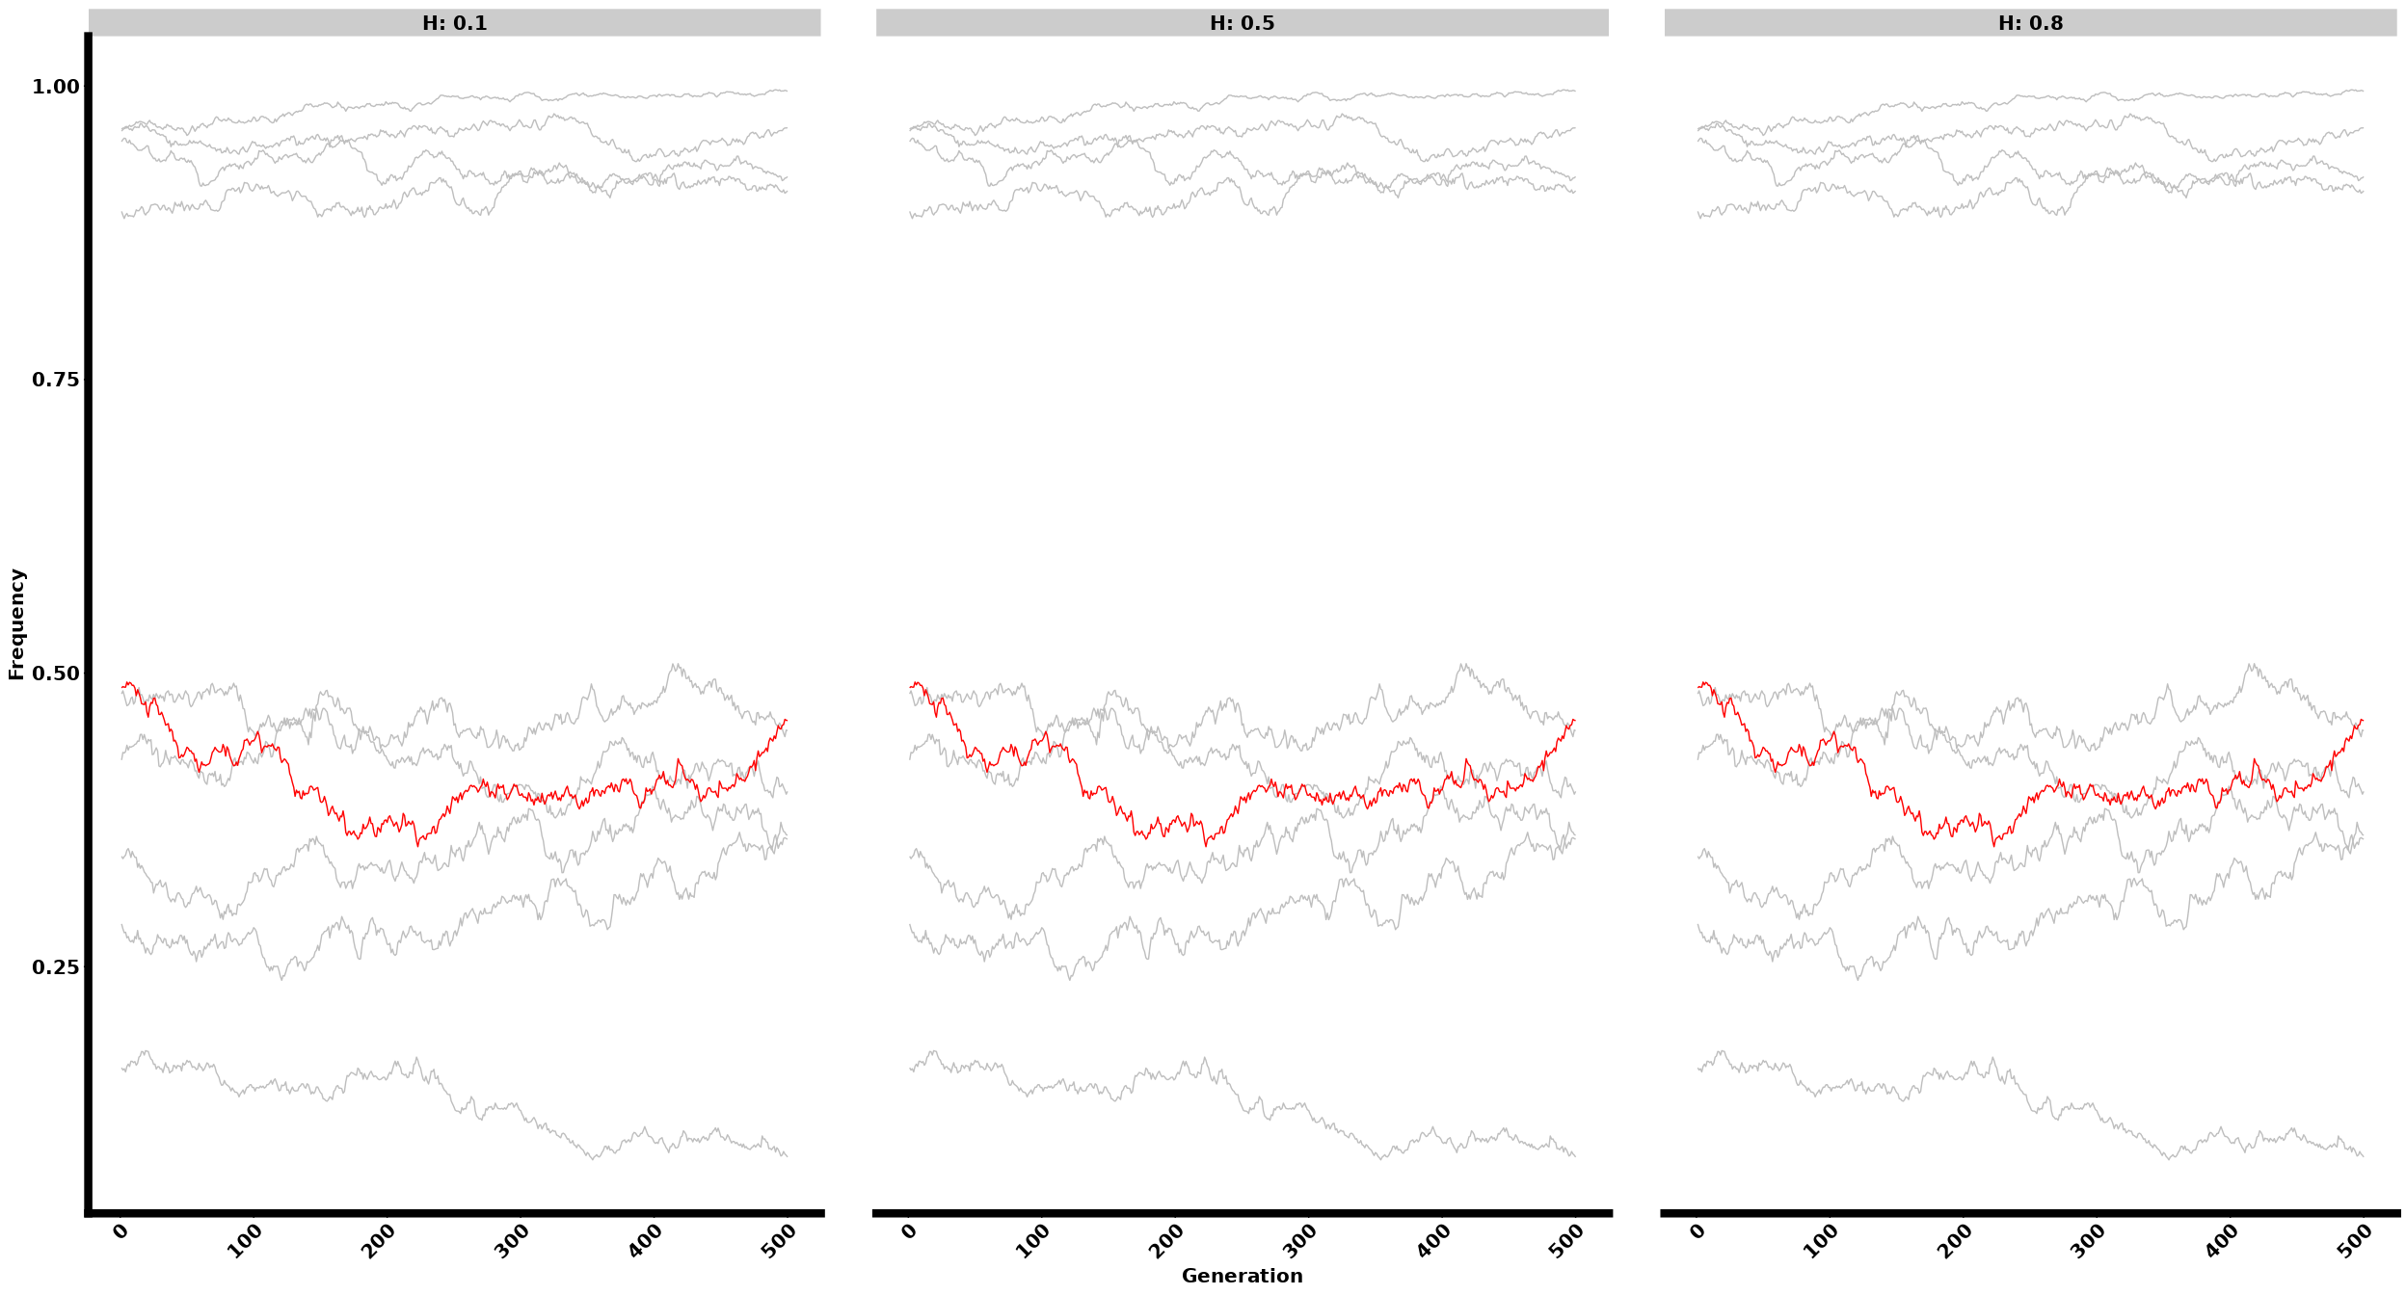

#### Monogenic

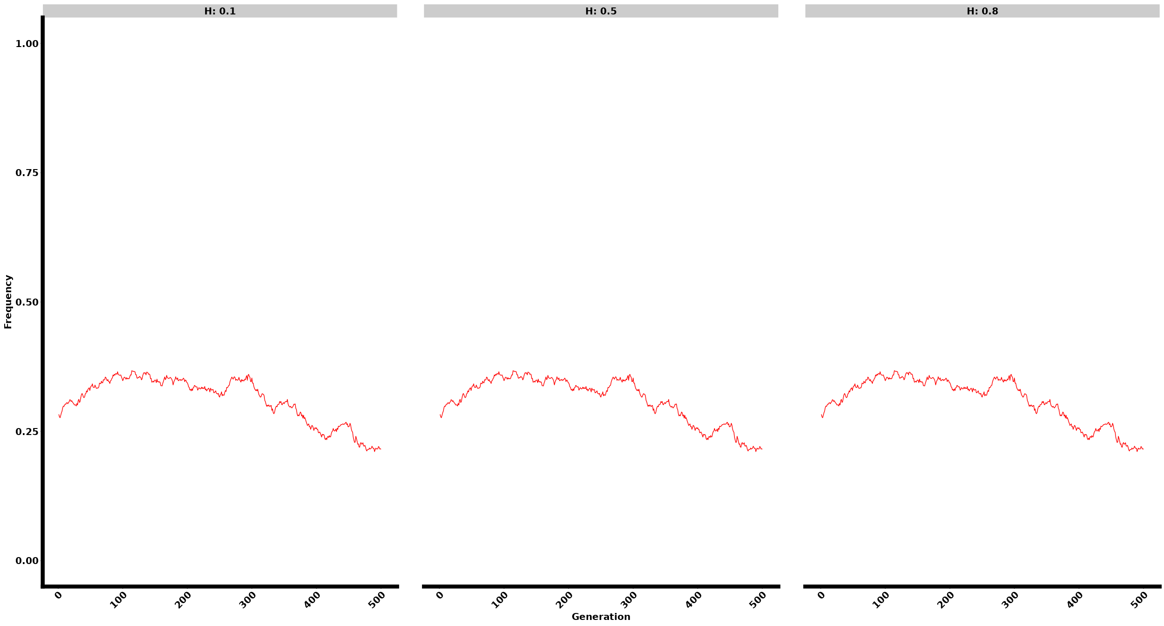

### Phenotypes

#### Polygenic

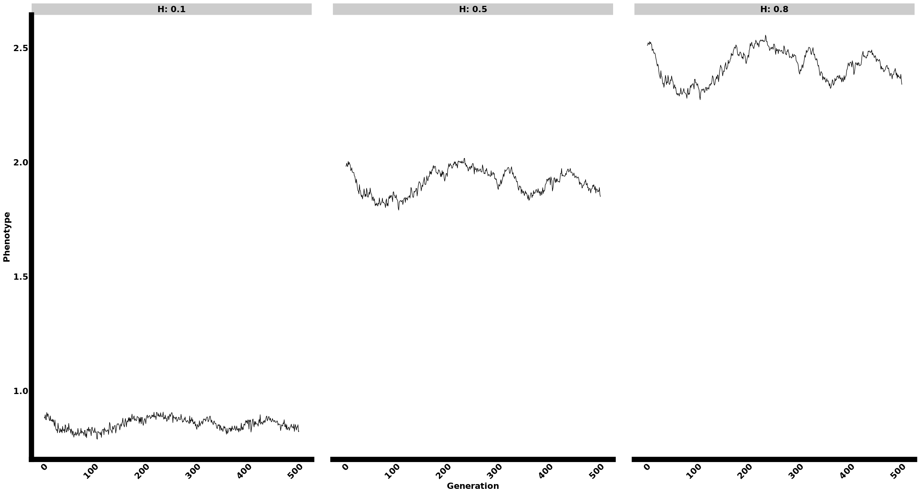

#### Oligogenic

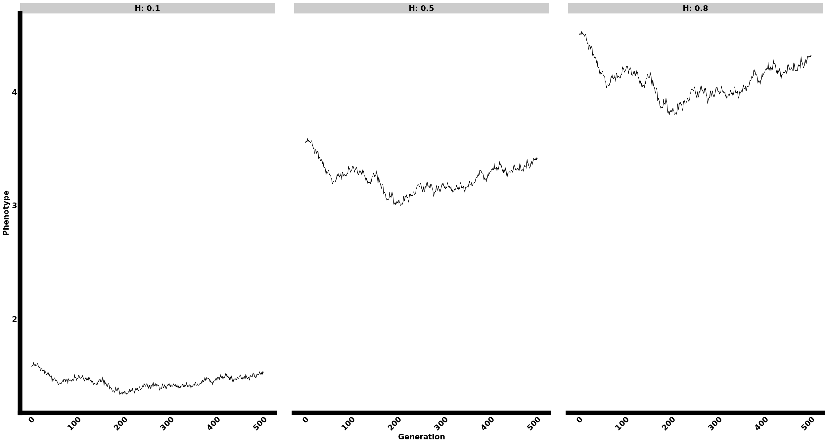

#### Monogenic

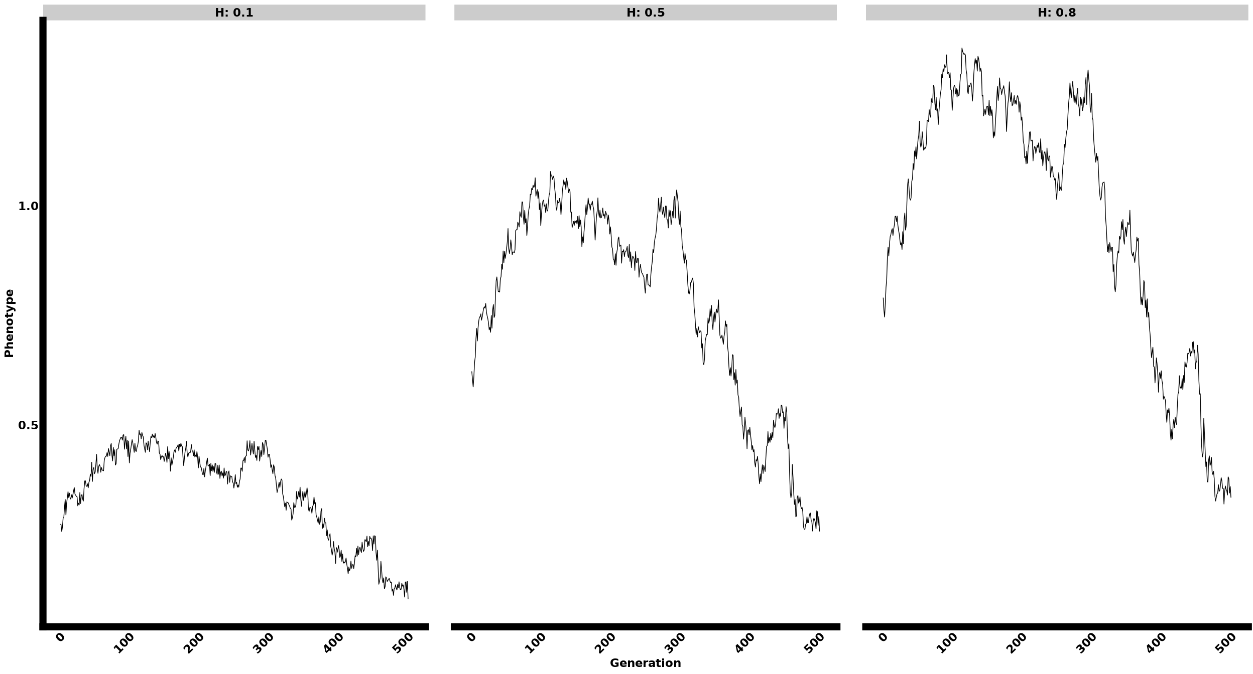

#### QTL effect and initial Frequency:

#### Higher effect, medium frequency

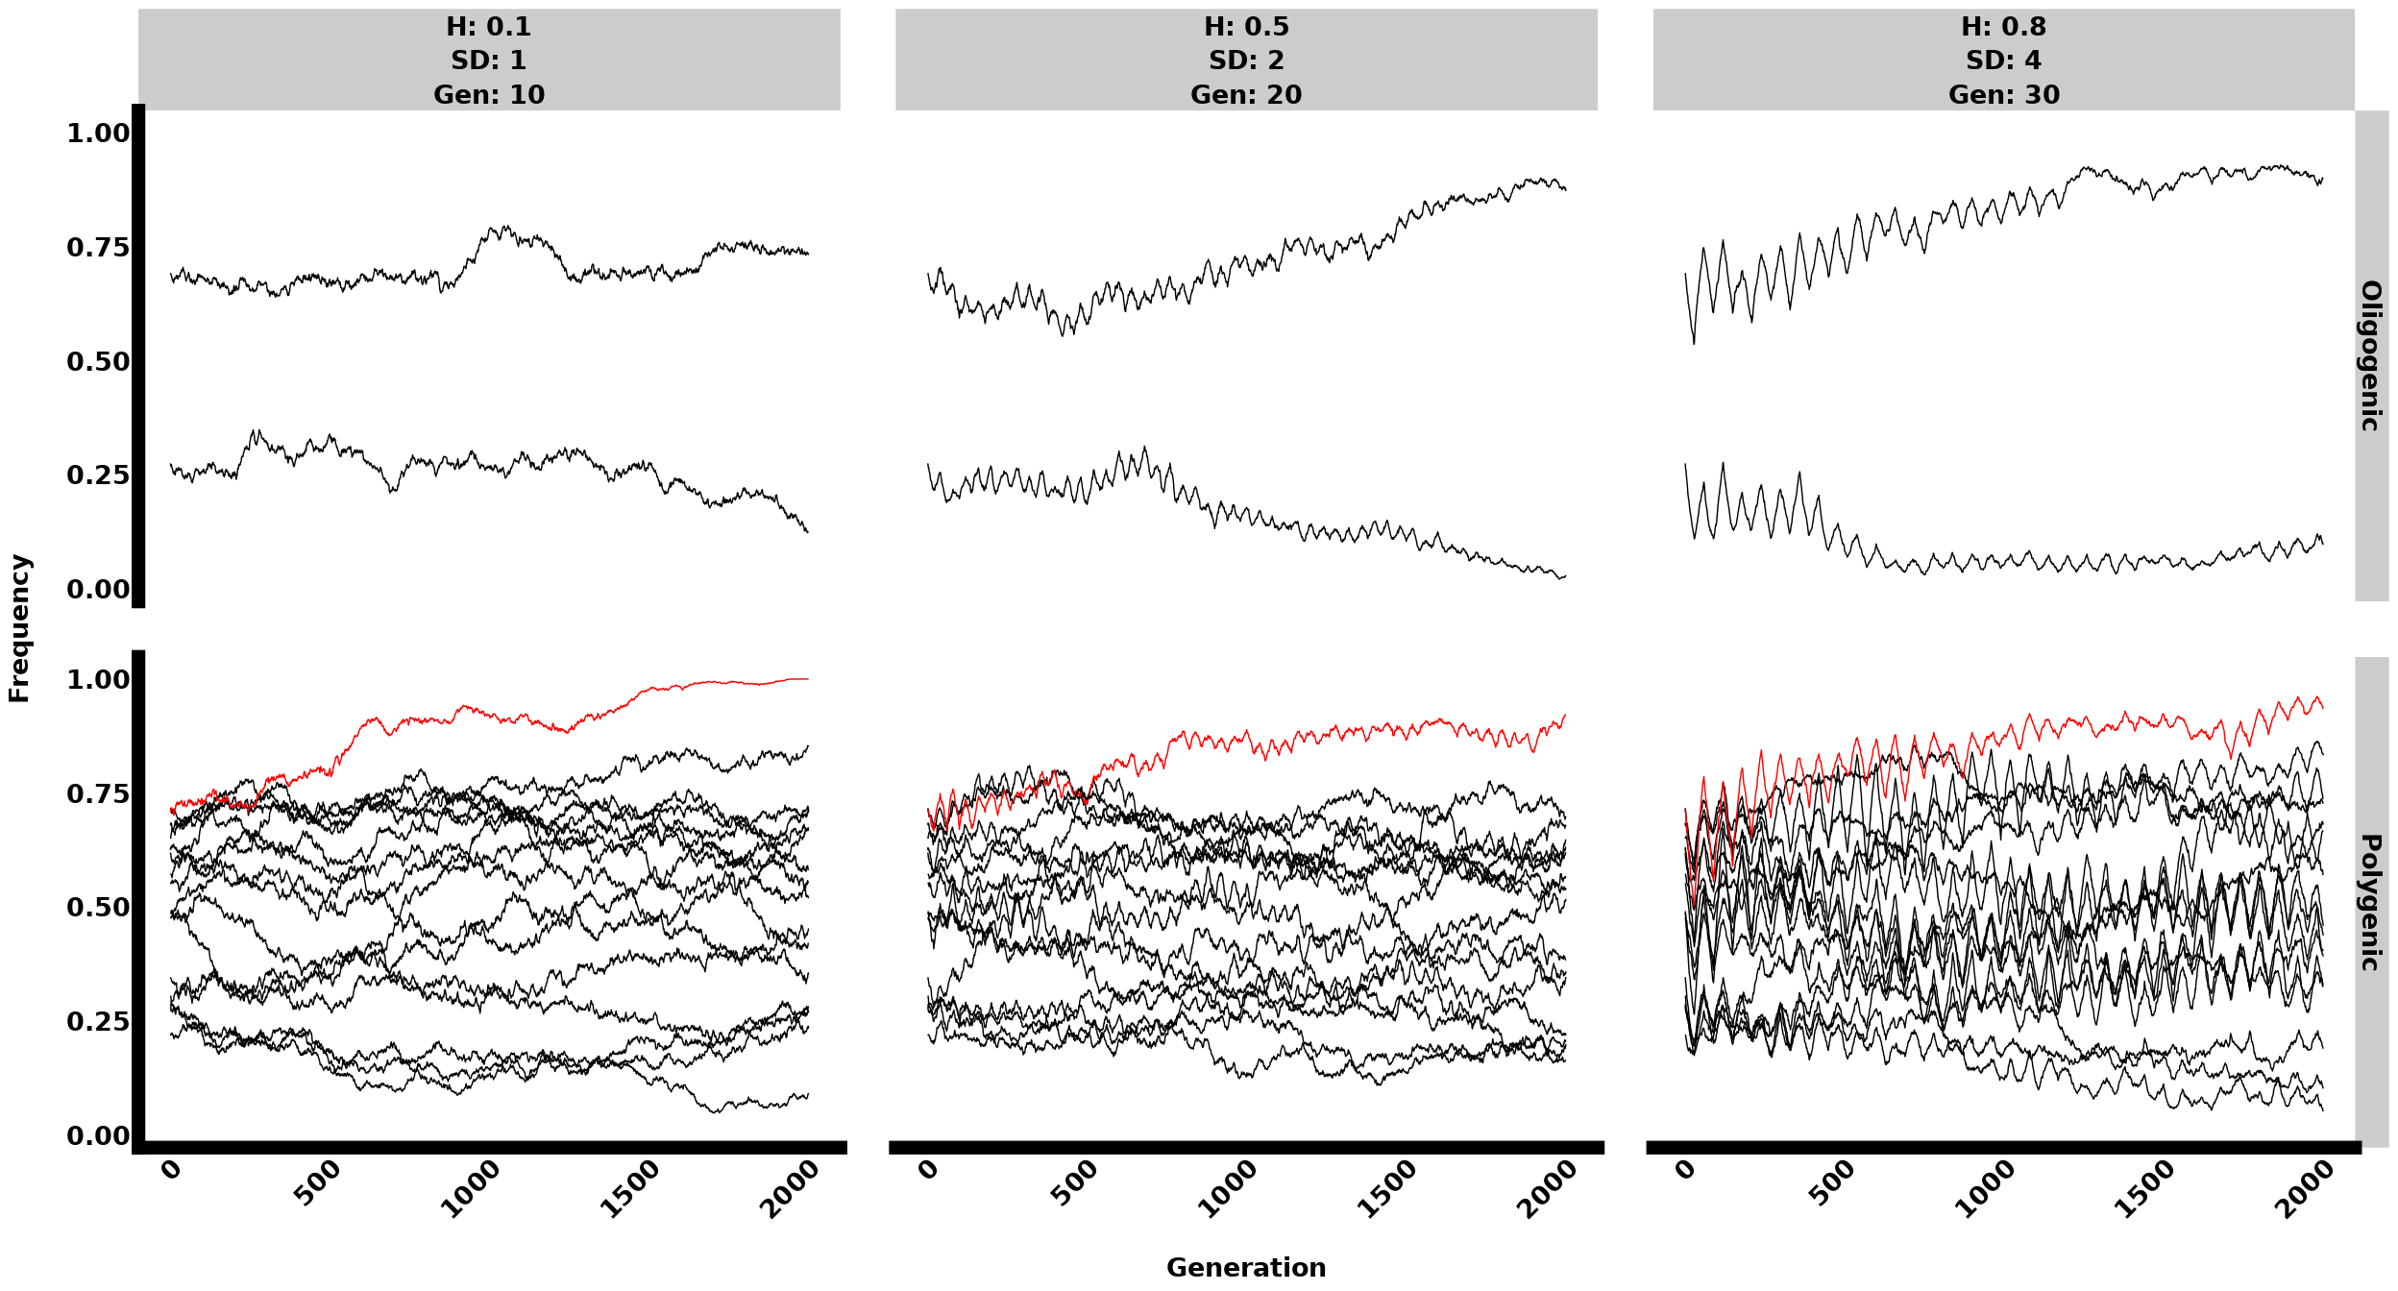

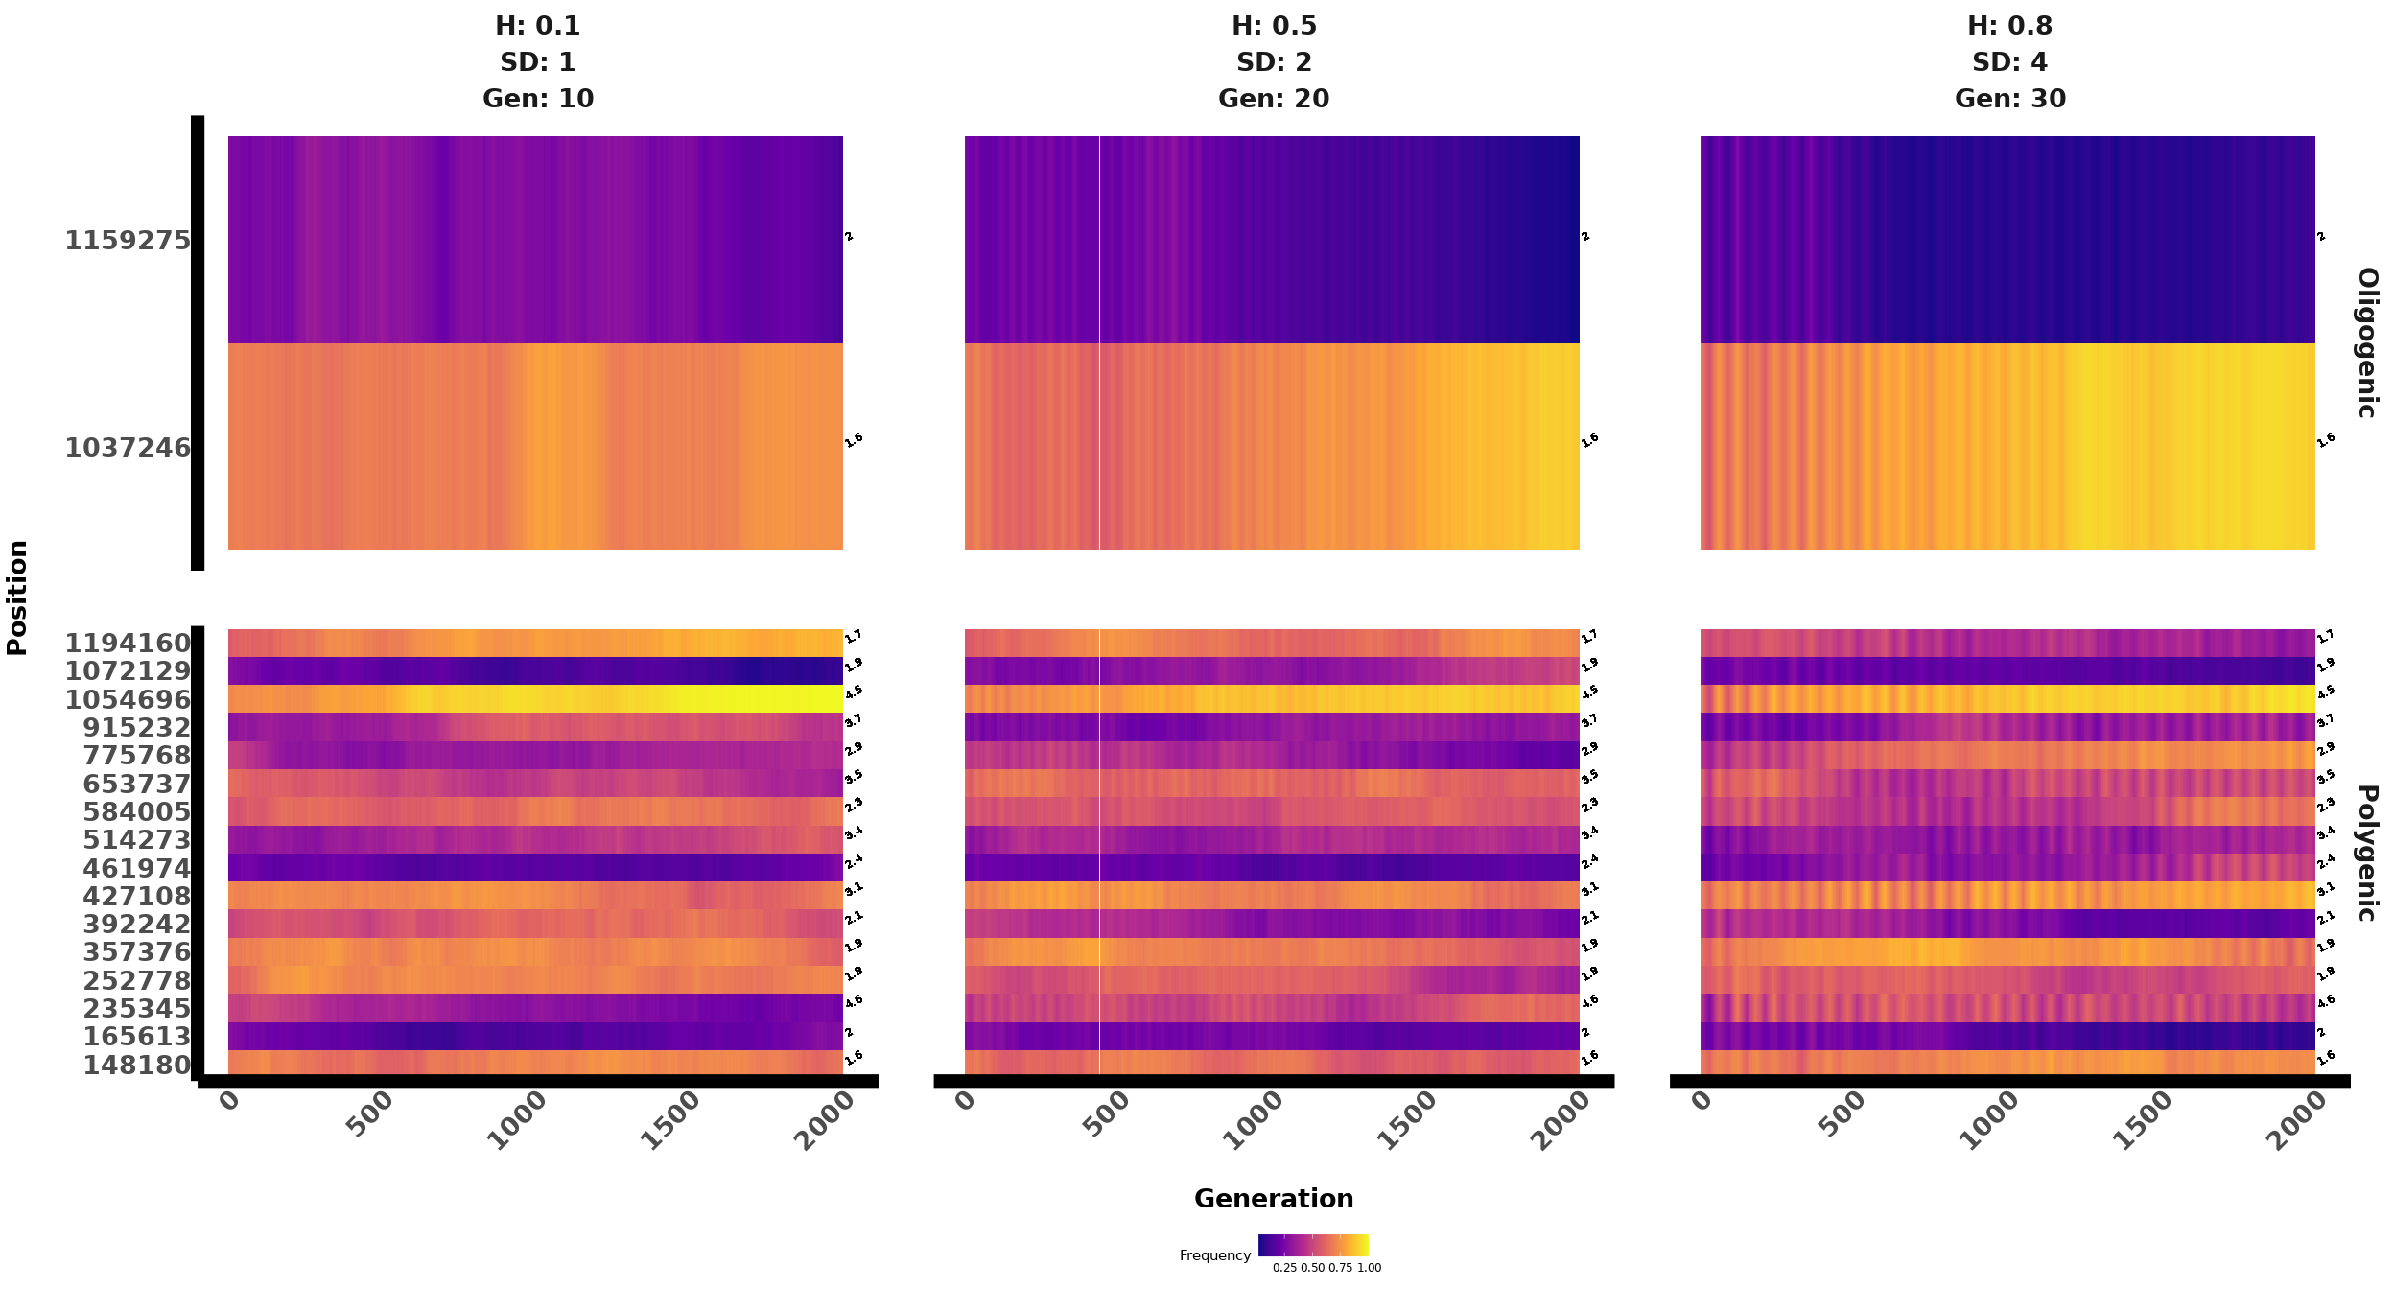

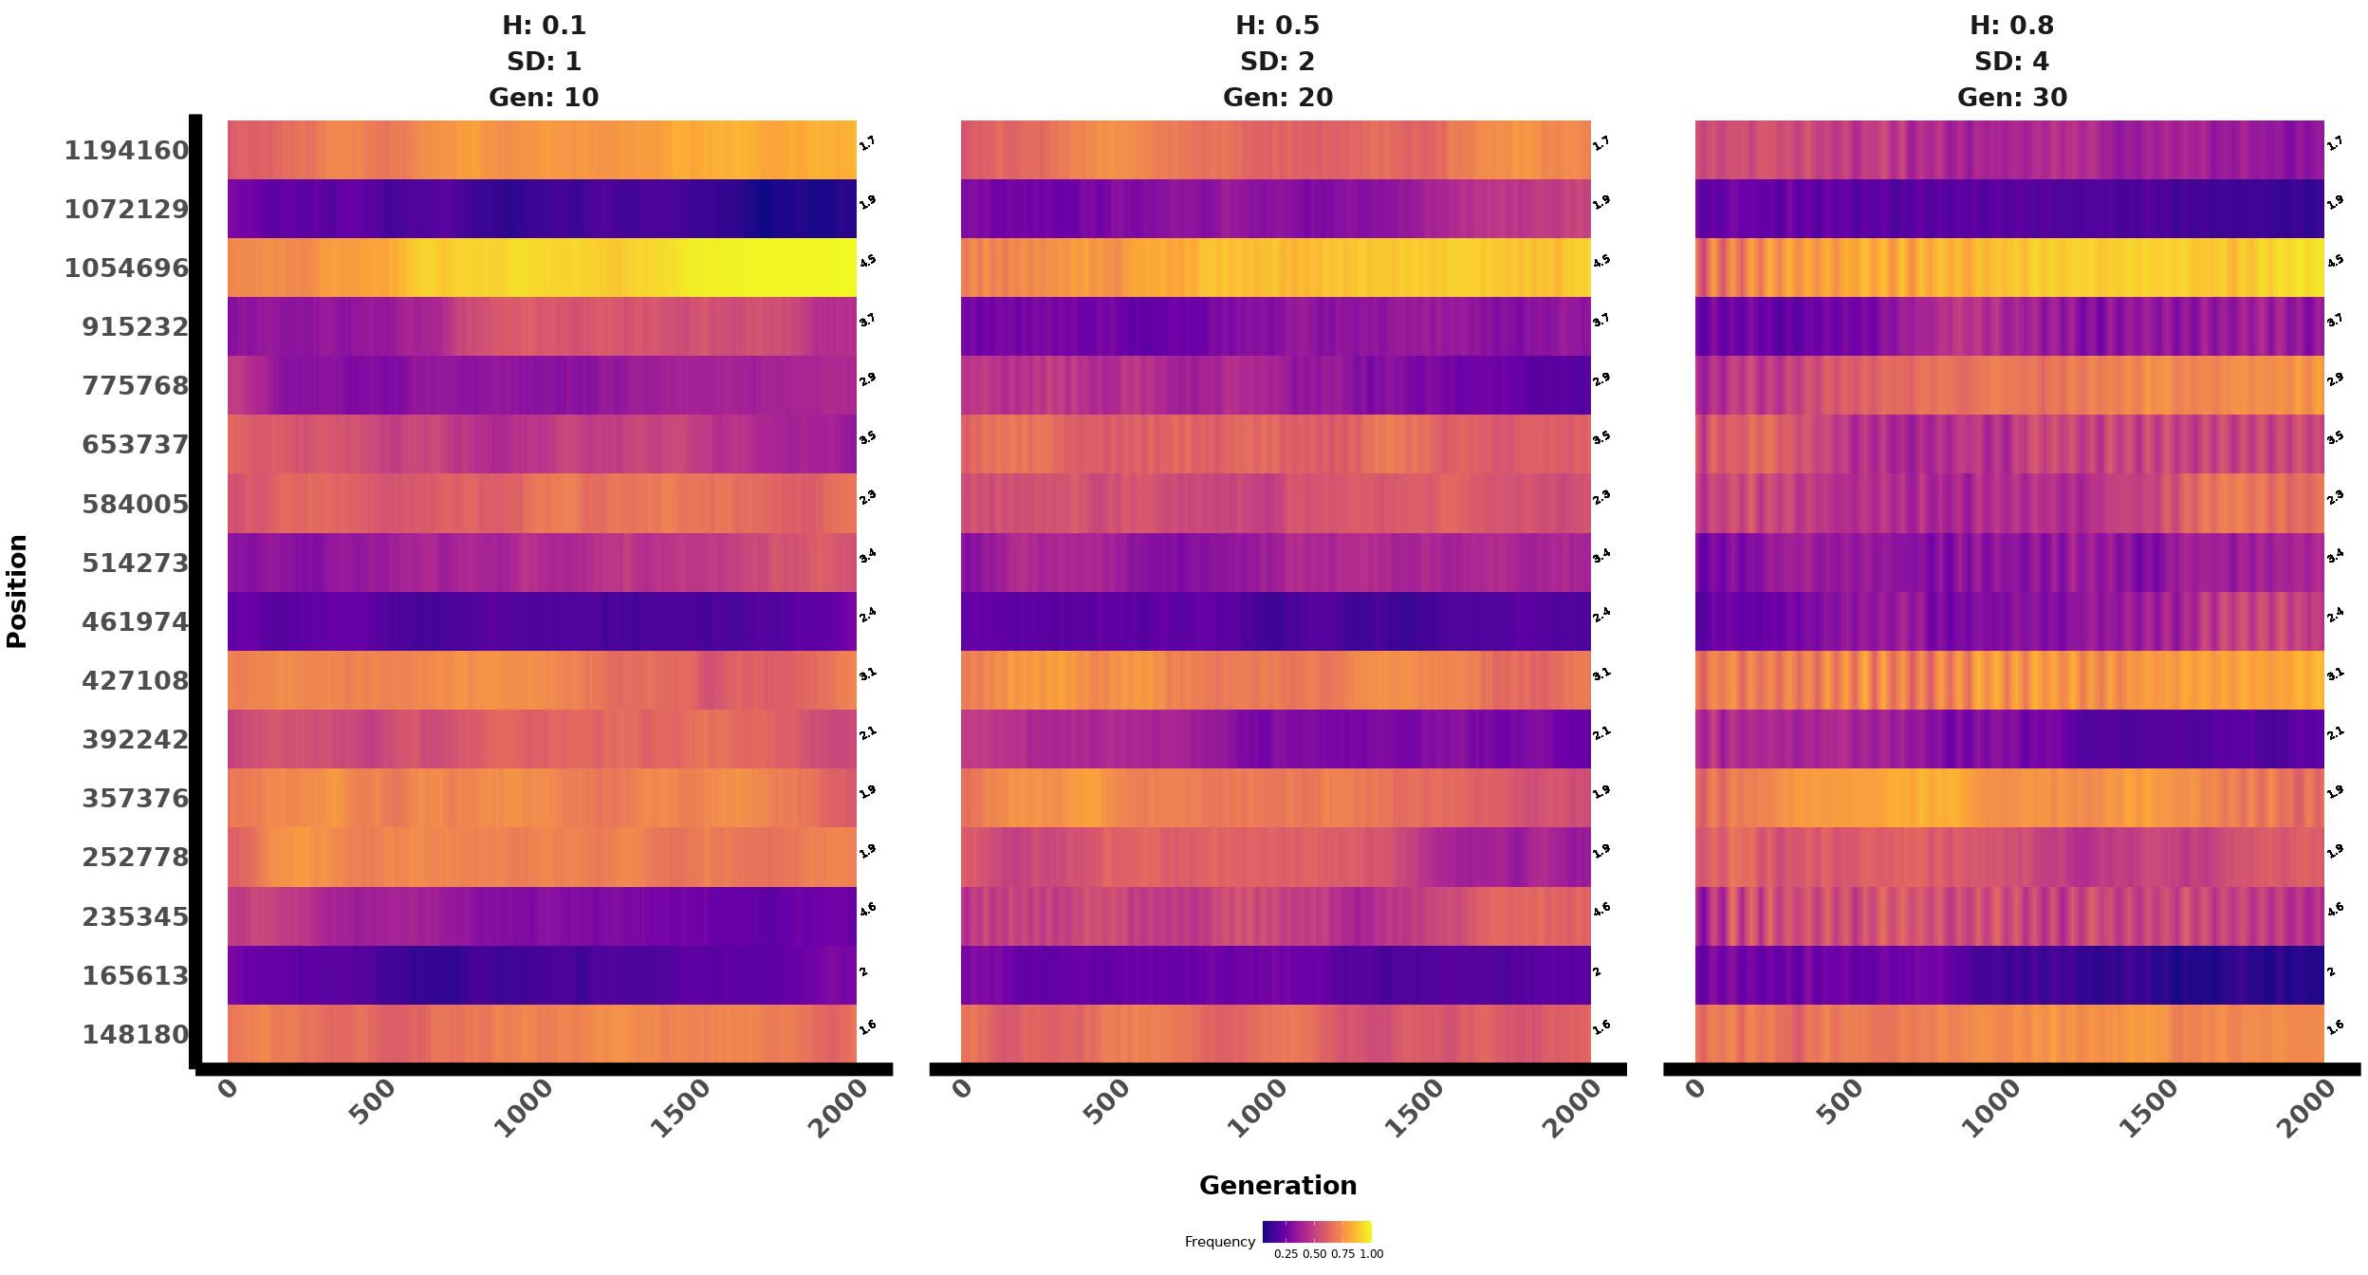

#### Lower Effect, high or low initial frequency

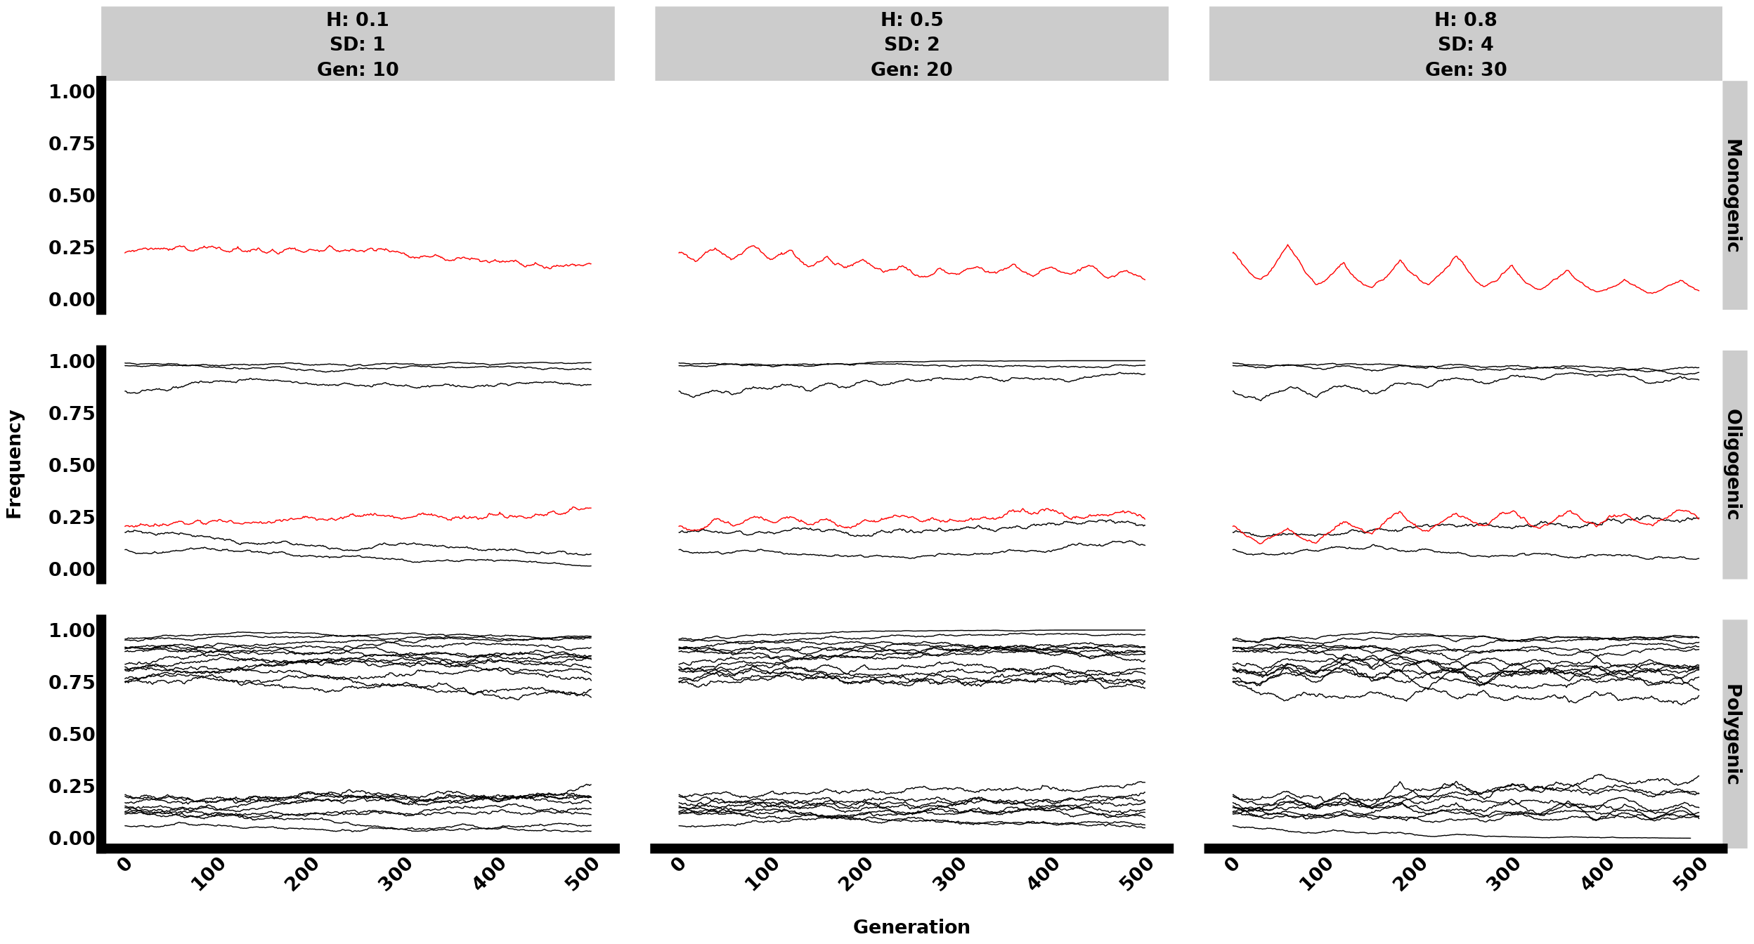

#### Using HeatMap

